SOFTWARE REQUIREMENTS SPECIFICATION
Online Auction House Website
Tuan-Thanh Phan
thanhphantuan1110@gmail.com
Prepared for
CHC Project
Version 0.8.0
Revision and Signoff Sheet
Change Record
Author | Version | Change reference | Date
Reviewers
Name | Company | Version | Position | Date
Trinh-Dong Nguyen |  | 0.1.0 | AD Team Lead
Trinh-Dong Nguyen |  | 0.2.0 | AD Team Lead
Trinh-Dong Nguyen |  | 0.3.0 | AD Team Lead
Trinh-Dong Nguyen |  | 0.4.0 | AD Team Lead
Trinh-Dong Nguyen |  | 0.5.0 | AD Team Lead
Trinh-Dong Nguyen |  | 0.6.0 | AD Team Lead
Trinh-Dong Nguyen |  | 0.7.0 | AD Team Lead
Trinh-Dong Nguyen |  | 0.8.0 | AD Team Lead

Table of Contents
1. Introduction 7
1.1 Purpose 7
1.2 Scope 7
1.3 Intended Audiences and Document Organization 7
1.4 References 7
2. Functional Requirements 8
2.1 Use Case Description 8
2.1.1 User Management UseCase 8
2.1.1.1 Register User 8
2.1.1.2 Verify Email Use Case 11
2.1.1.3 Sign in Use Case 14
2.1.1.4 Forgot Password 17
2.1.2 Manage Auctions Use Case 20
2.1.2.1 Manage Auctions Use Case 20
2.1.2.2 List All Auction Use Case 22
2.1.2.3 Auction Detail Use Case 25
2.1.2.4 Create Auction Use Case 27
2.1.2.5 Update Auction Use Case 30
2.1.2.6 Delete Auction Use Case 33
2.1.2.7 Update Auction Relations Use Case 36
2.1.2.8 Update Auction Resources Use Case 39
2.1.3 Manage Registration to Bid Use Case 42
2.1.3.1 Manage Registration to Bid Use Case 42
2.1.3.2 Register for Auction Use Case 45
2.1.3.3 Update Auction Use Case 48
2.1.3.3.1 Withdrawn Register for Auction Use Case 48
2.1.3.3.2 Check-in for Auction Use Case 51
2.1.3.3.3 Submit deposit for Auction Use Case 54
2.1.3.3.4 Verify deposit for Auction Use Case 57
2.1.3.3.5 View Own Registration for Auction Use Case 59
2.1.3.3.6 List All Registrations Use Case 62
2.1.3.3.7 Get All Registration for Auction Use Case 64
2.1.3.3.8 Reject Registration for Auction Use Case 66
2.1.3.3.9 Verify Document Registration (tier 1) for Auction Use Case 70
2.1.3.3.10 Reject Document Registration (tier 1) for Auction Use Case 73
2.1.3.3.11 Final Approval Registration (tier 2) for Auction Use Case 76
2.1.4 Manage Bidding Use Case 79
2.1.4.1 Manage Bidding Use Case 79
2.1.4.2 Manual Bidding Use Case 82
2.1.4.3 Deny Bid Use Case 86
2.1.5 Manage Auction Finalization Use Case 89
2.1.5.1 Manage Auction Finalization Use Case 89
2.1.5.2 Auction Evaluation Use Case 91
2.1.5.3 Auction Finalization Use Case 94
2.1.5.4 Auction Status Override Use Case 97
2.1.5.5 Get Auction Audit Logs Use Case 100
2.1.5.6 Get Auction Results Use Case 103
2.1.5.7 Get Winner Payment Requirements Use Case 106
2.1.5.8 Initiate Winner Payment Use Case 109
2.1.5.9 Verify Winner Payment Use Case 112
2.1.6 Manage Auction Costs Use Case 115
2.1.6.1 Manage Auction Cost Use Case 115
2.1.6.2 Create/Update Auction Cost Use Case 117
2.1.6.3 Get Auction Cost Use Case 120
2.1.6.4 Update Specific Auction Cost Use Case 123
2.1.6.5 Delete Auction Cost Use Case 126
2.1.6.6 Add Other Cost in Auction Cost Use Case 129
2.1.7 Manage Article Use Case 133
2.1.7.1 Manage Article Use Case 133
2.1.7.2 Get All Article Use Case 135
2.1.7.3 Create Article Use Case 138
2.1.7.4 Get Article Detail Use Case 141
2.1.7.5 Update Article Use Case 144
2.1.7.6 Update Article Relations Use Case 147
2.1.7.7 Delete Article Use Case 150
1.1 List Description 153
1.2 View Description 153
2. Non-functional Requirements 153
2.1 User Access and Security 153
2.2 Performance Requirements 154
2.3 Implementation Requirements 154
3. Other Requirements 155
3.1 Archive Function 155
3.2 Security Audit Function 155
3.3 ChildHeathCare Sites 156
3.4 ChildHeathCare Lists 156
3.5 Custom Pages 157
3.6 Scheduled Agents 158
3.7 Technical Concern 158
4. Appendixes 158
4.1 Glossary 158
4.2 Mapping to Notes Application 159
4.3 Messages 159
4.4 Issues List 159

Introduction

Purpose
This Software Requirements Specification and Design document is to outline the software requirements for the "Building an Online Auction House" project. This document provides a detailed technical foundation for the deployment, development, and operation of the mobile app and website on various platforms. It serves as a comprehensive guide for developers to plan, assign tasks, and implement the application. Additionally, testers will utilize this document to design test cases that align with the specified requirements, ensuring the final product meets quality standards and user expectations.

Scope
This document covers the Online Auction House Website, which is part of the broader initiative to improve auction processes through digital solutions.

Intended Audiences and Document Organization
This document is intended for:
- Development team: Responsible to develop detailed design, implement and perform unit test, integration test and system test for the migrated application.
- Data Migration team: Responsible for creating data migration scripts and performing data migration for the application.
- Documentation Team: Responsible for writing User Guide for the application.
- UAT team: Responsible for conducting user acceptance test sessions with end users.

Below are main sections of the document:
- 1. Introduction: This section describes the general introduction of this document.
- 2. Functional Requirements: This section describes the functional requirements in detail.
- 3. Non-functional Requirements: This section describes the non-functional requirements of this application such as user access and security, interfaces, screens, and performance.
- 4. Other Requirements: This section describes other requirements such as archive or security audit function.
- 5. Appendixes: This section describes other requirements for this application and other supporting information for this document.
- NOTE: Please refer to section 6.1 for all acronyms and abbreviations you may encounter within this document.

References
# | Title | Version | File Name / Link | Description
1 | User Interface | 0.2.0 | Link Figma | Demo high fidelity user interface
2 | List Description | 0.1.0 | List Description | Description of list in the system
3 | View Description | 0.1.0 | View Description | Description of view/screen in the system
4 | DB Sheet | 0.1.0 | DB Sheet | Description of table to store data in database

Functional Requirements

Use Case Description

User Management UseCase

Register User

Use Case Description
Name | Register Account
Description | This use case allows the Guest to create a new Account in the authentication provider and corresponding User record in the local database.
Actor | Guest
Trigger | - When the Guest clicks on the 'Sign Up' button on the RegistrationPage.
Pre-condition | • Guest's device must be connected to the internet.  • Guest is on the RegistrationPage.
Post-condition | - The Account is stored in Supabase Auth, the User record is stored in the local database, and a verification email is sent to the Guest.

Sequence Flow
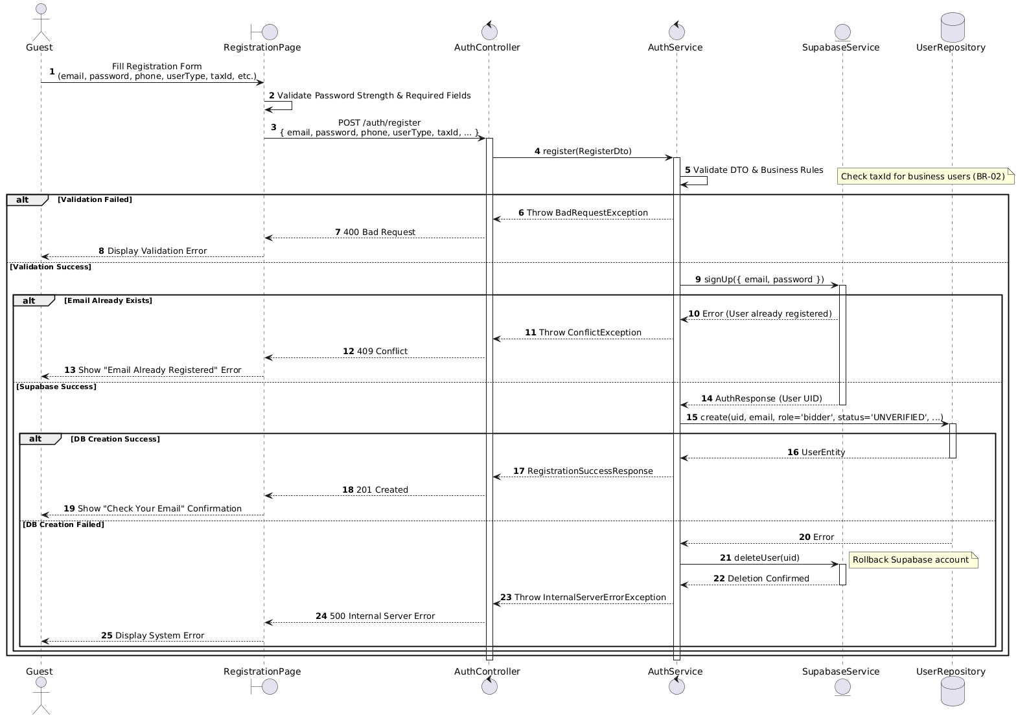

Activities Flow
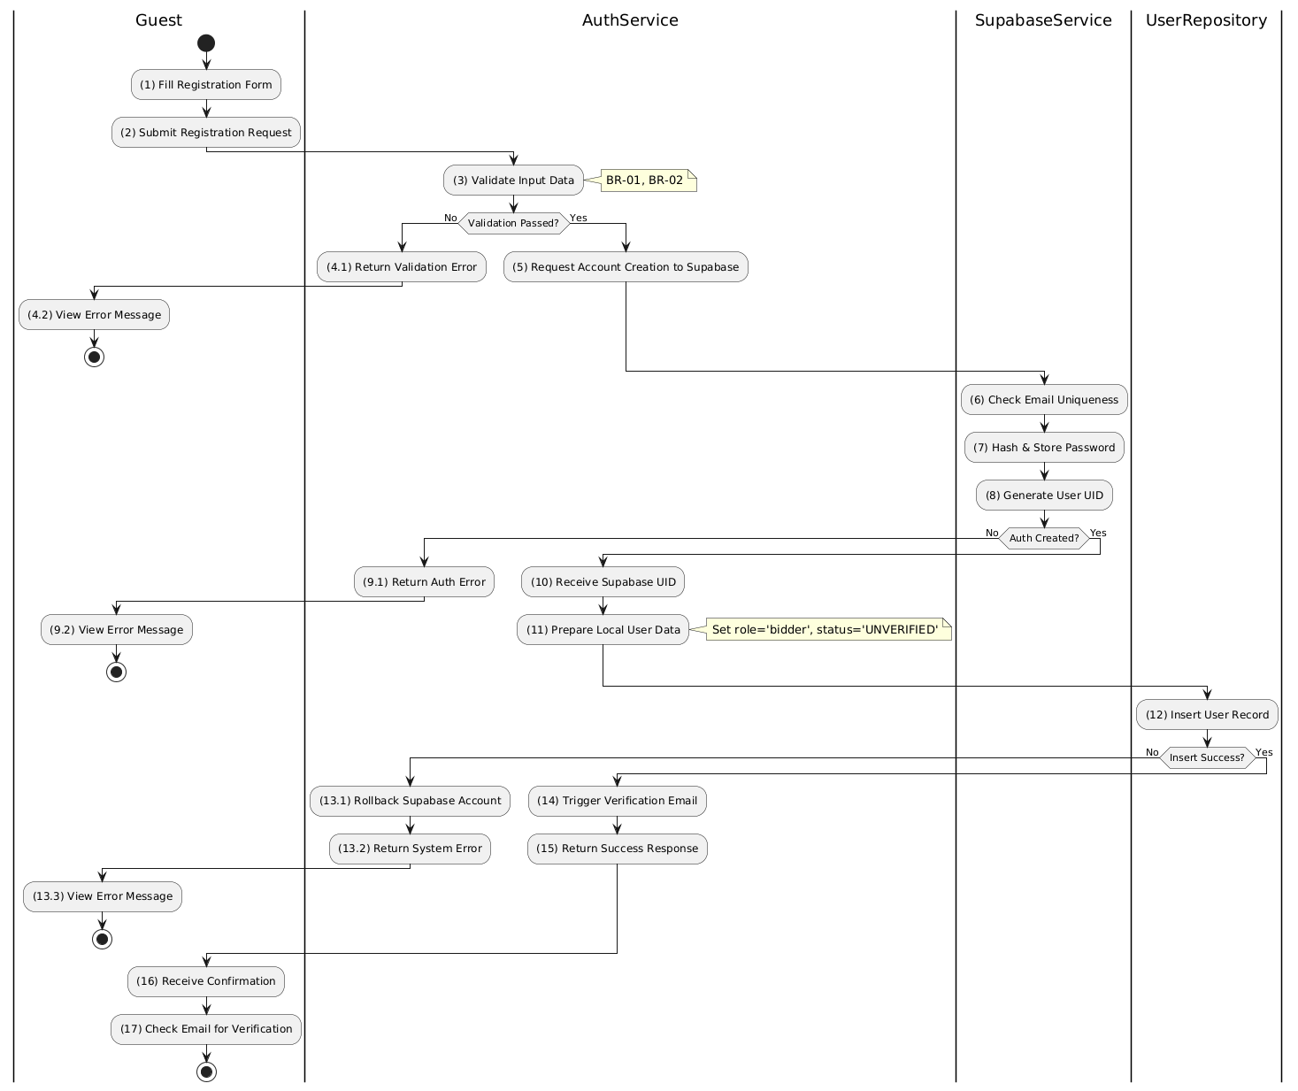

Business Rules
Activity | BR Code | Description
(1) | BR-01 | - Displaying Rule:  The system displays a 'RegistrationPage' screen. (Refer to 'RegistrationPage' view in 'View Description' file).  The form contains input fields for: email, password, confirm password, phone, userType, and taxId (conditional).
(1) | BR-02 | - Validation Rule (Front-end):  When user enters information, system uses Text_change() method.  Checks if input is valid (empty, wrong format).  If isEmpty() on mandatory fields → display MSG 1 (Mandatory field required).  If password does not meet complexity requirements → display MSG 4 (Invalid format).  If userType = 'business' and taxId is empty → display MSG 1.
(2) | BR-03 | - Validation Rule (Back-end/Save):  When user clicks 'Sign Up' button, send data to auth provider via function signUp({ email, password }).  Check Supabase Auth for email uniqueness constraint.  If email exists → show MSG 2 (Conflict - Email already registered), return 409 Conflict.  Else, hash & store password, generate User UID.
(12) | BR-04 | Storing Rule:  System stores data in table USERS with syntax INSERT INTO USERS (uid, email, role, status, phone, userType, taxId, ...) VALUES (...).  Set role = 'bidder', status = 'UNVERIFIED'.  If insert fails → call rollback via deleteUser(uid) on Supabase, show MSG 9 (System Error), return 500.  Else → proceed to send verification email.
(14) | BR-05 | Notification Rule:  System triggers verification email via Supabase sendVerificationEmail() method.  Email contains a unique verification link valid for 24 hours.
(16) | BR-06 | Displaying Rule (Confirmation):  The system displays a 'Check Email' instruction screen.  User receives confirmation that account is created but NOT active until email verification is completed.  No active session token is issued at this stage.

Verify Email Use Case

Use Case Description
Name | Verify Email (Link Click)
Description | This use case allows the Guest to update existing Email Verification information in the system.
Actor | Guest
Trigger | - When the Guest clicks on the verification link in the EmailClient.
Pre-condition | - • Guest's device must be connected to the internet.  • Guest has received a verification email.
Post-condition | - The Email Verification information will be updated in the system and Guest will be logged in.

Sequence Flow

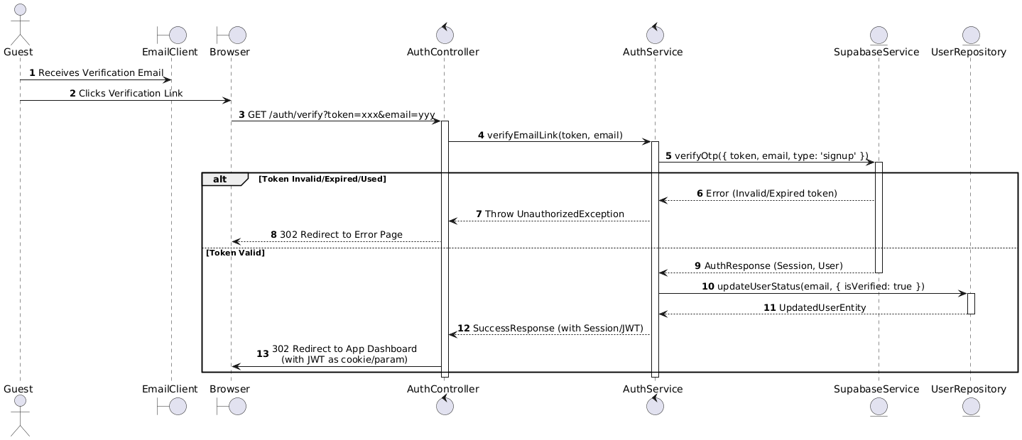

Activities Flow

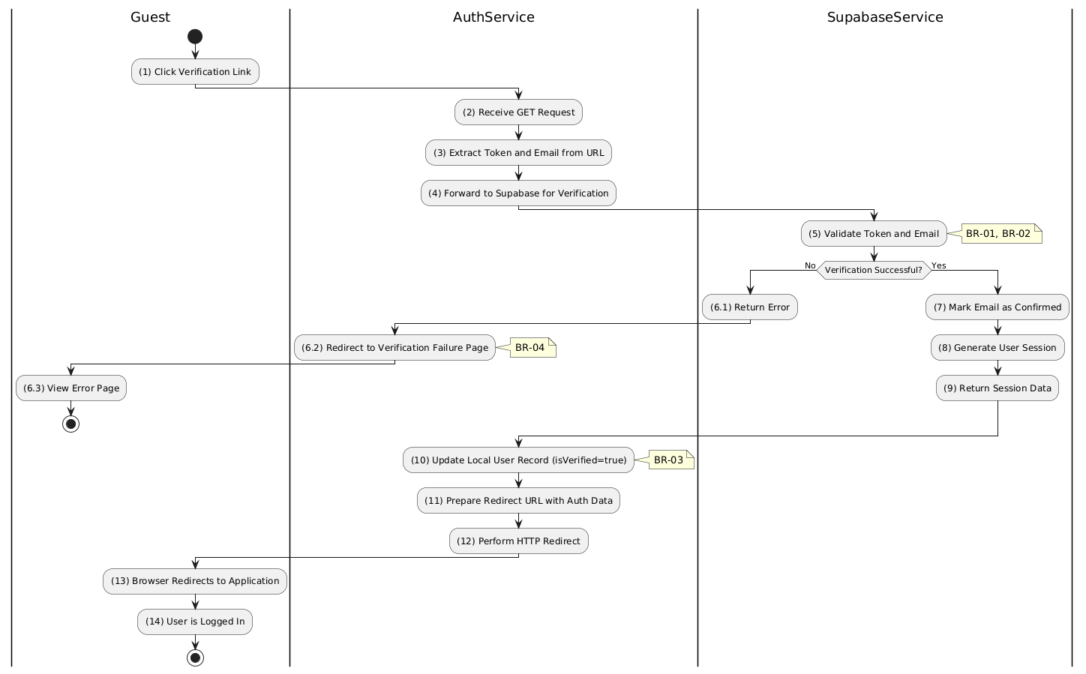

Business Rules
Activity | BR Code | Description
(1) | BR-01 | - Querying Rule:  When user clicks verification link, system extracts token and email from URL parameters.  System queries the authentication provider to verify the OTP token against the email.
(5) | BR-02 | - Validation Rule (Token Integrity):  System validates token signature and expiration against Supabase records.  If token invalid, expired, or tampered → redirect to error page with MSG 10 (Verification failed).  If token already used (replay attack) → redirect to error page.
(10) | BR-03 | - Storing Rule:  The User information will be updated in table 'USERS' in the database (Refer to 'USERS' table in 'DB Sheet' file) to set the verification status.  Sync local database status with Supabase.
(6.2) | BR-04 | Displaying Rule (Error):  If verification fails, system redirects browser to 'Verification Failed' page.  User sees friendly error message, not raw JSON error.
(14) | BR-05 | Displaying Rule (Success):  If verification succeeds, system performs HTTP 302 redirect to Application Dashboard.  JWT token is passed via cookie or URL parameter.  User is automatically logged in without separate login action.

Sign in Use Case

Use Case Description
Name | Login
Description | This use case allows the Guest to authenticate and access the system.
Actor | Guest
Trigger | - When the Guest clicks on the 'Login' button on the LoginPage.
Pre-condition | - • Guest's device must be connected to the internet.  • Guest is on the LoginPage.
Post-condition | - The Guest will be authenticated and granted access to the system homepage

Sequence Flow

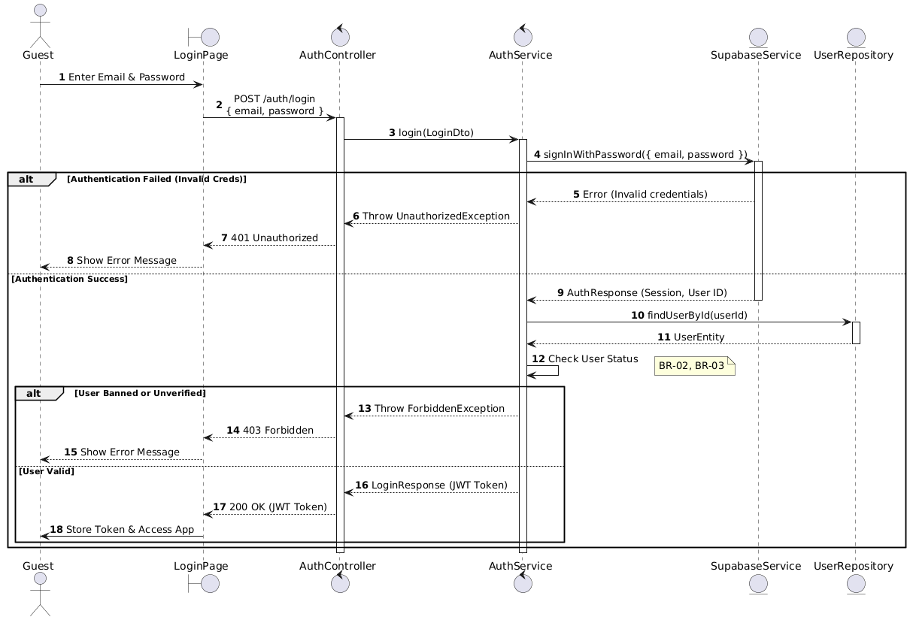

Activities Flow

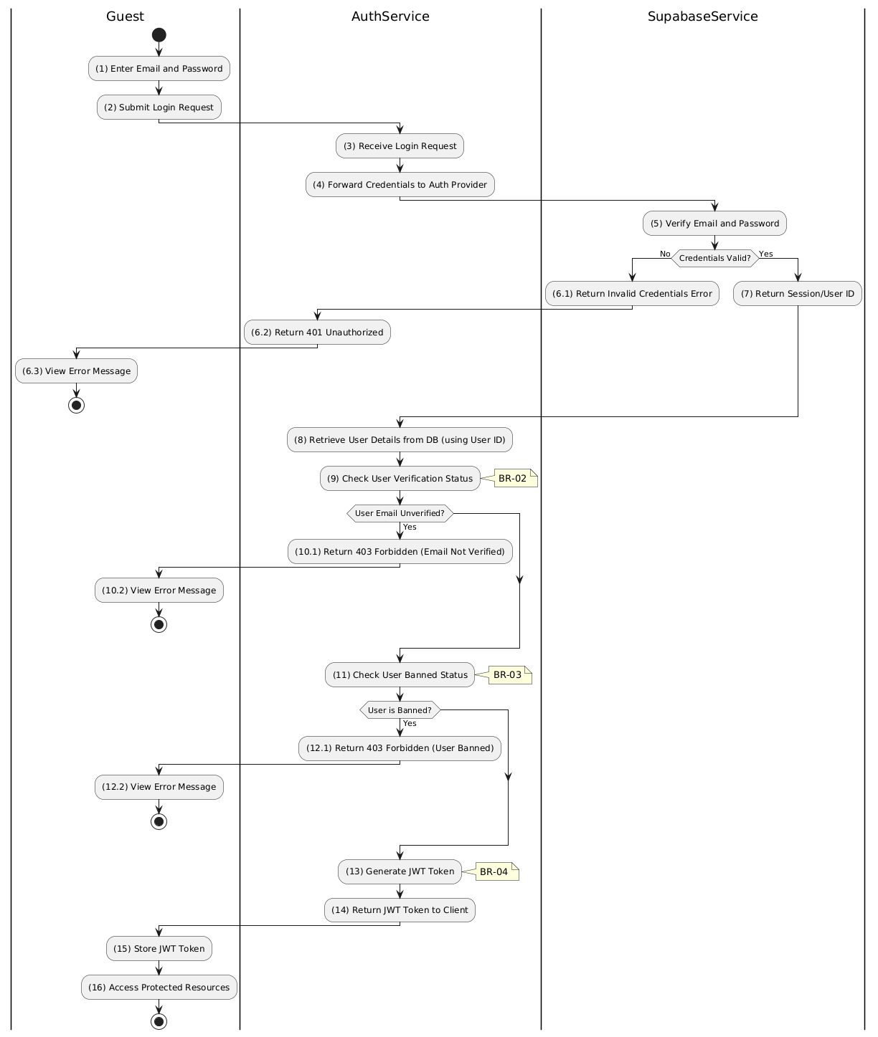

Business Rules
Activity | BR Code | Description
(1) | BR-01 | - Displaying Rule:  The system displays a 'LoginPage' screen. (Refer to 'LoginPage' view in 'View Description' file).  The form contains input fields for: email, password.
(1) | BR-02 | - Validation Rule (Front-end):  When user enters information, system uses Text_change() method.  Checks if input is valid (empty, wrong format).  If isEmpty() on email/password → display MSG 1 (Mandatory).  If wrong email format → display MSG 4 (Invalid format).
(2) | BR-03 | - Validation Rule (Back-end/Save):  When user clicks 'Login' button, send data to auth provider via function signInWithPassword({ email, password }).  Check credentials against Supabase Auth store.  If invalid credentials → show MSG 3 (Invalid credentials), return 401 Unauthorized.
(9) | BR-04 | Validation Rule (Status Check):  System queries data in table USERS with syntax SELECT * FROM USERS WHERE uid = [User ID].  Check isVerified status. If email not verified → show MSG 7 (Email not verified), return 403 Forbidden.
(11) | BR-05 | Validation Rule (Access Check):  Check isBanned status from retrieved user data.  If user is banned → show MSG 8 (User banned), return 403 Forbidden.
(15) | BR-06 | Displaying Rule (Success):  The system generates JWT Token and returns to client.  System displays successful login, stores JWT Token locally, and redirects user to access protected resources/dashboard.

Forgot Password

Use Case Description
Name | Forgot Password
Description | This use case allows the Guest to create a new Password Reset Request information in the system.
Actor | Guest
Trigger | - When the Guest clicks on the 'Forgot Password' button on the ForgotPasswordPage.
Pre-condition | - • Guest's device must be connected to the internet.  • Guest is on the ForgotPasswordPage.
Post-condition | - The Password Reset Request information will be stored into the system and a reset email will be sent to the Guest.

Sequence Flow
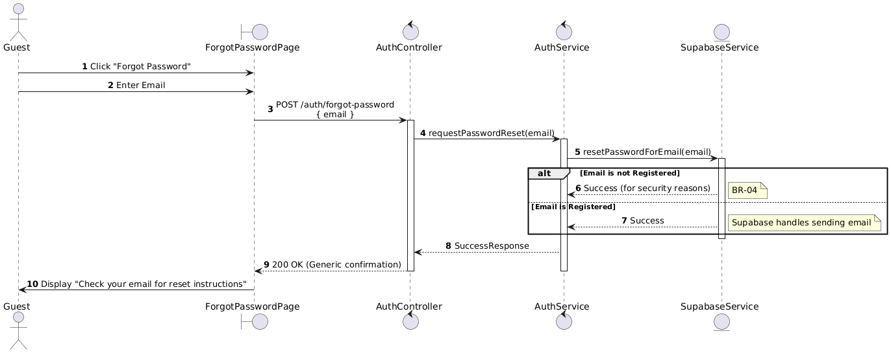

Activities Flow
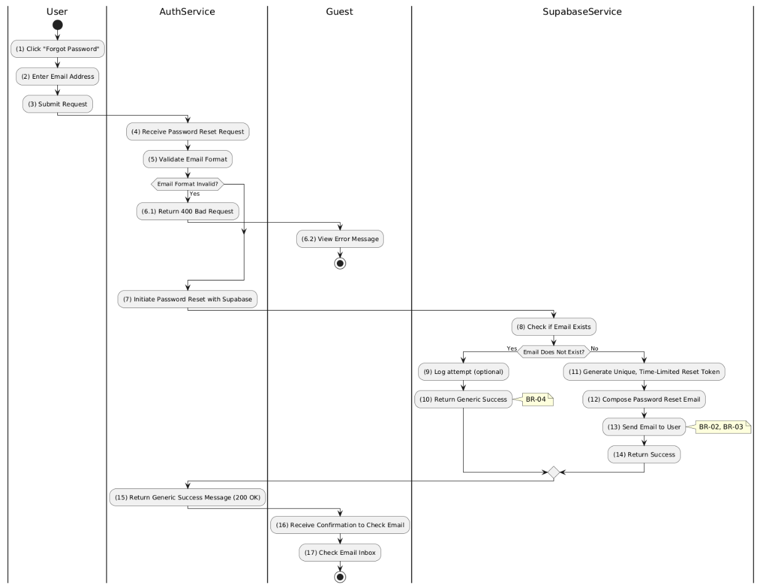

Business Rules
Activity | BR Code | Description
(1) | BR-01 | - Displaying Rule:  The system displays a 'ForgotPasswordPage' screen. (Refer to 'ForgotPasswordPage' view in 'View Description' file).  The form contains input field for: email address.
(2) | BR-02 | - Validation Rule (Front-end):  When user enters email, system uses Text_change() method.  Checks if input is valid (empty, wrong format).  If isEmpty() on email → display MSG 1 (Mandatory).  If wrong email format → display MSG 4 (Invalid format).
(3) | BR-03 | Validation Rule (Back-end/Save):  When user clicks 'Reset Password' button, send data to auth provider via function resetPasswordForEmail(email).  System internally checks if email exists in database but does NOT reveal result to user (security).
(16) | BR-04 | Displaying Rule (Security/Confirmation):  Regardless of whether email exists or not, system displays generic success message: "Check your email for reset instructions".  This prevents User Enumeration attacks.  If email exists → password reset link is sent via email service.

Manage Auctions Use Case

Manage Auctions Use Case

Use Case Description
Name | Manage Auction
Description | This use case allows the Auctioneer to choose one of the corresponding functions of CRUD to adjust Auction information in the system.
Actor | Auctioneer, Admin, Super Admin
Trigger | - When the Auctioneer clicks on the "Auction" button on the navigation sidebar.
Pre-condition | - 1. Auctioneer's device must be connected to the internet.  2. Auctioneer is signed in with their account.
Post-condition | - The Auction information is updated to the corresponding function that the Auctioneer executes.

Sequence Flow

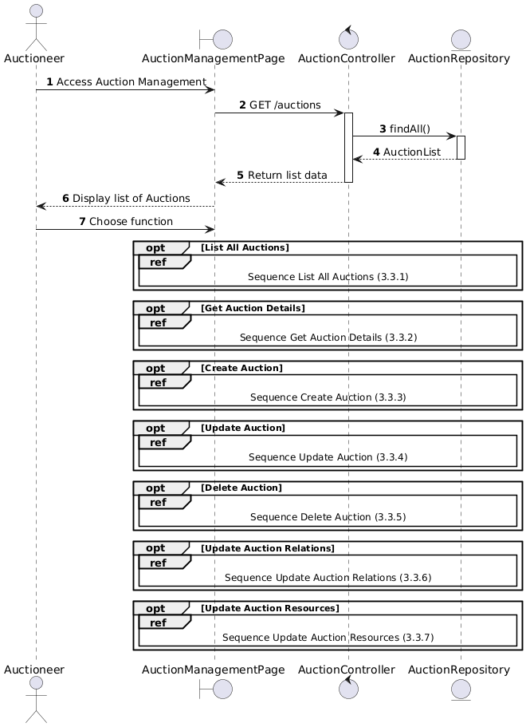

Activities Flow

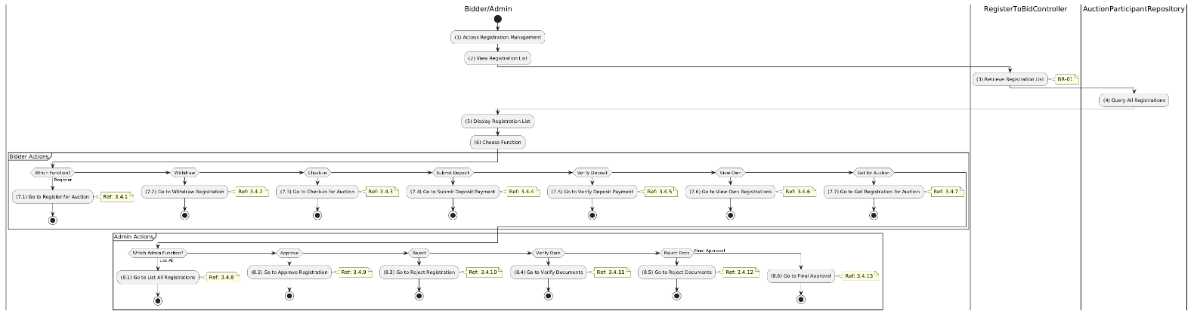

Business Rules
Activity | BR Code | Description
(5) | BR-01 | - Displaying Rule:  The system displays a "Registration to Bid Management" screen. (Refer to "Registration to Bid Management" view in "View Description" file).
(6) | BR-02 | - Choosing Rule:  Bidder/Admin can only choose one feature at a time to use.

List All Auction Use Case

Use Case Description
Name | List All Auctions
Description | This use case allows the User to search Auction information in the system based on input keywords.
Actor | User
Trigger | - When User enters searching keywords in the SearchBox on the top left of the AuctionListPage screen.
Pre-condition | - • User's device must be connected to the internet.  • User is on the AuctionListPage.
Post-condition | - The datagrid of Auction information will be filtered by keywords and displayed on the AuctionListPage screen.

Sequence Flow

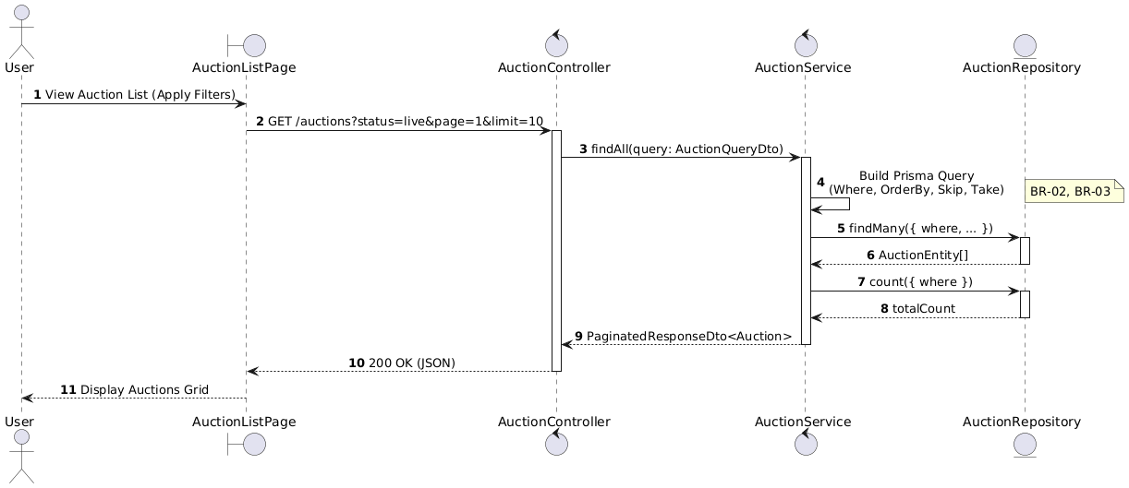

Activities Flow

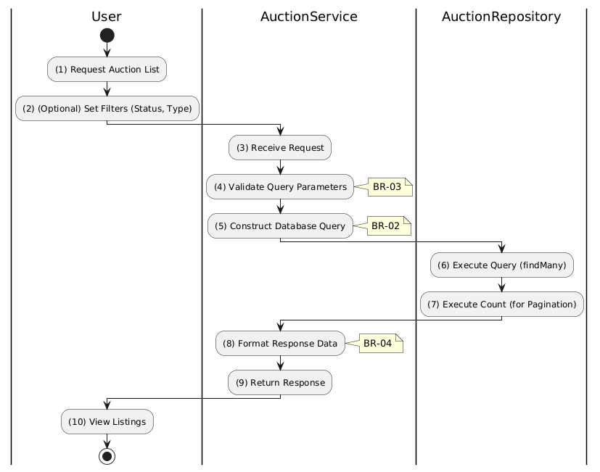

Business Rules
Activity | BR Code | Description
(1) | BR-01 | - Displaying Rule:  The system displays a 'AuctionListPage' screen. (Refer to 'AuctionListPage' view in 'View Description' file).  The screen contains filter options (status, type, price range) and pagination controls.
(2) | BR-02 | - Searching Rule:  When user enters keywords or selects filters, system uses Text_change(Event e) or Selection_change() method.  System queries data in the table 'AUCTION' in the database (Refer to 'AUCTION' table in 'DB Sheet' file) based on input keywords and selected filters.
(4) | BR-03 | - Validation Rule (Pagination):  System validates page and limit parameters.  Enforces maximum limit (e.g., 50) to prevent performance degradation.  If invalid, defaults to standard values (page = 1, limit = 10).
(10) | BR-04 | - Displaying Rule (Results):  The system displays 'AuctionListPage' screen with data on the datagrid updated according to entered filters/keywords.  Heavy fields (full descriptions, bid histories) are excluded to optimize list view response.

Auction Detail Use Case

Use Case Description
Name | Get Auction Details
Description | This use case allows the User to search Auction information in the system based on input keywords.
Actor | User
Trigger | - When User clicks on an Auction item in the AuctionListPage datagrid.
Pre-condition | - • User's device must be connected to the internet.  • User is on the AuctionListPage.
Post-condition | - The Auction details will be displayed on the AuctionDetailPage screen.

Sequence Flow

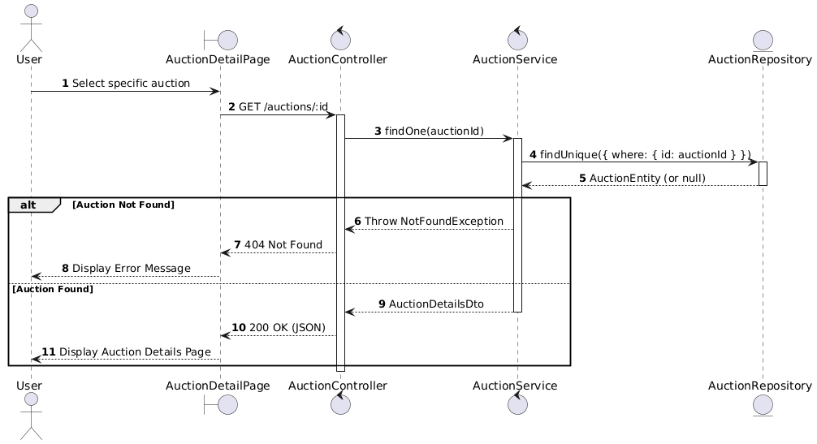

Activities Flow

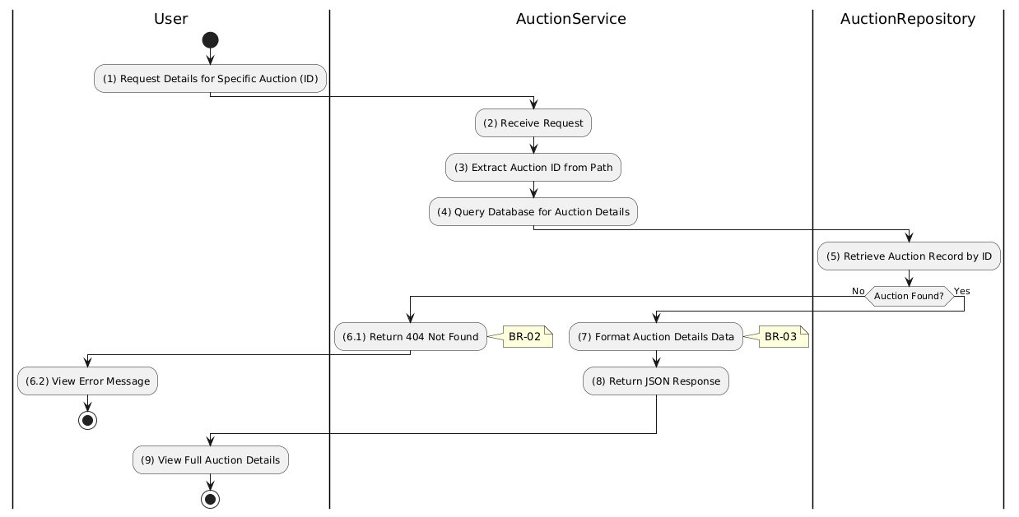

Business Rules
Activity | BR Code | Description
(1) | BR-01 | - Querying Rule:  System queries data in the table 'AUCTION' in the database (Refer to 'AUCTION' table in 'DB Sheet' file) based on the clicked auction ID.  Call method displayAuctionInformation(auctionData) to populate details view.
(6.1) | BR-02 | - Validation Rule:  System checks query result.  If auction ID not found in database → display MSG 11 (Not Found), return 404 Not Found.
(9) | BR-03 | - Displaying Rule:  The system displays a 'AuctionDetailPage' screen. (Refer to 'AuctionDetailPage' view in 'View Description' file).  Screen is populated with full auction details: description, timeline, pricing, media assets, fees.

Create Auction Use Case

Use Case Description
Name | Create Auction
Description | This use case allows the Auctioneer/Admin to create a new Auction information in the system.
Actor | Auctioneer/Admin
Trigger | - When the Auctioneer/Admin clicks on the 'Create Auction' button on the CreateAuctionPage.
Pre-condition | - • Auctioneer/Admin's device must be connected to the internet.  • Auctioneer/Admin is signed in with their account.
Post-condition | - The Auction information will be stored into the system and display new record on AuctionListPage datagrid.

Sequence Flow

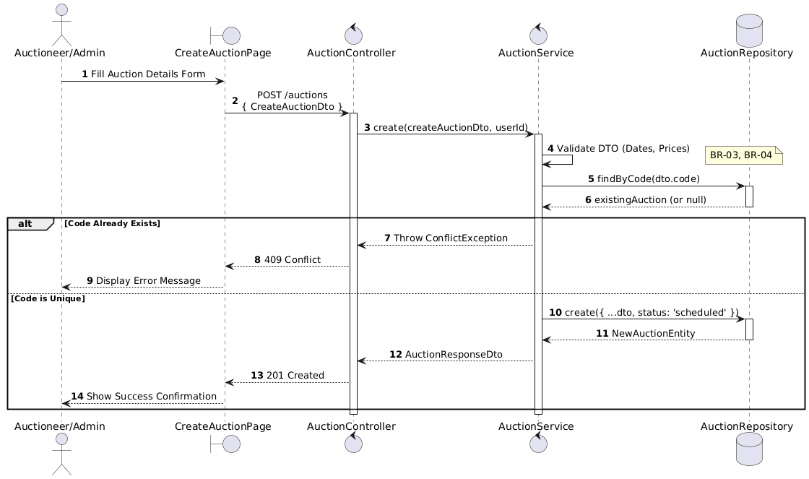

Activities Flow

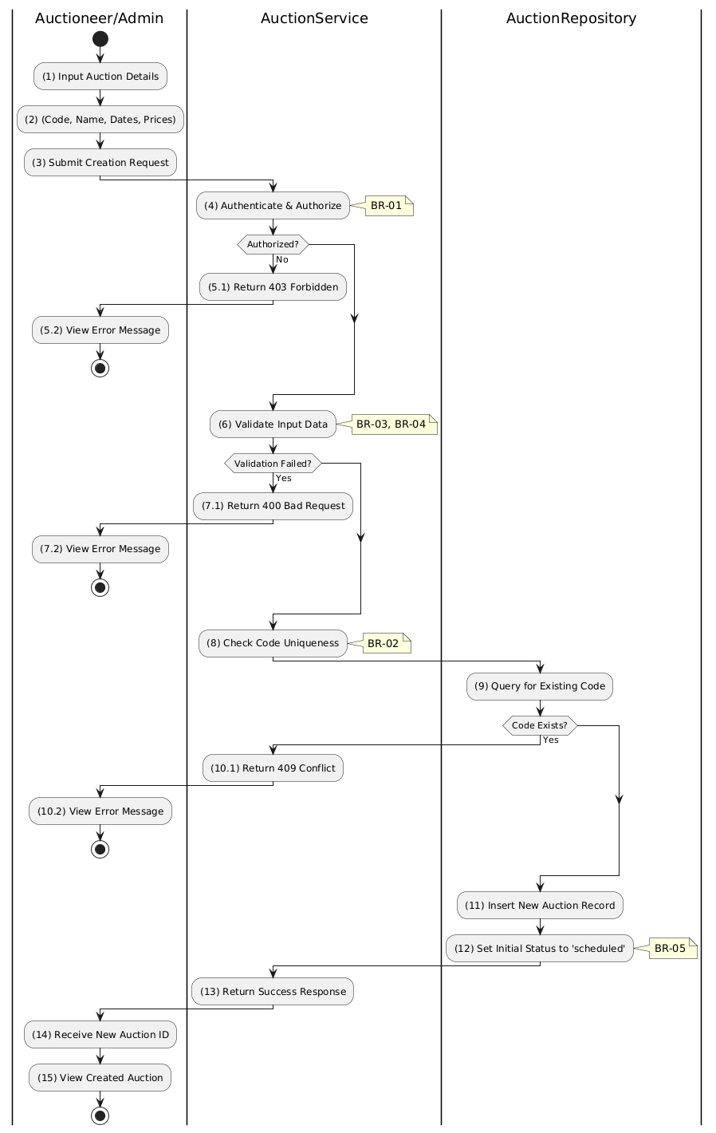

Business Rules
Activity | BR Code | Description
(1) | BR-01 | - Displaying Rule:  The system displays a 'CreateAuctionPage' screen. (Refer to 'CreateAuctionPage' view in 'View Description' file).  The form contains input fields for: code, name, description, dates (saleStart, saleEnd, auctionStart, auctionEnd), pricing (startingPrice, bidIncrement, depositAmount).
(2) | BR-02 | - Validation Rule (Front-end):  When user enters information, system uses Text_change() method.  Checks if input is valid (empty, wrong format).  If isEmpty() on mandatory fields → display MSG 1 (Mandatory).  If dates invalid (saleStartAt >= saleEndAt) → display MSG 4 (Invalid timeline).  If prices negative → display MSG 4 (Invalid price).
(3) | BR-03 | - Validation Rule (Back-end/Save):  When user clicks 'Create Auction' button, send data to database via function create(createAuctionDto).  Check table AUCTION for code uniqueness constraint.  If code exists → show MSG 12 (Duplicate code), return 409 Conflict.
(12) | BR-04 | - Storing Rule:  The input data will be checked by table AUCTION in the database (Refer to 'AUCTION' table in 'DB Sheet' file) to check if there are any constraints. Else data of the Auction will be stored as a new record in table AUCTION.  Set status = 'scheduled' (or 'draft').  Show MSG 7 (Success), close view, update auction list with new entry.

Update Auction Use Case

Use Case Description
Name | Update Auction
Description | This use case allows the Auctioneer/Admin to update existing Auction information in the system.
Actor | Auctioneer/Admin
Trigger | - When the Auctioneer/Admin clicks on the [Icon Edit] button on the right of each item on the AuctionListPage datagrid.
Pre-condition | - • Auctioneer/Admin's device must be connected to the internet.  • Auctioneer/Admin is signed in with their account.
Post-condition | - The Auction information will be updated in the system and display new record on AuctionListPage datagrid.

Sequence Flow

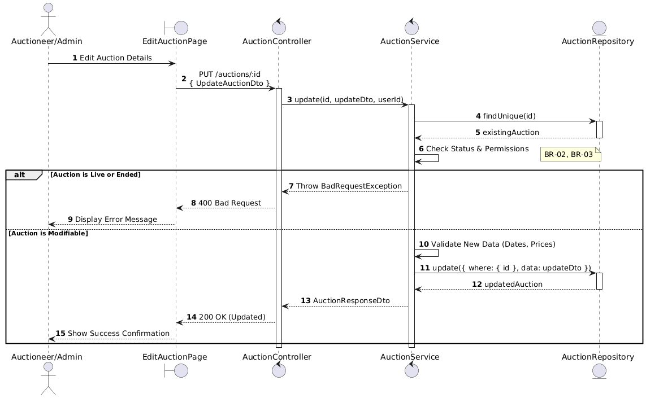

Activities Flow

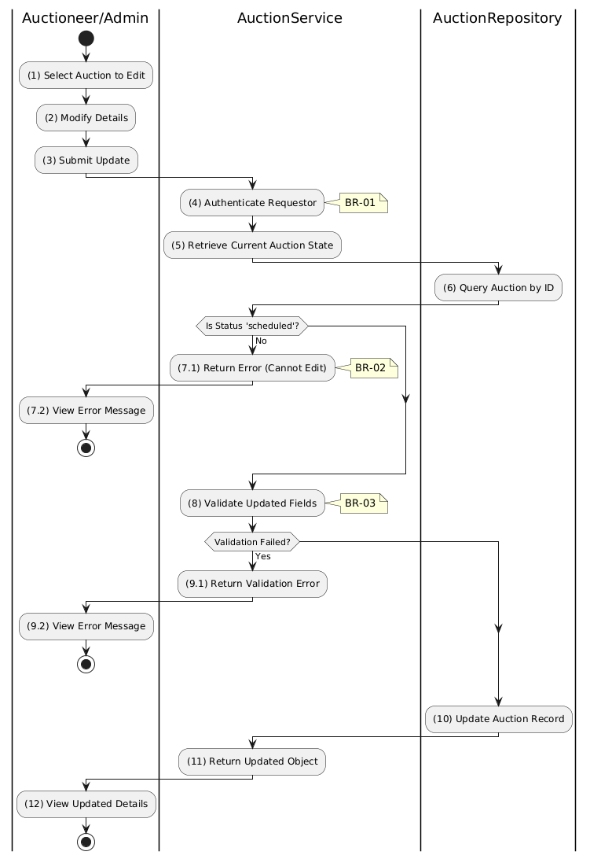

Business Rules
Activity | BR Code | Description
(1) | BR-01 | - Querying Rule:  System queries data in the table 'AUCTION' in the database (Refer to 'AUCTION' table in 'DB Sheet' file) based on the selected auction ID.  Call method displayAuctionInformation(auctionData) to populate edit form.
(2) | BR-02 | - Displaying Rule:  The system displays a 'EditAuctionPage' screen. (Refer to 'EditAuctionPage' view in 'View Description' file).  Form is populated with data queried in previous step.
(2) | BR-03 | - Validation Rule (Front-end):  When user modifies information, system uses Text_change() method.  Checks if input is valid (empty, wrong format).  If isEmpty() on mandatory fields → display MSG 1 (Mandatory).  If dates invalid → display MSG 4 (Invalid format).
(7.1) | BR-04 | - Validation Rule (State Locking):  System checks auction status before allowing update.  If status is NOT 'scheduled' or 'draft' (e.g., 'live', 'ended') → display MSG 13 (Cannot edit active/ended auction), return 400.
(3) | BR-05 | - Validation Rule (Back-end/Save):  When user clicks 'Save Changes' button, send data to database via function update(id, updateAuctionDto).  Check table AUCTION for constraints.  If invalid → show MSG 9 (Error).  Else, update record, show MSG 7 (Success), update view.

Delete Auction Use Case

Use Case Description
Name | Delete Auction
Description | This use case allows the Auctioneer/Admin to delete an existing Auction from the system.
Actor | Auctioneer, Admin
Trigger | - When the Auctioneer/Admin clicks on the 'Delete Auction' button and confirms deletion.
Pre-condition | - • Auctioneer/Admin's device must be connected to the internet.  • Auctioneer/Admin is signed in with their account.  • Auction exists and is in appropriate state for deletion.
Post-condition | - The Auction and its related data are removed from the system.

Sequence Flow

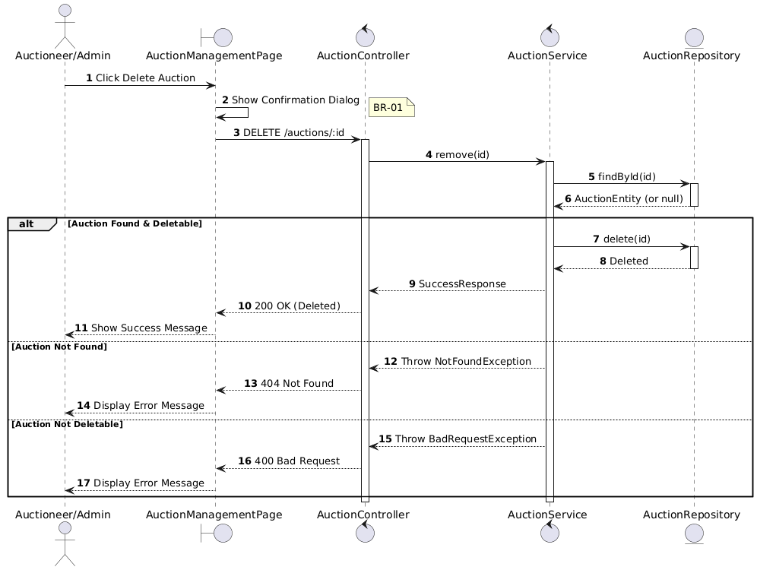

Activities Flow

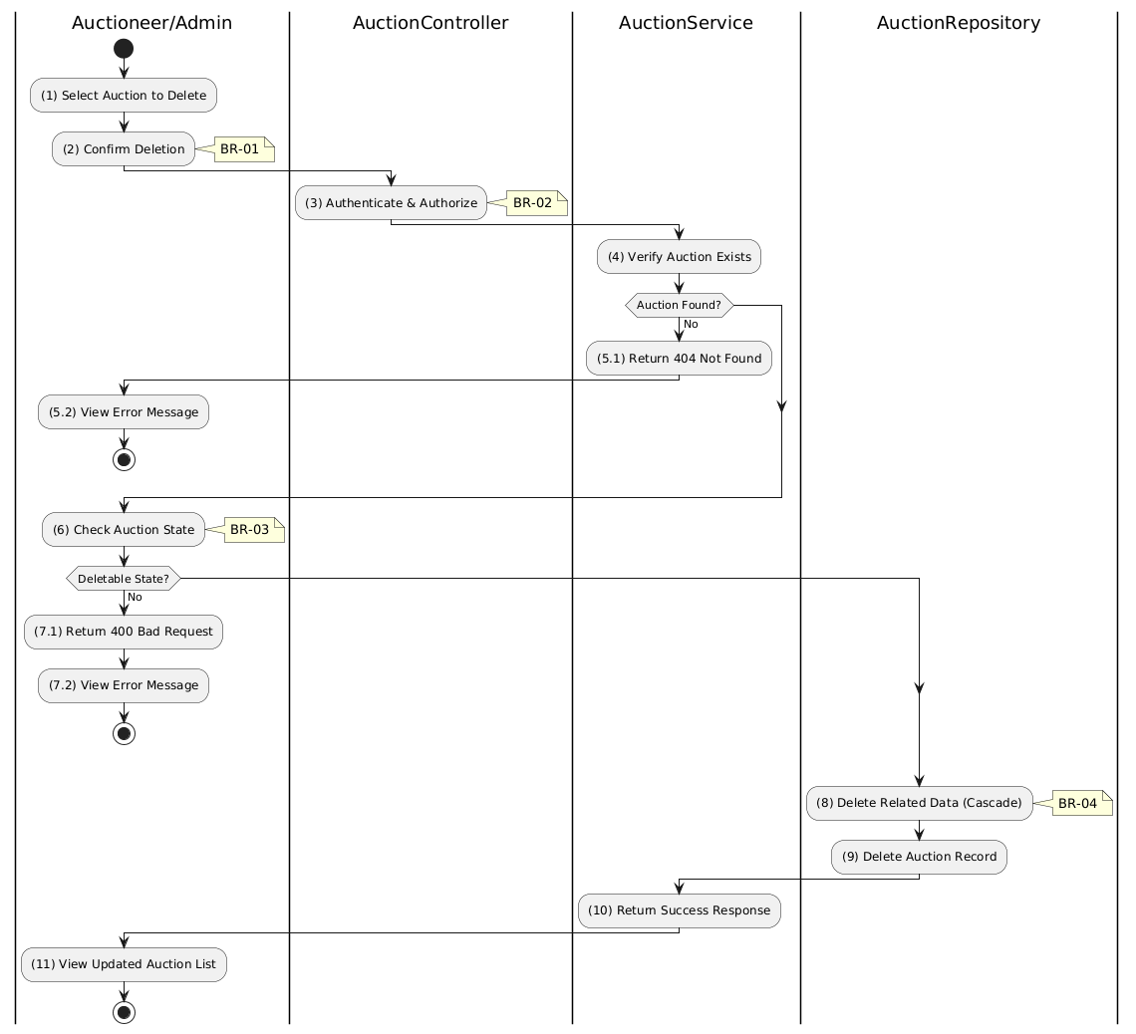

Business Rules
Activity | BR Code | Description
(1) | BR-01 | - Validation Rule (Confirmation - Front-end):  System displays MSG 11 ("Are you sure you want to delete this auction? This action cannot be undone.").  System waits for confirmation before proceeding.
(3) | BR-02 | - Validation Rule (Authorization - Back-end):  System checks if requestor role is auctioneer, admin, or super_admin.  If unauthorized:  $→$ System displays MSG 5 ("Forbidden").
(6) | BR-03 | - Validation Rule (State Check):  System checks auction status:  - scheduled: Can be deleted  - live, awaiting_result, success, failed: Cannot be deleted (has active/completed bids).
(8) | BR-04 | - Processing Rule (Cascade Delete):  System deletes related data via CASCADE:  - AUCTION_PARTICIPANT records  - AUCTION_BID records  - AUCTION_COST records  - AUCTION_AUDIT_LOG records.
(11) | BR-05 | - Displaying Rule (Success Confirmation):  System displays MSG 7 ("Auction deleted successfully") on the View.  System refreshes auction list to remove deleted entry.

Update Auction Relations Use Case

Use Case Description
Name | Update Auction Relations
Description | This use case allows the Auctioneer/Admin to update related auctions for a specific auction.
Actor | Auctioneer, Admin
Trigger | - When the Auctioneer/Admin submits related auction updates via “edit” button
Pre-condition | - • Auctioneer/Admin's device must be connected to the internet.  • Auctioneer/Admin is signed in with their account.  • Auction exists.
Post-condition | - The auction's relations are updated in the database.

Sequence Flow

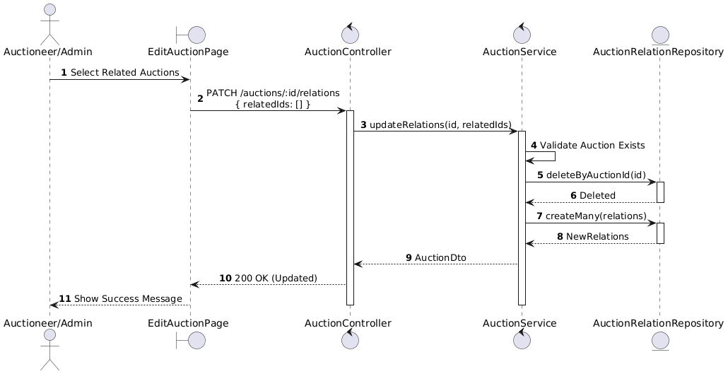

Activities Flow

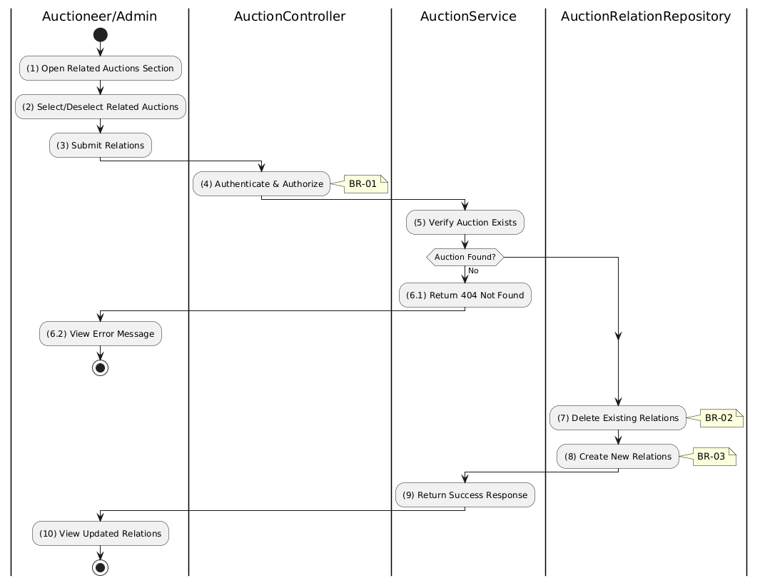

Business Rules
Activity | BR Code | Description
(1) | BR-01 | - Displaying Rule (Relations Section):  System displays searchable/selectable list of other auctions.  Currently related auctions are pre-selected.  User can select/deselect auctions.
(4) | BR-02 | - Validation Rule (Authorization - Back-end):  System checks if requestor role is auctioneer, admin, or super_admin.  If unauthorized:  $→$ System displays MSG 5 ("Forbidden").
(7) | BR-03 | - Processing Rule (Replace Strategy):  System uses replace strategy for relations.  Deletes all existing relations for the auction.  Creates new relations from provided IDs.
(8) | BR-04 | - Storing Rule:  System saves to AUCTION_RELATION table:  - auctionId = [current auction]  - relatedAuctionId = [each selected auction]  Supports bidirectional linking.
(10) | BR-05 | - Displaying Rule (Success Confirmation):  System displays MSG 7 ("Relations updated successfully") on the View.  System refreshes related auctions section.

Update Auction Resources Use Case

Use Case Description
Name | Update Auction Resources
Description | This use case allows the Auctioneer/Admin to update existing Auction Resource information in the system.
Actor | Auctioneer/Admin
Trigger | - When the Auctioneer/Admin clicks on the [Icon Edit] button on the right of each item on the ManageResourcesPage datagrid.
Pre-condition | - • Auctioneer/Admin's device must be connected to the internet.  • Auctioneer/Admin is signed in with their account.
Post-condition | - The Auction Resource information will be updated in the system and display new record on ManageResourcesPage datagrid.

Sequence Flow

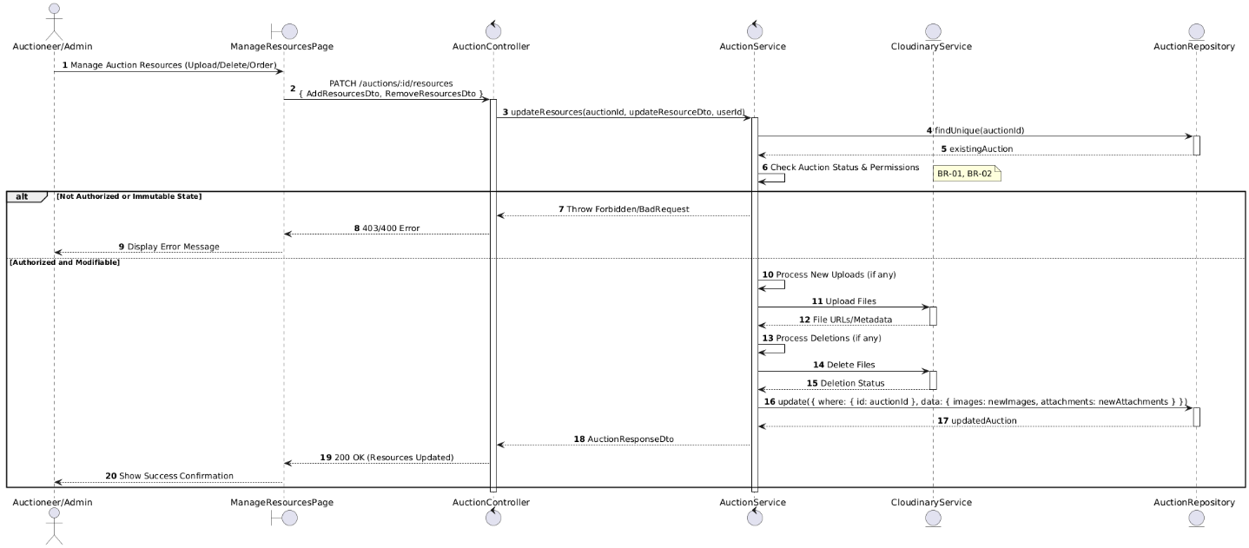

Activities Flow

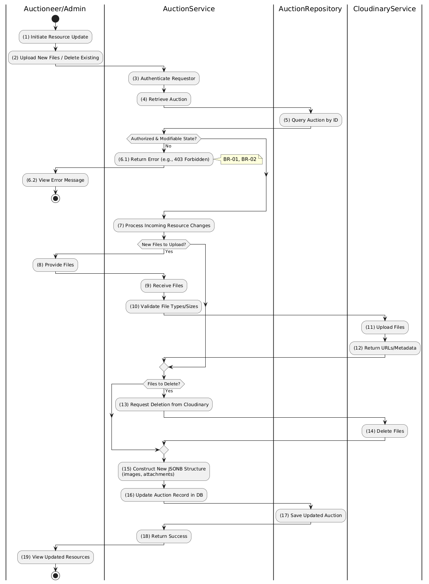

Business Rules
Activity | BR Code | Description
(1) | BR-01 | - Querying Rule:  System queries data in the table 'AUCTION' in the database (Refer to 'AUCTION' table in 'DB Sheet' file) based on the selected auction ID.  Call method displayAuctionResources(images, attachments) to populate resource management view.
(2) | BR-02 | - Displaying Rule:  The system displays a 'ManageResourcesPage' screen. (Refer to 'ManageResourcesPage' view in 'View Description' file).  Screen is populated with current images and attachments, with options to upload/delete/reorder.
(6.1) | BR-03 | - Validation Rule (State Locking):  System checks auction status before allowing resource changes.  If status is 'live' or 'finalized' → display MSG 13 (Cannot modify resources), return 400.
(10) | BR-04 | - Validation Rule (Front-end - File Constraints):  When user uploads files, system validates file types (JPG, PNG, PDF) and size limits (max 5MB).  If invalid file type → display MSG 4 (Invalid file format).  If file too large → display MSG 4 (File size exceeded).
(16) | BR-05 | - Validation Rule (Back-end/Save):  When user clicks 'Save' button, send data via function updateResources(auctionId, resourceDto).  Upload new files to Cloudinary, delete removed files.  Update images and attachments JSONB fields in table AUCTION.  If success → show MSG 7, update view. If cloud operation fails → show MSG 9 (System Error).

Manage Registration to Bid Use Case

Manage Registration to Bid Use Case

Use Case Description
Name | Manage Registration to Bid
Description | This use case allows the Bidder/Admin to choose one of the corresponding functions of CRUD to adjust Registration to Bid information in the system.
Actor | Bidder, Admin, Auctioneer
Trigger | - When the Bidder/Admin clicks on the "Registration to Bid" button on the navigation sidebar.
Pre-condition | - 1. Bidder/Admin's device must be connected to the internet.  2. Bidder/Admin is signed in with their account.
Post-condition | - The Registration to Bid information is updated to the corresponding function that the Bidder/Admin executes.

Sequence Flow

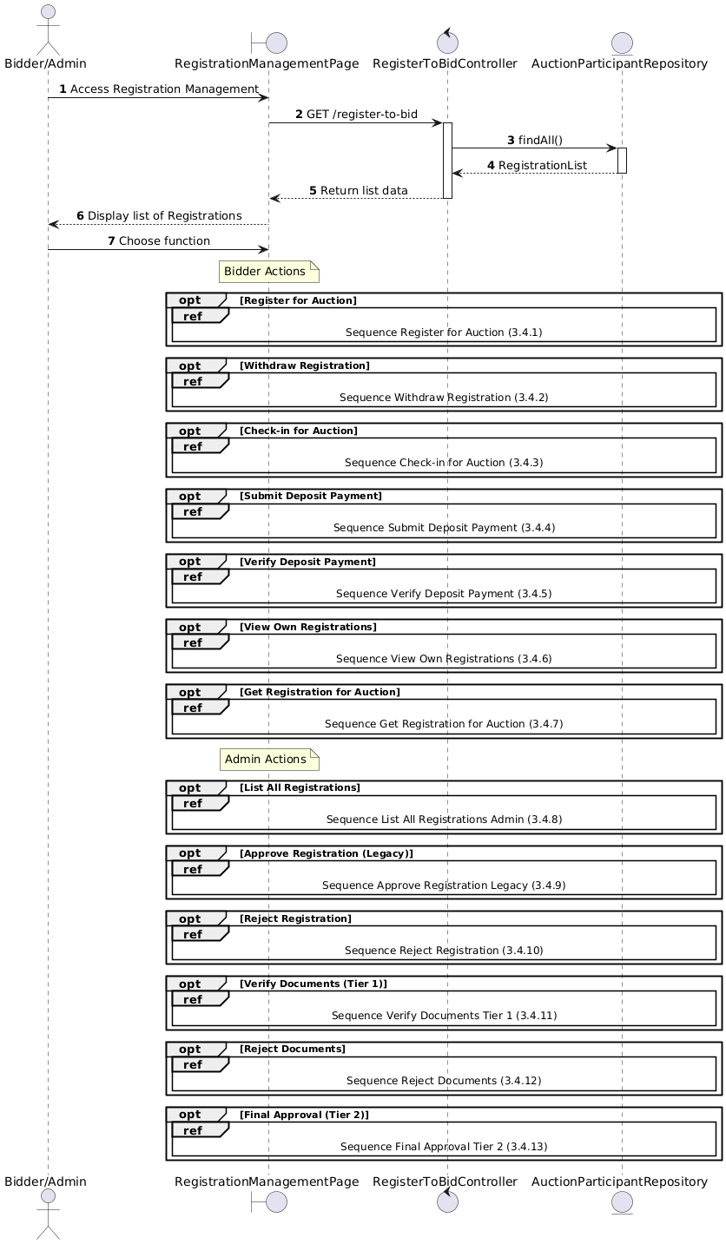

Activities Flow

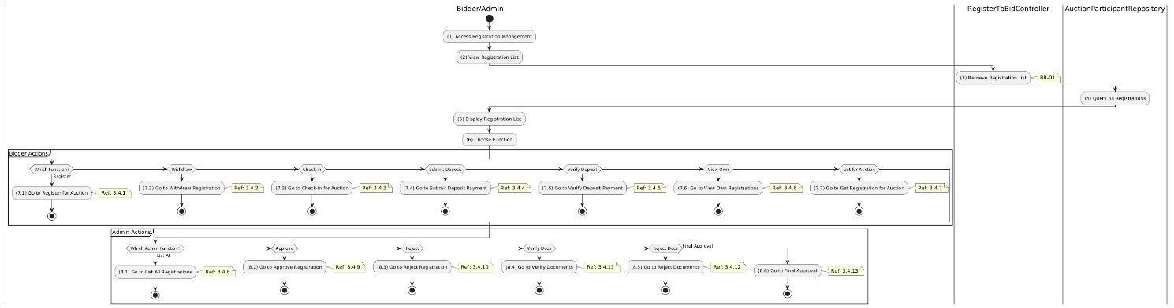

Business Rules
Activity | BR Code | Description
(5) | BR-01 | - Displaying Rule:  The system displays a "Registration to Bid Management" screen. (Refer to "Registration to Bid Management" view in "View Description" file).
(6) | BR-02 | - Choosing Rule:  Bidder/Admin can only choose one feature at a time to use.

Register for Auction Use Case

Use Case Description
Name | Register for Auction (Bidder)
Description | This use case allows the Bidder to create a new Auction Registration information in the system.
Actor | Bidder
Trigger | - When the Bidder clicks on the 'Register for Auction' button on the AuctionRegistrationPage.
Pre-condition | - • Bidder's device must be connected to the internet.  • Bidder is signed in with their account.
Post-condition | - The Auction Registration information will be stored into the system and display new record on RegistrationListPage datagrid.

Sequence Flow

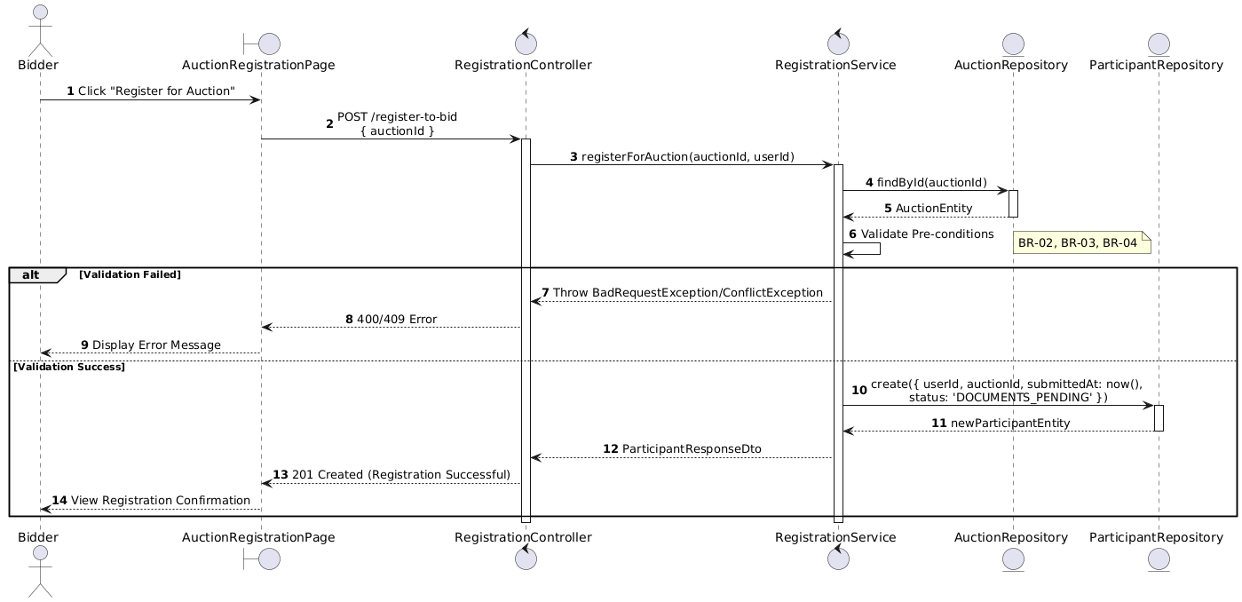

Activities Flow

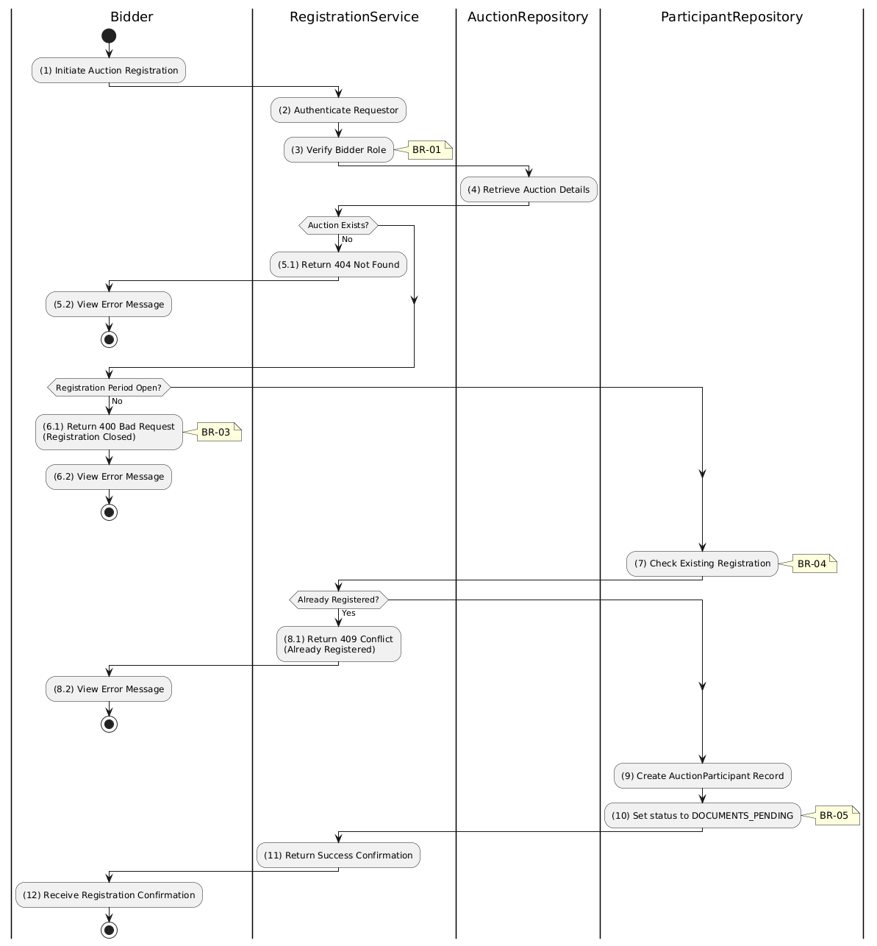

Business Rules
Activity | BR Code | Description
(1) | BR-01 | - Displaying Rule:  The system displays a 'AuctionRegistrationPage' screen. (Refer to 'AuctionRegistrationPage' view in 'View Description' file).  The screen shows auction details and a 'Register for Auction' button.
(1) | BR-02 | - Validation Rule (Front-end):  System checks user authentication and role via checkAuthentication() method.  If not authenticated → redirect to LoginPage.  If role is not 'bidder' → display MSG 5 (Forbidden).
(1) | BR-03 | - Validation Rule (Back-end/Save):  When user clicks 'Register for Auction' button, send data to database via function registerForAuction(auctionId, userId).  Check table AUCTION for eligibility (status = 'scheduled', current date < depositEndAt).  If not eligible → show MSG 14 (Registration closed), return 400.  Check table AUCTION_PARTICIPANT for existing registration.  If already registered → show MSG 12 (Already registered), return 409.
(10) | BR-04 | - Storing Rule:  The input data will be checked by table AUCTION_PARTICIPANT in the database (Refer to 'AUCTION_PARTICIPANT' table in 'DB Sheet' file) to check if there are any constraints. Else data of the Auction Registration will be stored as a new record in table AUCTION_PARTICIPANT.  Set status = 'DOCUMENTS_PENDING'.  Show MSG 7 (Success), update view with registration confirmation.

Update Auction Use Case

Withdrawn Register for Auction Use Case

Use Case Description
Name | Withdraw Registration
Description | This use case allows the Bidder to delete a Auction Registration information in the system.
Actor | Bidder
Trigger | - When the Bidder clicks on the [Icon Delete] button on the right of each item on the RegistrationWithdrawalPage datagrid.
Pre-condition | - • Bidder's device must be connected to the internet.  • Bidder is signed in with their account.
Post-condition | - The Auction Registration information will be removed from the system and display data change on RegistrationListPage datagrid.

Sequence Flow

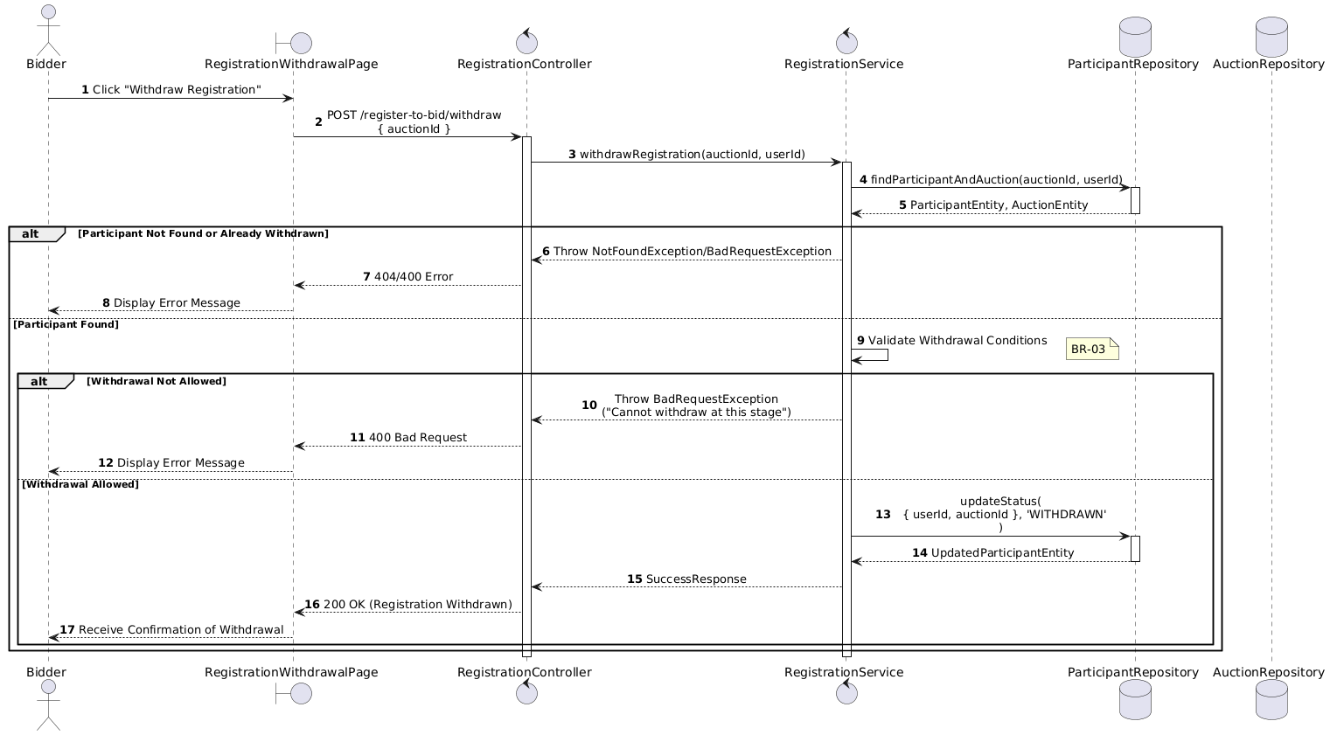

Activities Flow

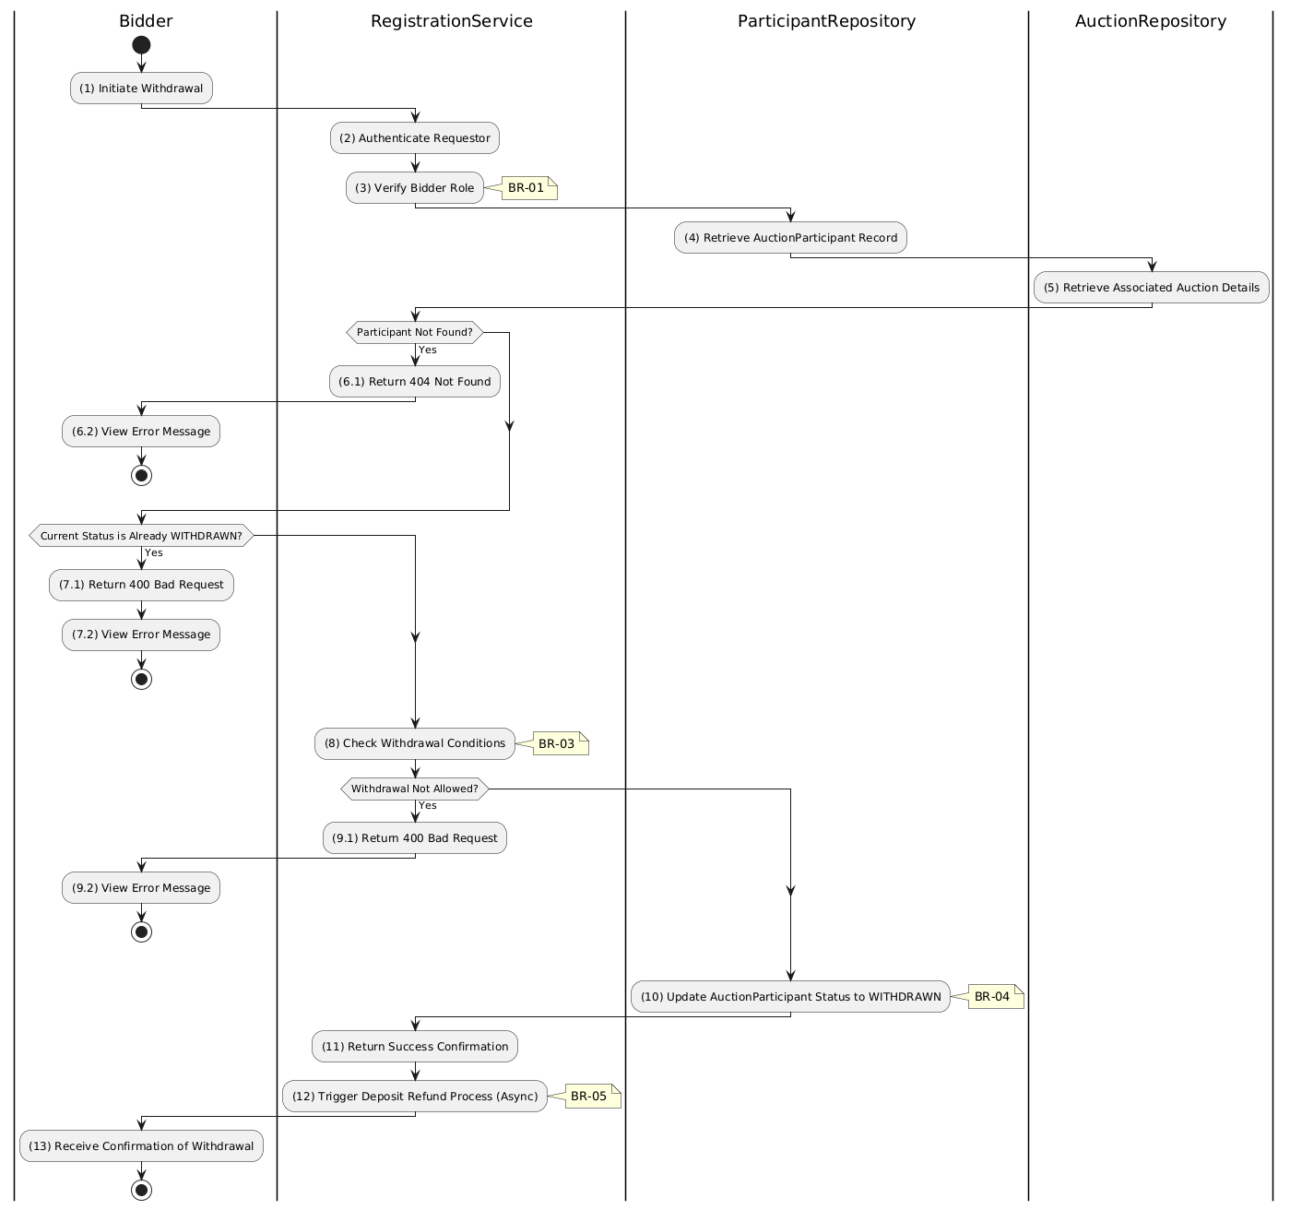

Business Rules
Activity | BR Code | Description
(1) | BR-01 | - Querying Rule:  System queries data in the table 'AUCTION_PARTICIPANT' in the database (Refer to 'AUCTION_PARTICIPANT' table in 'DB Sheet' file) based on the auction ID and user ID.  Call method displayRegistrationDetails(registration) to show current status.
(1) | BR-02 | - Displaying Rule:  The system displays a 'Confirmation message box' screen. (Refer to View Description) with MSG 11 (Confirm withdrawal?).  Shows current registration status and 'Cancel' / 'Confirm Withdrawal' buttons.
(1) | BR-03 | - Selecting Rule:  User selects button. If 'Cancel', use Close() to end.  If 'Confirm Withdrawal', call method withdrawRegistration(auctionId, userId).
(8) | BR-04 | - Validation Rule (Withdrawal Window):  System checks withdrawal conditions: auctionStartAt must be in future, bidder must not have checkedInAt.  If either fails → display MSG 18 (Cannot withdraw at this stage), return 400.
(10) | BR-05 | - Validation Rule (Back-end/Save):  The Registration information will be updated in table 'AUCTION_PARTICIPANT' in the database (Refer to 'AUCTION_PARTICIPANT' table in 'DB Sheet' file) to set the status as 'WITHDRAWN'.  Trigger async deposit refund process.  Show MSG 7 (Success), use Close(), update registration list.

Check-in for Auction Use Case

Use Case Description
Name | Check-in for Auction
Description | This use case allows the Bidder to update existing Auction Registration information in the system.
Actor | Bidder
Trigger | - When the Bidder clicks on the 'Check In' button on the AuctionCheckInPage.
Pre-condition | - • Bidder's device must be connected to the internet.  • Bidder is signed in with their account.
Post-condition | - The Auction Registration information will be updated in the system and display checked-in status on AuctionCheckInPage datagrid.

Sequence Flow

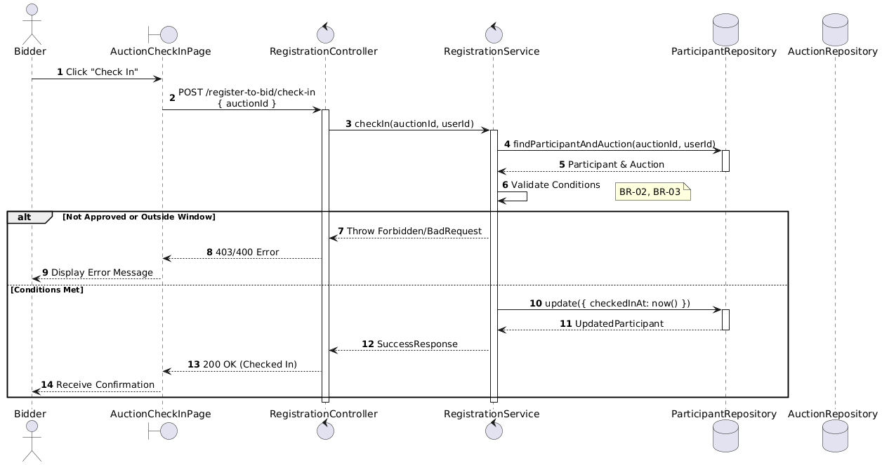

Activities Flow

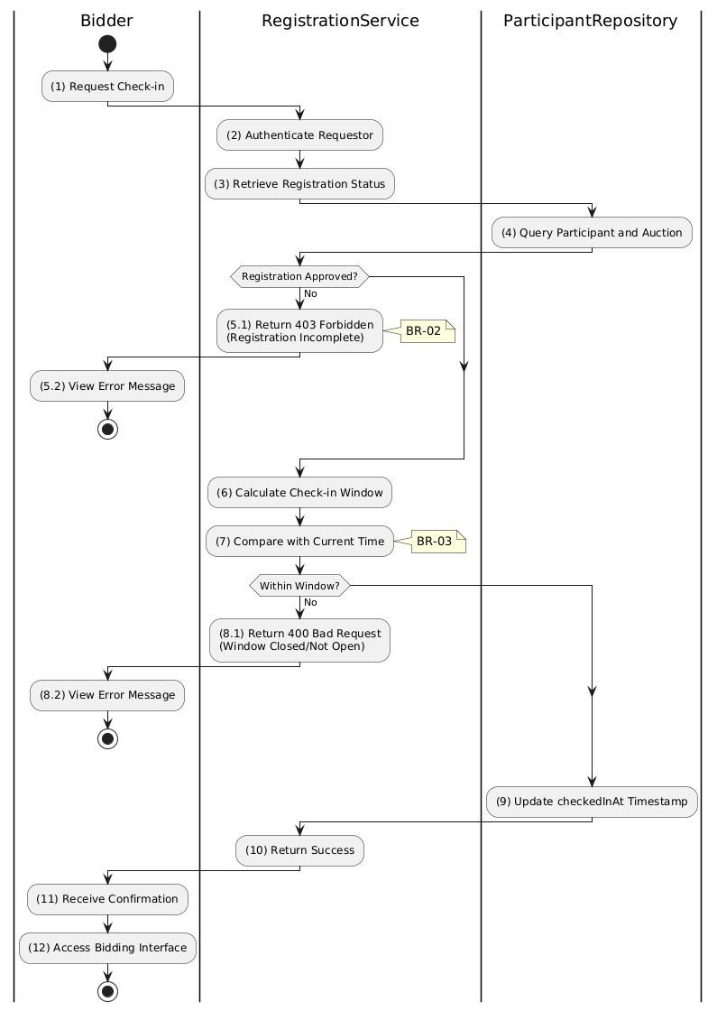

Business Rules
Activity | BR Code | Description
(1) | BR-01 | - Querying Rule:  System queries data in the table 'AUCTION_PARTICIPANT' in the database (Refer to 'AUCTION_PARTICIPANT' table in 'DB Sheet' file) based on the auction ID and user ID.  Call method displayRegistrationStatus(registration) to show approval status.
(1) | BR-02 | - Displaying Rule:  The system displays a 'AuctionCheckInPage' screen. (Refer to 'AuctionCheckInPage' view in 'View Description' file).  Screen shows registration status, auction time, and 'Check In' button (enabled only if approved).
(5.1) | BR-03 | - Validation Rule (Front-end):  System checks registration status before enabling Check In button.  If status != 'FINAL_APPROVED' → disable button, display MSG 19 (Registration incomplete).
(7) | BR-04 | - Validation Rule (Time Window):  System calculates check-in window (e.g., 30 mins before to 15 mins after auctionStartAt).  If current time outside window → display MSG 20 (Check-in window closed/not open).
(9) | BR-05 | - Validation Rule (Back-end/Save):  When user clicks 'Check In' button, send data via function checkIn(auctionId, userId).  The Participant information will be updated in table 'AUCTION_PARTICIPANT' in the database (Refer to 'AUCTION_PARTICIPANT' table in 'DB Sheet' file) to set the check-in timestamp.  If already checked in → gracefully handle (no duplicate update).  Else, show MSG 7 (Success), enable bidding interface access.

Submit deposit for Auction Use Case

Use Case Description
Name | Submit Deposit Payment
Description | This use case allows the Bidder to create a new Deposit Payment information in the system.
Actor | Bidder
Trigger | - When the Bidder clicks on the 'Pay Deposit' button on the DepositPaymentPage.
Pre-condition | - • Bidder's device must be connected to the internet.  • Bidder is signed in with their account.
Post-condition | - The Deposit Payment information will be stored into the system and display payment session on DepositPaymentPage.

Sequence Flow

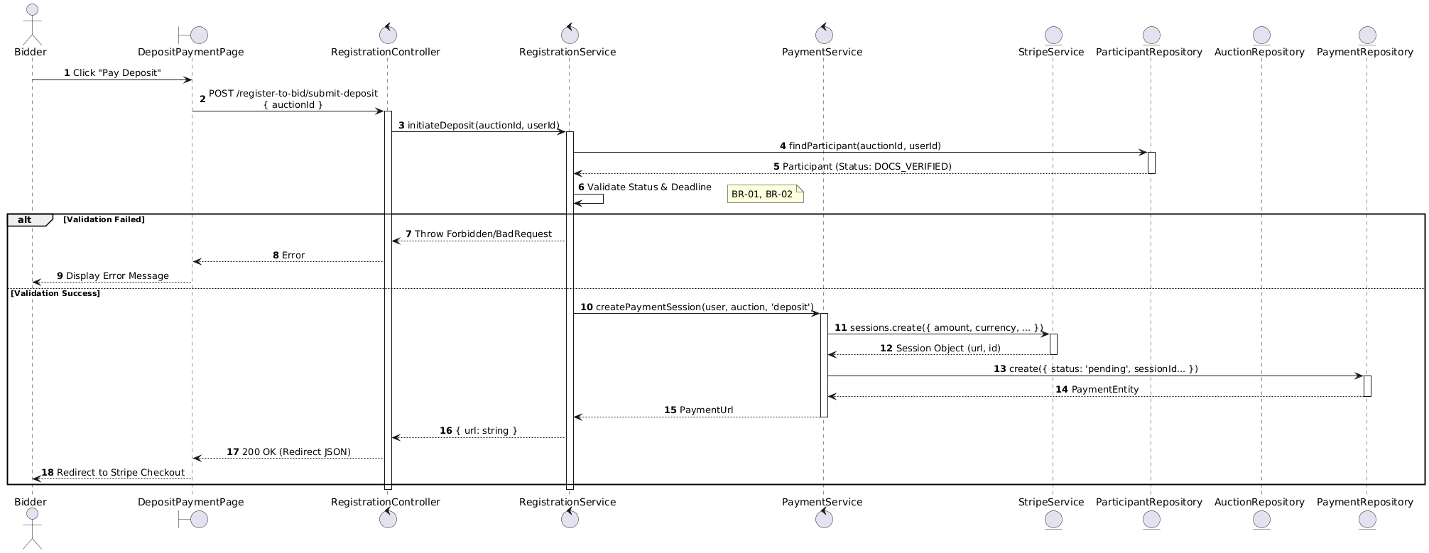

Activities Flow

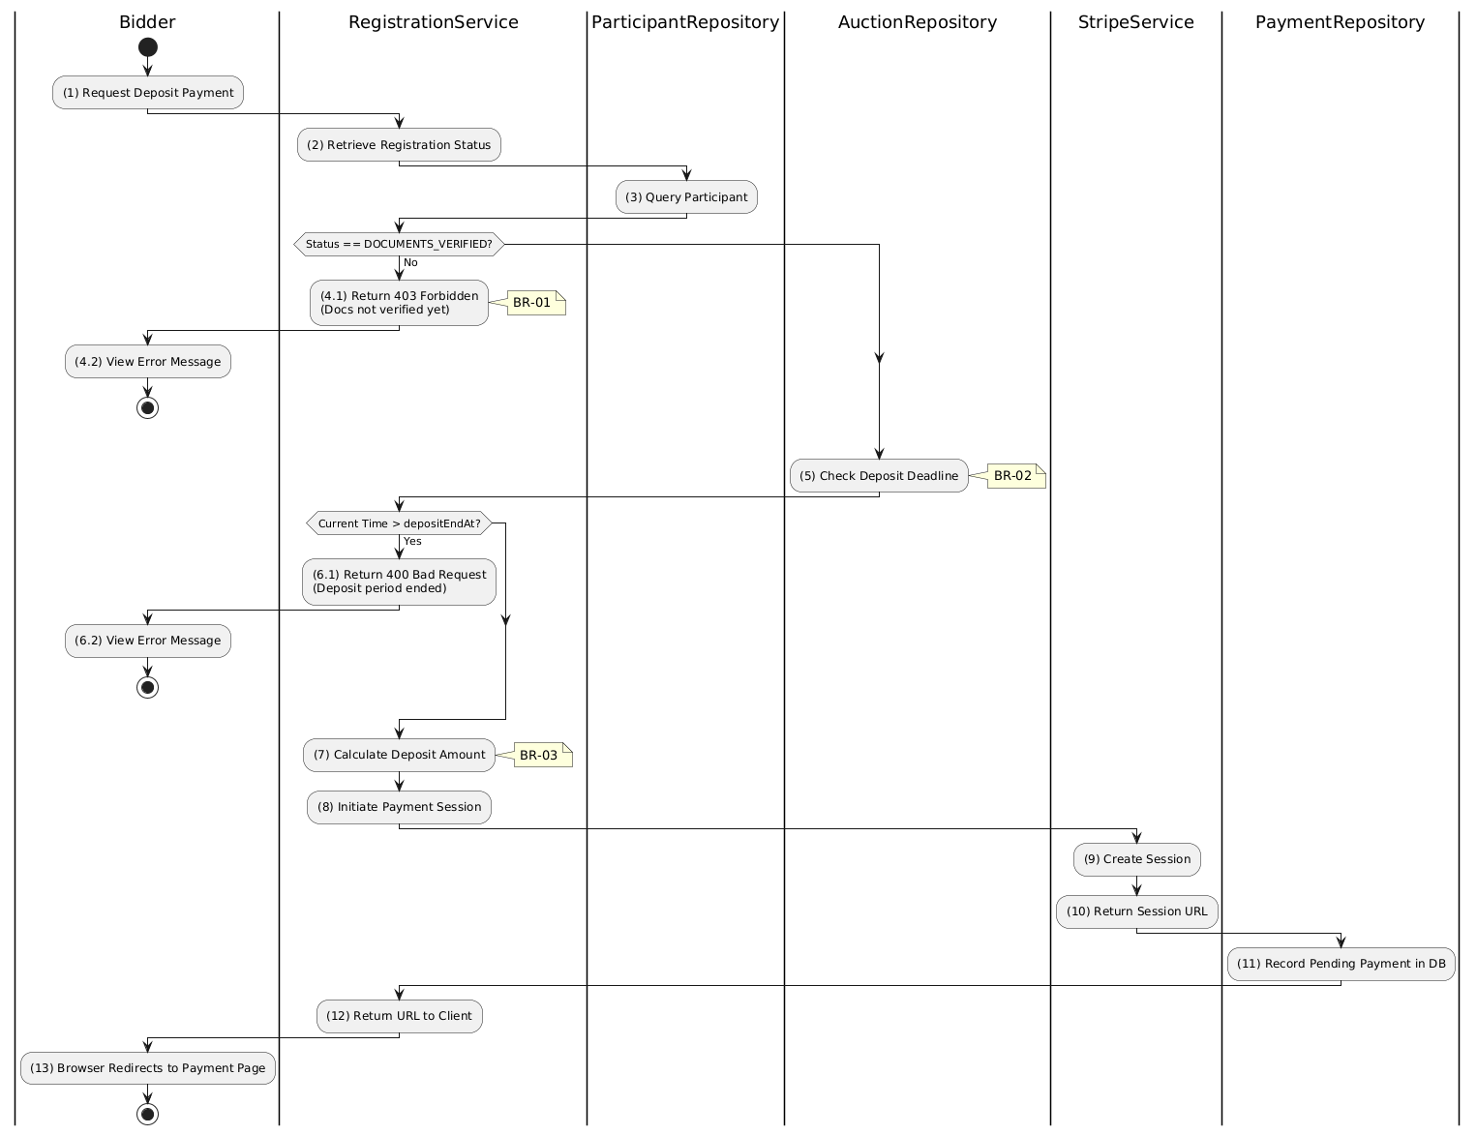

Business Rules
Activity | BR Code | Description
(1) | BR-01 | - Displaying Rule:  The system displays a 'DepositPaymentPage' screen. (Refer to 'DepositPaymentPage' view in 'View Description' file).  Screen shows deposit amount required, payment deadline, and 'Pay Deposit' button.
(1) | BR-02 | - Validation Rule (Front-end):  System checks registration status before enabling payment.  If status != 'DOCUMENTS_VERIFIED' → disable button, display MSG 21 (Documents not verified yet).  If current time > depositEndAt → disable button, display MSG 15 (Deposit period ended).
(1) | BR-03 | - Validation Rule (Back-end/Save):  When user clicks 'Pay Deposit' button, send request via function initiateDeposit(auctionId, userId).  Check table PAYMENT for existing pending payments (prevent duplicates).  Create Stripe Checkout Session with exact depositAmountRequired.
(11) | BR-04 | - Storing Rule:  The input data will be checked by table PAYMENT in the database (Refer to 'PAYMENT' table in 'DB Sheet' file) to check if there are any constraints. Else data of the Payment will be stored as a new record in table PAYMENT.  Set status = 'pending'.  Return Stripe Session URL to client.
(13) | BR-05 | - Displaying Rule (Redirect):  System redirects user's browser to Stripe Checkout Page using returned session URL.  User completes payment on external payment gateway.

Verify deposit for Auction Use Case

Use Case Description
Name | Verify Deposit Payment
Description | This use case allows the Bidder to update existing Deposit Payment information in the system.
Actor | Bidder
Trigger | - When the Bidder is redirected back from Stripe to the PaymentVerificationPage.
Pre-condition | - • Bidder's device must be connected to the internet.  • Bidder is signed in with their account.
Post-condition | - The Deposit Payment information will be updated in the system and display verified status on PaymentVerificationPage datagrid.

Sequence Flow

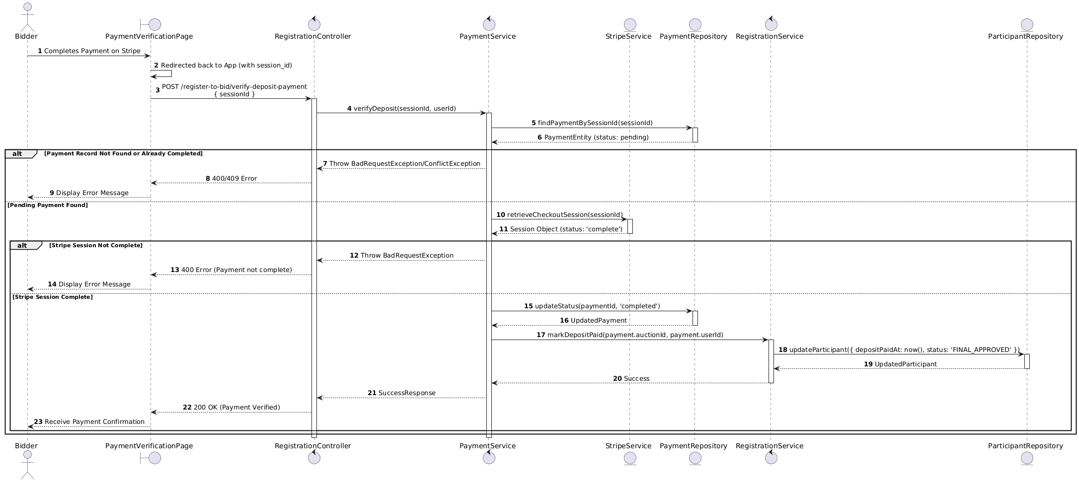

Activities Flow

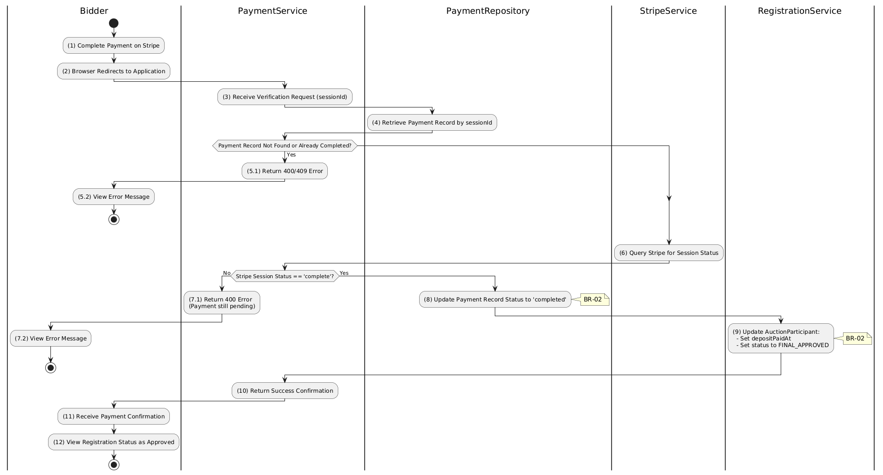

Business Rules
Activity | BR Code | Description
(2) | BR-01 | - Displaying Rule (Payment Verification Page):  When user is redirected back from Stripe, system displays PaymentVerificationPage.  System shows loading indicator while verification is in progress.
(3)-(6) | BR-02 | - Validation Rule (Back-end Verification):  System retrieves data from the 'PAYMENT' table in the database (Refer to 'PAYMENT' table in 'DB Sheet' file) based on the session ID.  If payment record not found or already completed:  $→$ System displays MSG 9 ("Payment verification failed") on the View.  System queries Stripe API to confirm payment status is complete.  If Stripe session not complete:  $→$ System displays MSG 9 ("Payment not yet confirmed") on the View.
(6) | BR-03 | - Validation Rule (Amount Matching):  System verifies amount_total from Stripe matches depositAmountRequired in AUCTION table.  If mismatch:  $→$ System displays MSG 9 ("Payment amount mismatch") and flags for admin review.
(8), (9) | BR-04 | - Storing Rule:  On successful verification, system saves to PAYMENT table: status = 'completed'.  System saves to AUCTION_PARTICIPANT table: depositPaidAt = now(), status = 'FINAL_APPROVED'.
(10)-(12) | BR-05 | - Displaying Rule (Success Confirmation):  System displays MSG 7 ("Deposit payment verified successfully") on the View.  System displays updated registration status showing FINAL_APPROVED.  User can now proceed to auction check-in.

View Own Registration for Auction Use Case

Use Case Description
Name | View Own Registrations
Description | This use case allows the Bidder to search Registration information in the system based on input keywords.
Actor | Bidder
Trigger | - When Bidder clicks on the 'View Registration' button on the MyRegistrationsPage screen.
Pre-condition | - • Bidder's device must be connected to the internet.  • Bidder is signed in with their account.
Post-condition | - The Registration information will be displayed on the MyRegistrationsPage screen.

Sequence Flow

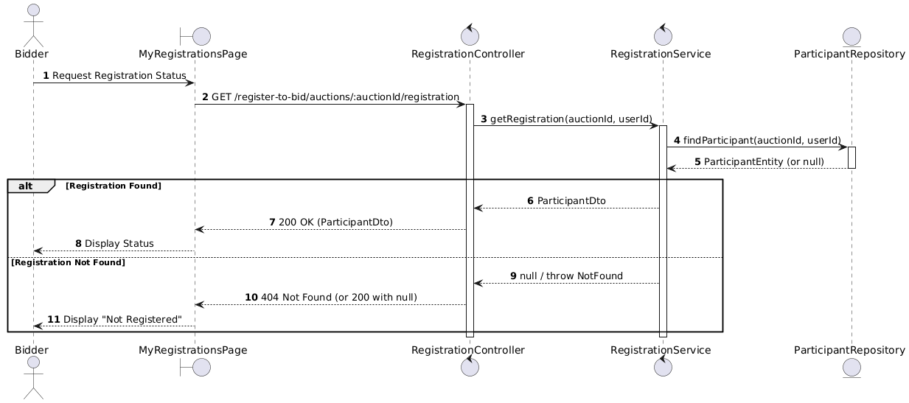

Activities Flow

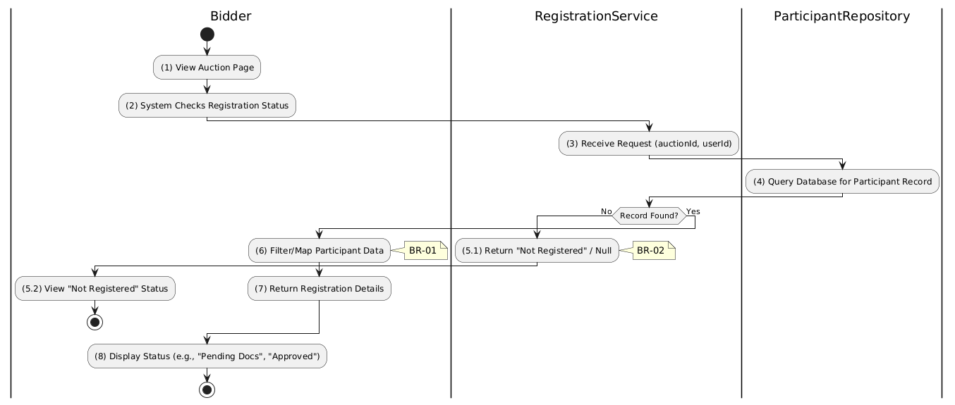

Business Rules
Activity | BR Code | Description
(1) | BR-01 | - Searching Rule:  When user navigates to registrations page, system extracts userId from JWT token.  System queries data in the table 'AUCTION_PARTICIPANT' in the database (Refer to 'AUCTION_PARTICIPANT' table in 'DB Sheet' file) based on the user ID and auction ID.
(4) | BR-02 | - Querying Rule:  System retrieves registration record with all status fields: submittedAt, documentsVerifiedAt, depositPaidAt, checkedInAt, status.  Call method displayRegistrationStatus(registration).
(8) | BR-03 | - Displaying Rule:  The system displays a 'MyRegistrationsPage' screen. (Refer to 'MyRegistrationsPage' view in 'View Description' file).  Screen shows registration status (e.g., 'Pending Docs', 'Verified', 'Approved', 'Rejected').  If no registration found → display 'Not Registered' status.

List All Registrations Use Case

Use Case Description
Name | List All Registrations (Admin)
Description | This use case allows the Admin to search Registration information in the system based on input keywords.
Actor | Admin
Trigger | - When Admin enters searching keywords in the SearchBox on the top left of the RegistrationDashboard screen.
Pre-condition | - • Admin's device must be connected to the internet.  • Admin is signed in with their account.
Post-condition | - The datagrid of Registration information will be filtered by keywords and displayed on the RegistrationDashboard screen.

Sequence Flow

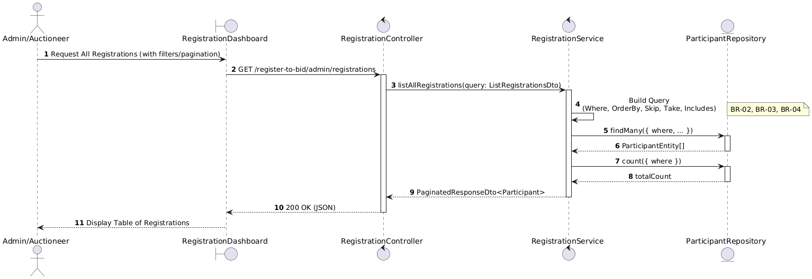

Activities Flow

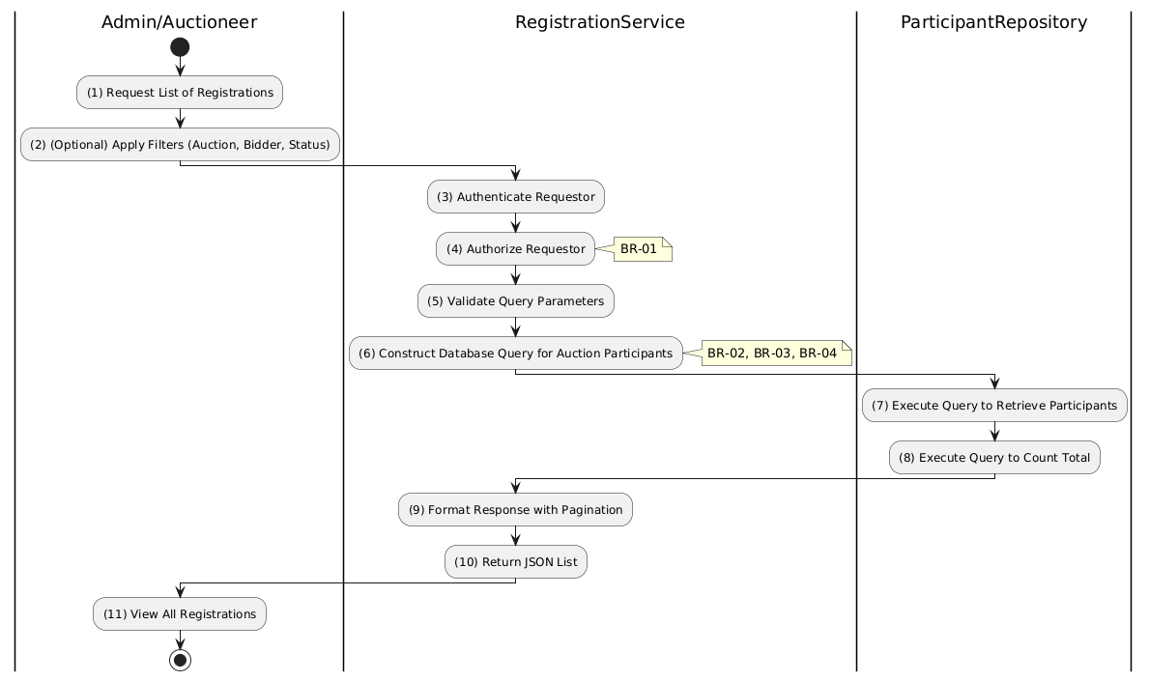

Business Rules
Activity | BR Code | Description
(1)-(2) | BR-01 | - Displaying Rule (Registration Dashboard):  When Admin/Auctioneer navigates to registration management, system displays RegistrationDashboard.  System displays filter controls: Auction, Bidder, Status dropdowns.  System displays pagination controls: Page, Items per page.
(2) | BR-02 | - Validation Rule (Filter Input - Front-end):  When user selects filter options, system uses Selection_change() method.  When user enters bidder search text, system uses Text_change() method.  System validates filter parameters before sending query.
(3)-(4) | BR-03 | - Validation Rule (Authorization - Back-end):  System checks if user role is admin or auctioneer in USERS table.  If unauthorized:  $→$ System displays MSG 5 ("Forbidden") on the View.  If auctioneer, system automatically scopes query to their managed auctions.
(6)-(8) | BR-04 | - Querying Rule:  System retrieves data from the 'AUCTION_PARTICIPANT' table in the database (Refer to 'AUCTION_PARTICIPANT' table in 'DB Sheet' file) based on the applied filters.  System retrieves related User and Auction information to enrich data.  System applies pagination controls and counts total records.
(11) | BR-05 | - Displaying Rule (Results Table):  System displays results in data table showing: Bidder Name, Auction Code, Status, Registration Date, Actions.  System displays pagination info: "Showing X-Y of Z registrations".  If no results found, system displays MSG 19 ("No registrations found").

Get All Registration for Auction Use Case

Use Case Description
Name | Get Registration for Auction
Description | This use case allows the Bidder to view their registration status for a specific auction.
Actor | Bidder
Trigger | - When Bidder navigates to an auction
Pre-condition | - • Bidder's device must be connected to the internet.  • Bidder is signed in with their account.
Post-condition | - The registration status for the specific auction is displayed to the Bidder.

Sequence Flow

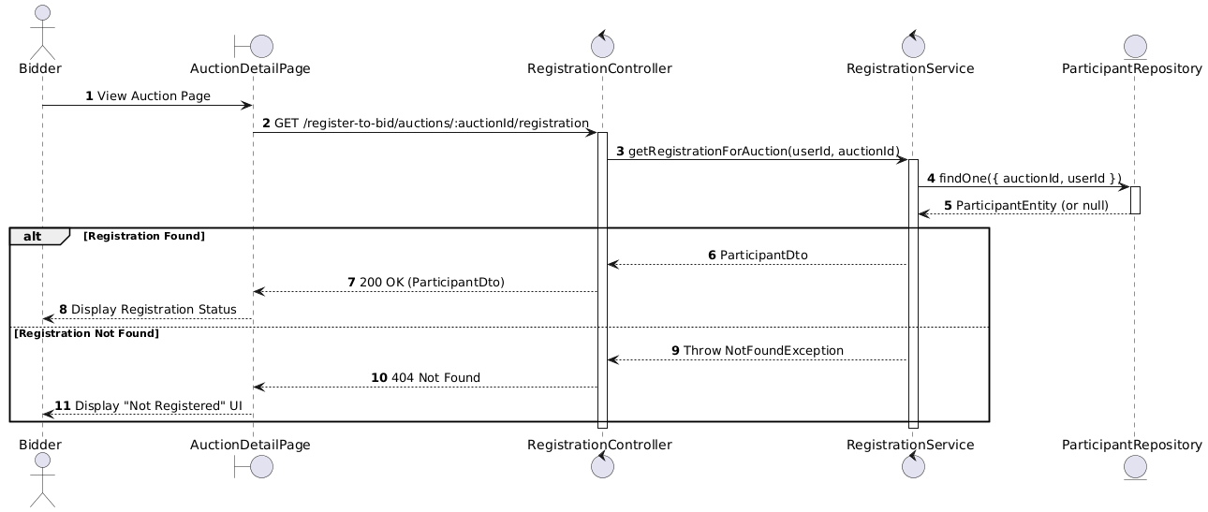

Activities Flow

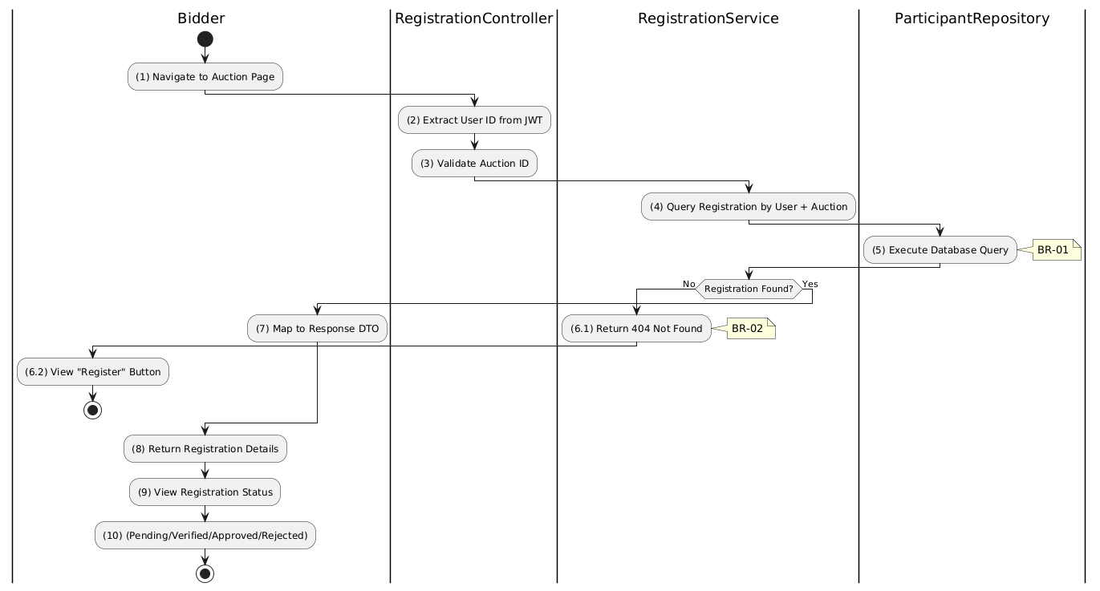

Business Rules
Activity | BR Code | Description
(1) | BR-01 | - Displaying Rule (Auction Detail Page):  When bidder visits auction page, system checks their registration status automatically.  System displays appropriate UI: "Register" button (not registered), status badge (registered).
(2) | BR-02 | - Processing Rule (User Identification):  System extracts user ID from JWT token.  User can only view their own registration status.  No explicit user ID parameter needed - derived from auth token.
(5) | BR-03 | - Querying Rule:  System retrieves data from the 'AUCTION_PARTICIPANT' table in the database where userId and auctionId match.  System retrieves all status fields: submittedAt, documentsVerifiedAt, depositPaidAt, confirmedAt, checkedInAt, withdrawnAt.
(6.1) | BR-04 | - Processing Rule (Not Found Handling):  If no registration exists, system returns 404 Not Found.  Frontend interprets this as "user has not registered yet".  Frontend displays "Register for Auction" button.
(9) | BR-05 | - Displaying Rule (Status Display):  System displays registration status based on timestamp fields:  - submittedAt set: "Pending Review"  - documentsVerifiedAt set: "Documents Verified"  - depositPaidAt set: "Deposit Paid"  - confirmedAt set: "Approved"  - checkedInAt set: "Checked In".

Reject Registration for Auction Use Case

Use Case Description
Name | Reject Registration
Description | This use case allows the Admin to update existing Registration information in the system.
Actor | Admin
Trigger | - When the Admin clicks on the 'Reject' button on the RegistrationApprovalPage.
Pre-condition | - • Admin's device must be connected to the internet.  • Admin is signed in with their account.
Post-condition | - The Registration information will be updated in the system and display new record on RegistrationApprovalPage datagrid.

Sequence Flow

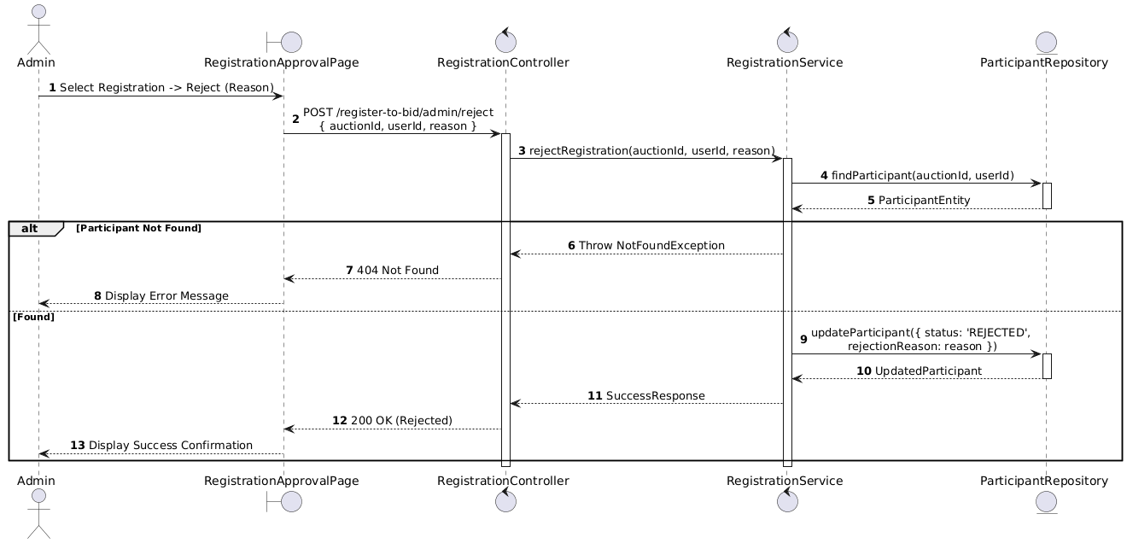

Activities Flow

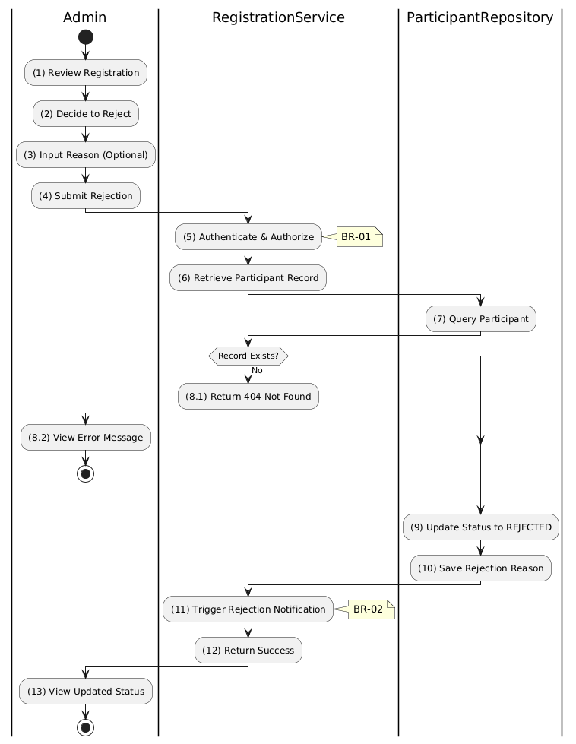

Business Rules
Activity | BR Code | Description
(1) | BR-01 | - Displaying Rule (Registration Approval Page):  When Admin reviews a registration, system displays RegistrationApprovalPage.  System displays registration details, bidder info, and submitted documents.  System displays "Reject" button with reason input field.
(2)-(4) | BR-02 | - Validation Rule (Input - Front-end):  When Admin enters rejection reason, system uses Text_change() method.  System enables "Submit Rejection" button when reason is provided.  On submit, system displays MSG 11 ("Are you sure you want to reject this registration?").
(5) | BR-03 | - Validation Rule (Authorization - Back-end):  System checks if requestor role is admin or auctioneer in USERS table.  If unauthorized:  $→$ System displays MSG 5 ("Forbidden") on the View.
(7)-(8.1) | BR-04 | - Validation Rule (Record Existence - Back-end):  System retrieves data from the 'AUCTION_PARTICIPANT' table in the database (Refer to 'AUCTION_PARTICIPANT' table in 'DB Sheet' file) based on the auction ID and user ID.  If record not found:  $→$ System displays MSG 20 ("Registration not found") on the View.
(9)-(10) | BR-05 | - Storing Rule:  System saves to AUCTION_PARTICIPANT table:  - status = 'REJECTED'  - rejectionReason = [input reason]  - rejectedAt = now()
(11) | BR-06 | - Processing Rule (Notification):  System triggers email notification to bidder with rejection reason.  Notification explains why registration was denied.
(13) | BR-07 | - Displaying Rule (Success Confirmation):  System displays MSG 7 ("Registration rejected successfully") on the View.  System refreshes registration list showing updated REJECTED status.

Verify Document Registration (tier 1) for Auction Use Case

Use Case Description
Name | Verify Documents (Tier 1)
Description | This use case allows the Admin to update existing Registration Document information in the system.
Actor | Admin
Trigger | - When the Admin clicks on the 'Verify Documents' button on the DocumentVerificationPage.
Pre-condition | - • Admin's device must be connected to the internet.  • Admin is signed in with their account.
Post-condition | - The Registration Document information will be updated in the system and display new record on DocumentVerificationPage datagrid.

Sequence Flow

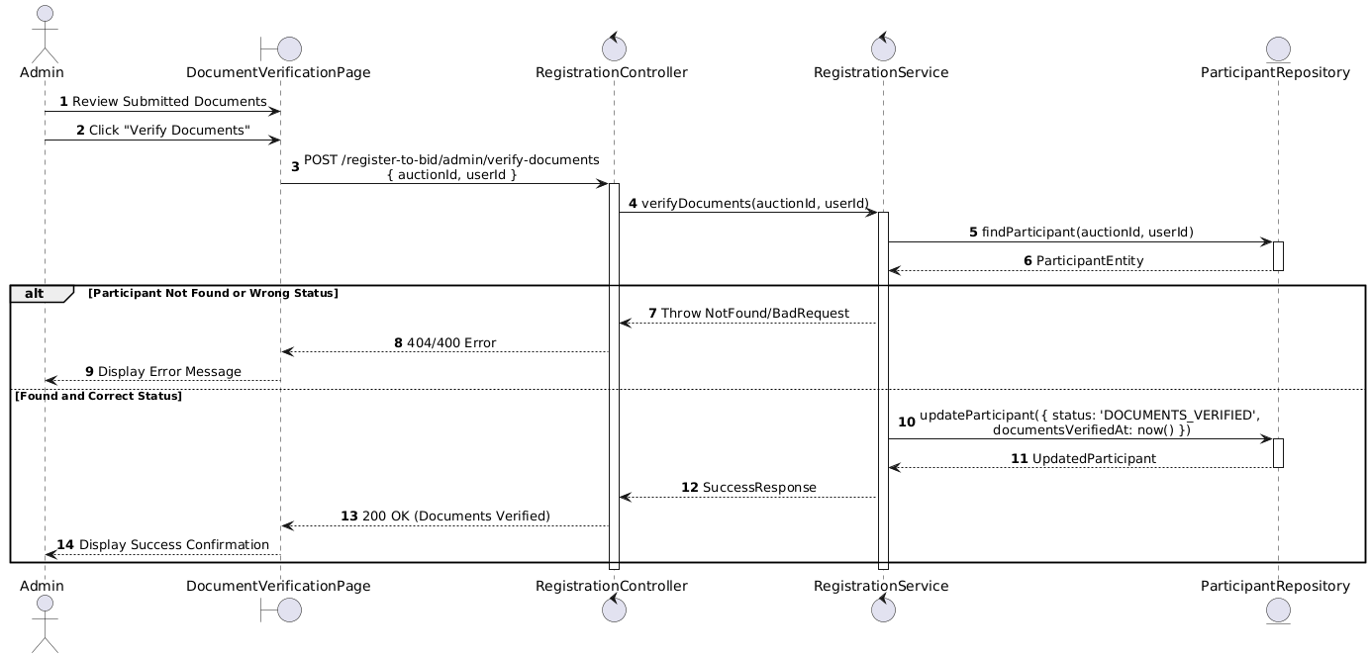

Activities Flow

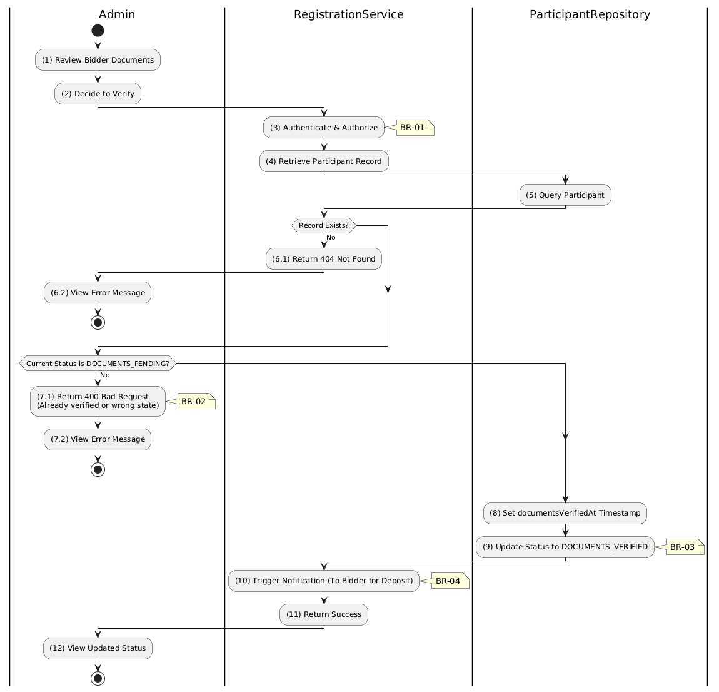

Business Rules
Activity | BR Code | Description
(1) | BR-01 | - Displaying Rule (Document Verification Page):  When Admin reviews submitted documents, system displays DocumentVerificationPage.  System displays bidder info, uploaded document previews, and verification status.  System displays "Verify Documents" button.
(2) | BR-02 | - Validation Rule (Confirmation - Front-end):  When Admin clicks "Verify Documents" button, system displays MSG 11 ("Confirm document verification?").  System waits for confirmation before proceeding.
(3) | BR-03 | - Validation Rule (Authorization - Back-end):  System checks if requestor role is admin or auctioneer in USERS table.  If unauthorized:  $→$ System displays MSG 5 ("Forbidden") on the View.
(5)-(6.1) | BR-04 | - Validation Rule (Record Existence - Back-end):  System retrieves data from the 'AUCTION_PARTICIPANT' table in the database (Refer to 'AUCTION_PARTICIPANT' table in 'DB Sheet' file) based on the auction ID and user ID.  If record not found:  $→$ System displays MSG 20 ("Registration not found") on the View.
(7.1) | BR-05 | - Validation Rule (Status Pre-requisite - Back-end):  System checks current status of participant record.  If status is NOT DOCUMENTS_PENDING:  $→$ System displays MSG 16 ("Invalid status for this operation") on the View.
(8)-(9) | BR-06 | - Storing Rule:  System saves to AUCTION_PARTICIPANT table:  - documentsVerifiedAt = now()  - status = 'DOCUMENTS_VERIFIED'
(10) | BR-07 | - Processing Rule (Notification):  System triggers notification to bidder informing Tier 1 is complete.  Notification instructs bidder to proceed with deposit payment (Tier 2).
(12) | BR-08 | - Displaying Rule (Success Confirmation):  System displays MSG 7 ("Documents verified successfully") on the View.  System updates registration status display to DOCUMENTS_VERIFIED.

Reject Document Registration (tier 1) for Auction Use Case

Use Case Description
Name | Reject Documents
Description | This use case allows the Admin to update existing Registration Document information in the system.
Actor | Admin
Trigger | - When the Admin clicks on the 'Reject Documents' button on the DocumentVerificationPage.
Pre-condition | - • Admin's device must be connected to the internet.  • Admin is signed in with their account.
Post-condition | - The Registration Document information will be updated in the system and display new record on DocumentVerificationPage datagrid.

Sequence Flow

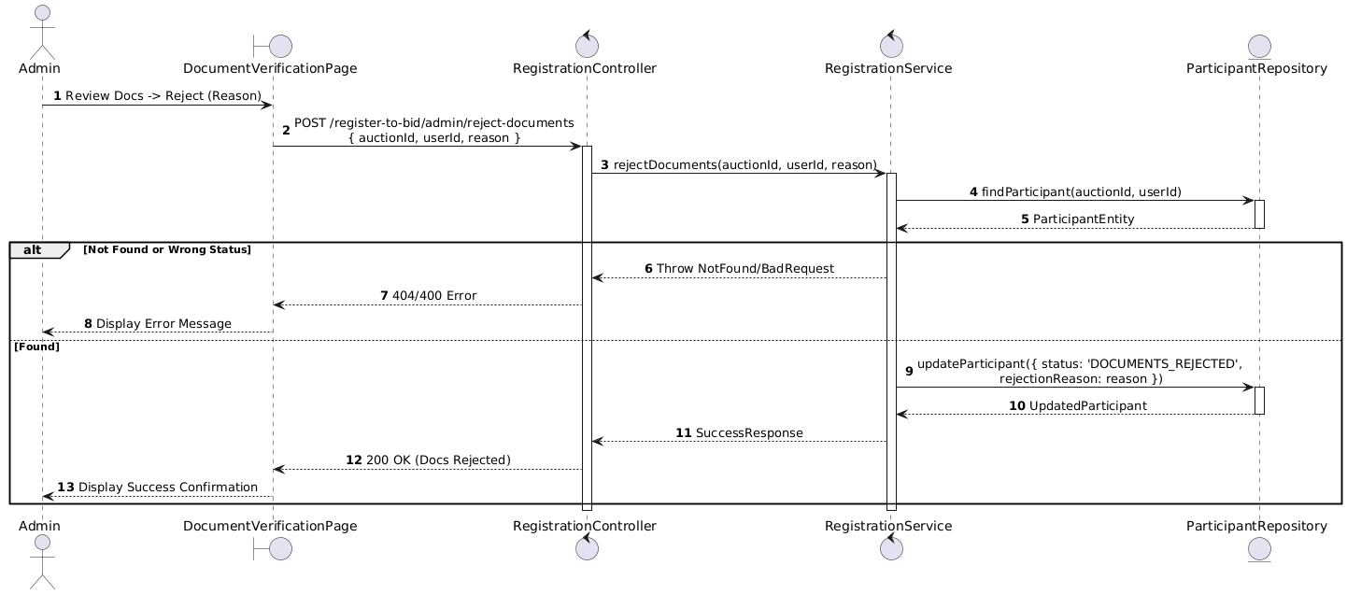

Activities Flow

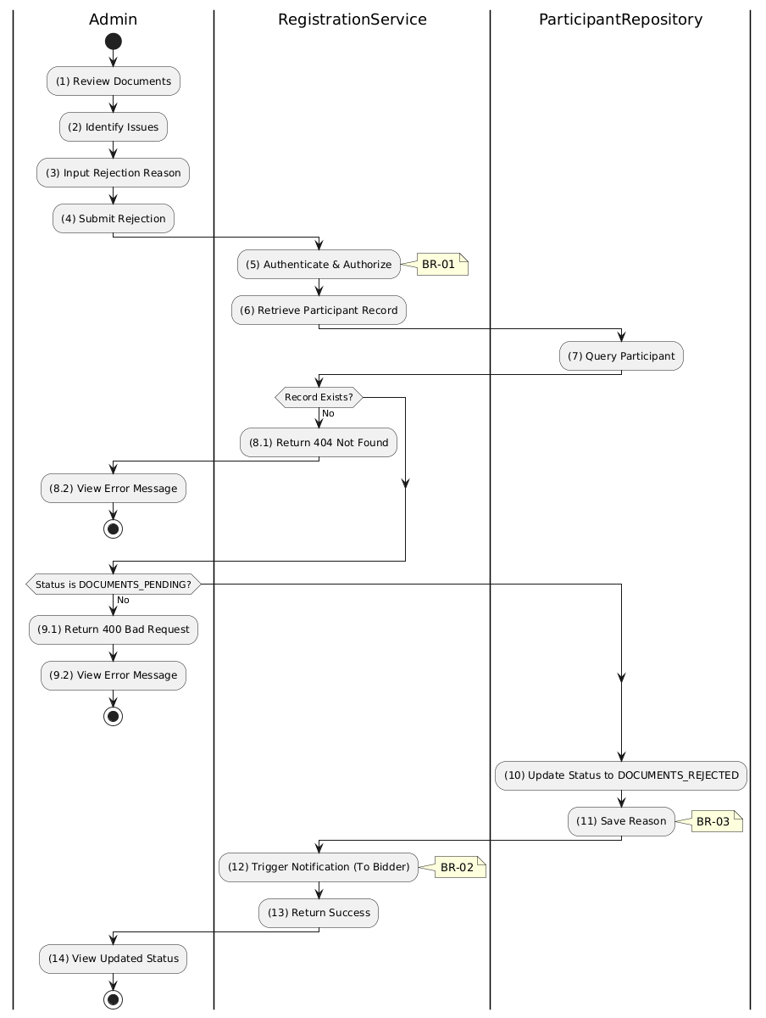

Business Rules
Activity | BR Code | Description
(1)-(2) | BR-01 | - Displaying Rule (Document Verification Page):  When Admin reviews documents and identifies issues, system displays DocumentVerificationPage.  System displays document previews and "Reject Documents" button.  System displays rejection reason text input field.
(3)-(4) | BR-02 | - Validation Rule (Input - Front-end):  When Admin enters rejection reason, system uses Text_change() method.  If isEmpty(rejectionReason):  $→$ System displays MSG 1 ("Rejection reason is mandatory").  On submit, system displays MSG 11 ("Confirm document rejection?").
(5) | BR-03 | - Validation Rule (Authorization - Back-end):  System checks if requestor role is admin or auctioneer in USERS table.  If unauthorized:  $→$ System displays MSG 5 ("Forbidden") on the View.
(7)-(8.1) | BR-04 | - Validation Rule (Record Existence - Back-end):  System retrieves data from the 'AUCTION_PARTICIPANT' table in the database (Refer to 'AUCTION_PARTICIPANT' table in 'DB Sheet' file) based on the auction ID and user ID.  If record not found:  $→$ System displays MSG 20 ("Registration not found") on the View.
(9.1) | BR-05 | - Validation Rule (Status Pre-requisite - Back-end):  System checks current status of participant record.  If status is NOT DOCUMENTS_PENDING:  $→$ System displays MSG 16 ("Invalid status for this operation") on the View.
(10)-(11) | BR-06 | - Storing Rule:  System saves to AUCTION_PARTICIPANT table:  - status = 'DOCUMENTS_REJECTED'  - rejectionReason = [input reason]  User can resubmit documents after fixing issues.
(12) | BR-07 | - Processing Rule (Notification):  System sends notification to bidder explaining document rejection.  Notification includes admin's reason so bidder knows what to fix.
(14) | BR-08 | - Displaying Rule (Success Confirmation):  System displays MSG 7 ("Documents rejected - awaiting resubmission") on the View.  System updates status display to DOCUMENTS_REJECTED.

Final Approval Registration (tier 2) for Auction Use Case

Use Case Description
Name | Final Approval (Tier 2)
Description | This use case allows the Admin to update existing Registration information in the system.
Actor | Admin
Trigger | - When the Admin clicks on the 'Final Approve' button on the RegistrationApprovalPage.
Pre-condition | - • Admin's device must be connected to the internet.  • Admin is signed in with their account.
Post-condition | - The Registration information will be updated in the system and display new record on RegistrationApprovalPage datagrid.

Sequence Flow

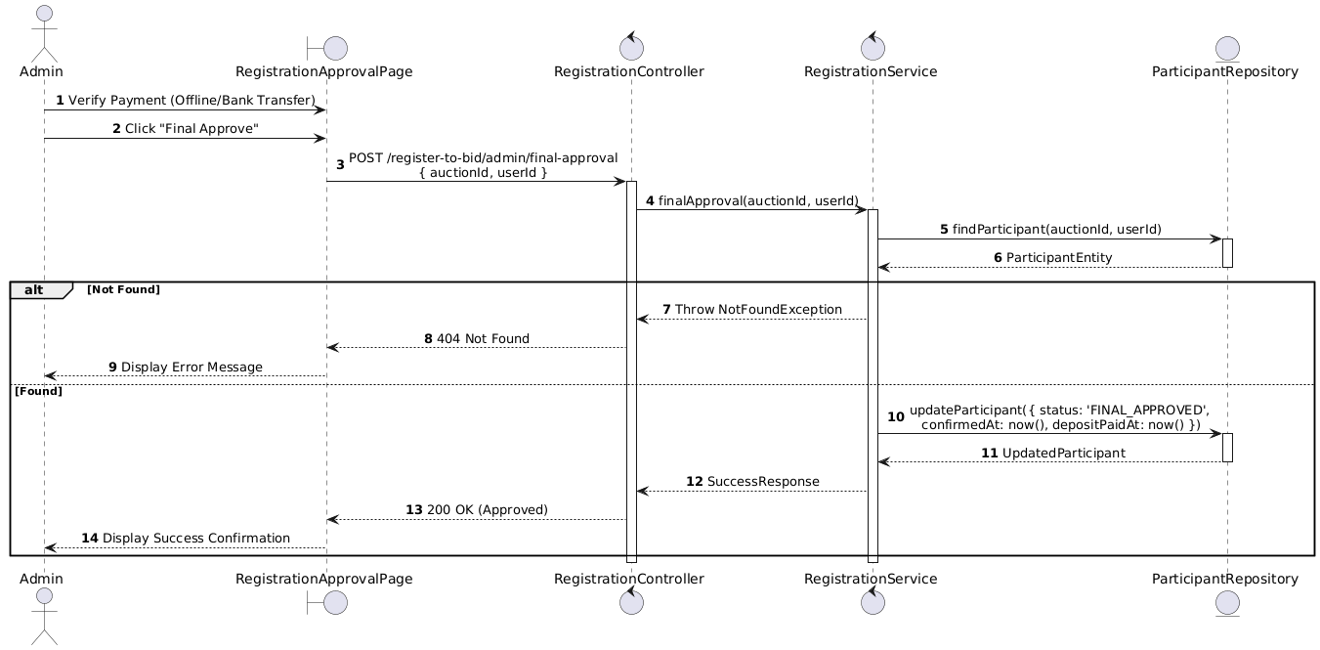

Activities Flow

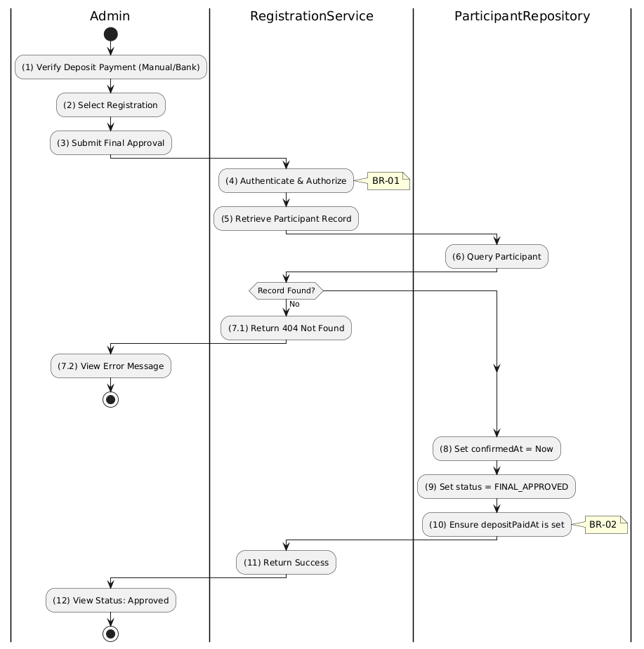

Business Rules
Activity | BR Code | Description
(1)-(2) | BR-01 | - Displaying Rule (Registration Approval Page):  When Admin verifies offline/bank payment, system displays RegistrationApprovalPage.  System displays current registration status (typically DOCUMENTS_VERIFIED).  System displays "Final Approve" button.
(3) | BR-02 | - Validation Rule (Confirmation - Front-end):  When Admin clicks "Final Approve" button, system displays MSG 11 ("Confirm final approval? This will mark deposit as paid.").  System waits for confirmation before proceeding.
(4) | BR-03 | - Validation Rule (Authorization - Back-end):  System checks if requestor role is admin or auctioneer in USERS table.  If unauthorized:  $→$ System displays MSG 5 ("Forbidden") on the View.
(6)-(7.1) | BR-04 | - Validation Rule (Record Existence - Back-end):  System retrieves data from the 'AUCTION_PARTICIPANT' table in the database (Refer to 'AUCTION_PARTICIPANT' table in 'DB Sheet' file) based on the auction ID and user ID.  If record not found:  $→$ System displays MSG 20 ("Registration not found") on the View.
(7.1) | BR-05 | - Validation Rule (Idempotency - Back-end):  If participant status is already FINAL_APPROVED:  $→$ System returns success without re-processing (idempotent behavior).
(8)-(10) | BR-06 | - Storing Rule:  System saves to AUCTION_PARTICIPANT table:  - confirmedAt = now()  - depositPaidAt = now() (if not already set)  - status = 'FINAL_APPROVED'  Bidder is now eligible to check in for auction.
(12) | BR-07 | - Displaying Rule (Success Confirmation):  System displays MSG 7 ("Registration fully approved") on the View.  System refreshes registration status showing FINAL_APPROVED.

Manage Bidding Use Case

Manage Bidding Use Case

Use Case Description
Name | Manage Bidding
Description | This use case allows the Bidder to choose one of the corresponding functions of CRUD to adjust Bidding information in the system.
Actor | Bidder, Auctioneer, Admin, System
Trigger | - When the Bidder clicks on the "Bidding" button on the navigation sidebar or joins an active auction room.
Pre-condition | - 1. Bidder's device must be connected to the internet.  2. Bidder is signed in with their account.
Post-condition | - The Bidding information is updated to the corresponding function that the Bidder executes.

Sequence Flow

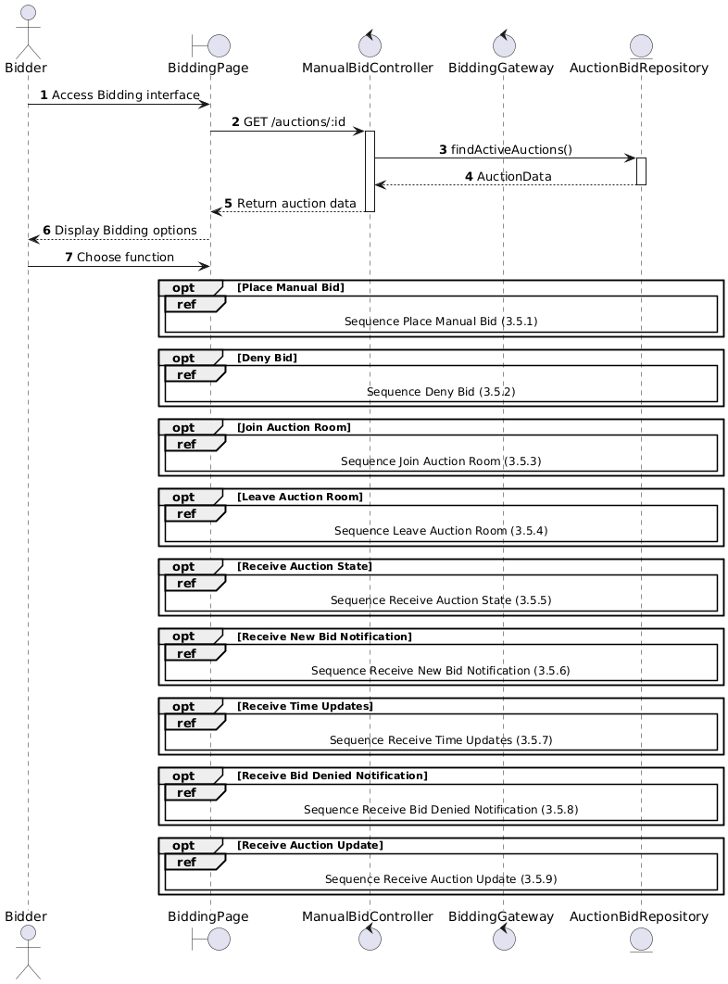

Activities Flow

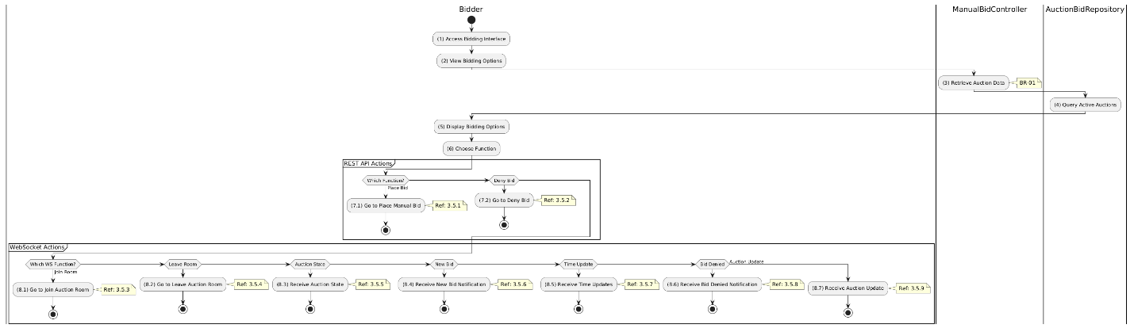

Business Rules
Activity | BR Code | Description
(5) | BR-01 | - Displaying Rule:  The system displays a "Bidding Management" screen. (Refer to "Bidding Management" view in "View Description" file).
(6) | BR-02 | - Choosing Rule:  Bidder can only choose one feature at a time to use.

Manual Bidding Use Case

Use Case Description
Name | Place Manual Bid
Description | This use case allows the Bidder to create a new Bid information in the system.
Actor | Bidder
Trigger | - When the Bidder clicks on the 'Place Bid' button on the BiddingPage.
Pre-condition | - • Bidder's device must be connected to the internet.  • Bidder is signed in with their account.
Post-condition | - The Bidding information is updated to the corresponding function that the Bidder executes.

Sequence Flow

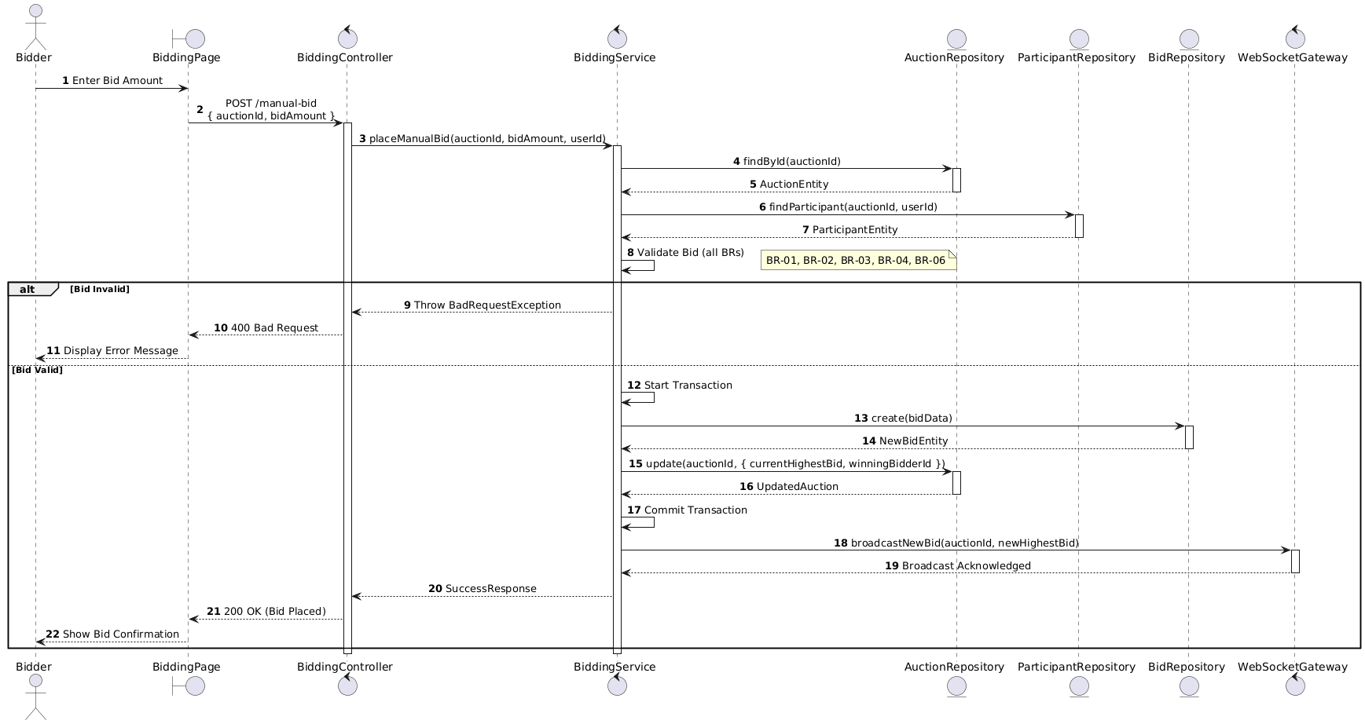

Activities Flow

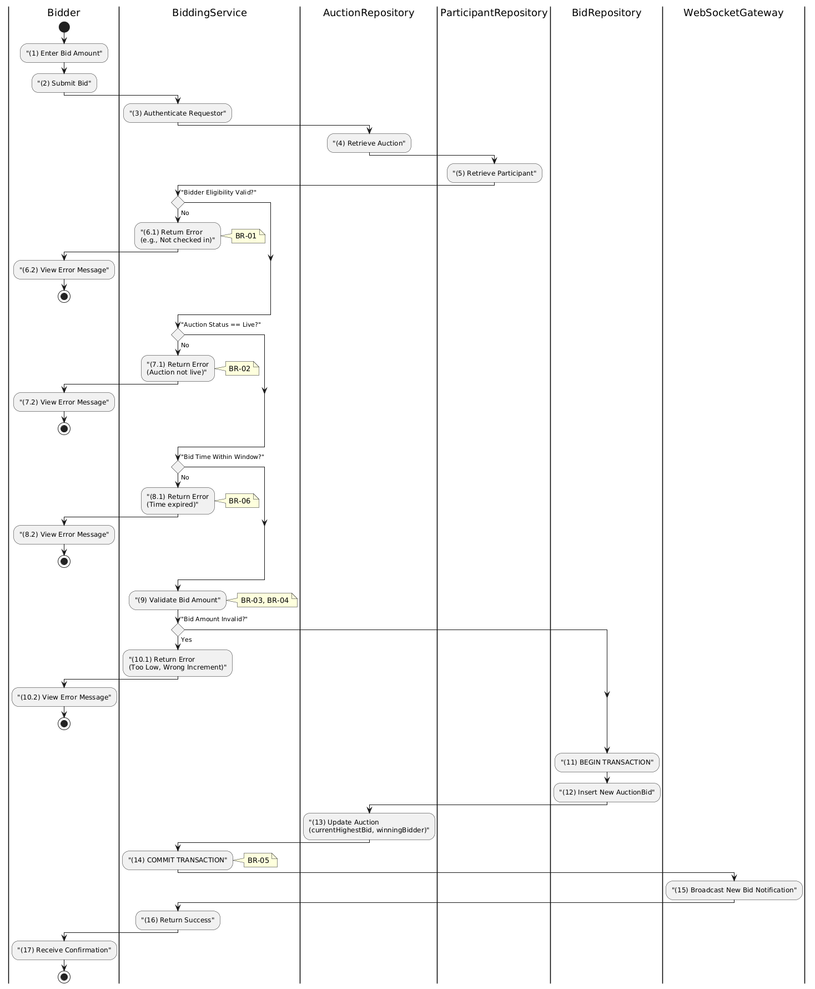

Business Rules
Activity | BR Code | Description
(1) | BR-01 | - Displaying Rule:  The system displays a 'BiddingPage' screen. (Refer to 'BiddingPage' view in 'View Description' file).  Screen shows current highest bid, bid increment, input field for bid amount, and 'Place Bid' button.
(1) | BR-02 | - Validation Rule (Front-end):  When user enters bid amount, system uses Text_change() method.  Checks if input is valid (empty, wrong format).  If isEmpty() → display MSG 1 (Mandatory).  If amount < startingPrice (first bid) → display MSG 24 (Bid too low).  If amount <= currentHighestBid → display MSG 24 (Bid must be higher).  If (amount - previousBid) not multiple of bidIncrement → display MSG 4 (Invalid increment).
(6.1) | BR-03 | - Validation Rule (Bidder Eligibility):  System checks if bidder is FINAL_APPROVED and has checkedInAt for the auction.  If not → display MSG 19 (Not eligible to bid), return 403.
(7.1) | BR-04 | - Validation Rule (Auction Status):  System checks if auction status is 'live'.  If not live → display MSG 22 (Auction not active), return 400.
(2) | BR-05 | - Validation Rule (Back-end/Save):  When user clicks 'Place Bid' button, send data via function placeManualBid(auctionId, bidAmount, userId).  Check time is within auctionStartAt and auctionEndAt.  Execute in transaction: Insert bid in AUCTION_BID, update AUCTION with currentHighestBid.  Broadcast new bid via WebSocket.  Show MSG 7 (Success).
(15) | BR-06 | - Processing Rule (Anti-sniping):  If bid placed within last 60 seconds before auctionEndAt, system automatically extends auctionEndAt by fixed duration.  Prevents sniping, ensures fairness.

Deny Bid Use Case

Use Case Description
Name | Deny Bid
Description | This use case allows the Admin to update existing Bid information in the system.
Actor | Admin
Trigger | - When the Admin clicks on the 'Deny Bid' button on the BidManagementPage.
Pre-condition | - • Admin's device must be connected to the internet.  • Admin is signed in with their account.
Post-condition | - The Bid information will be updated in the system and display new record on BidManagementPage datagrid.

Sequence Flow

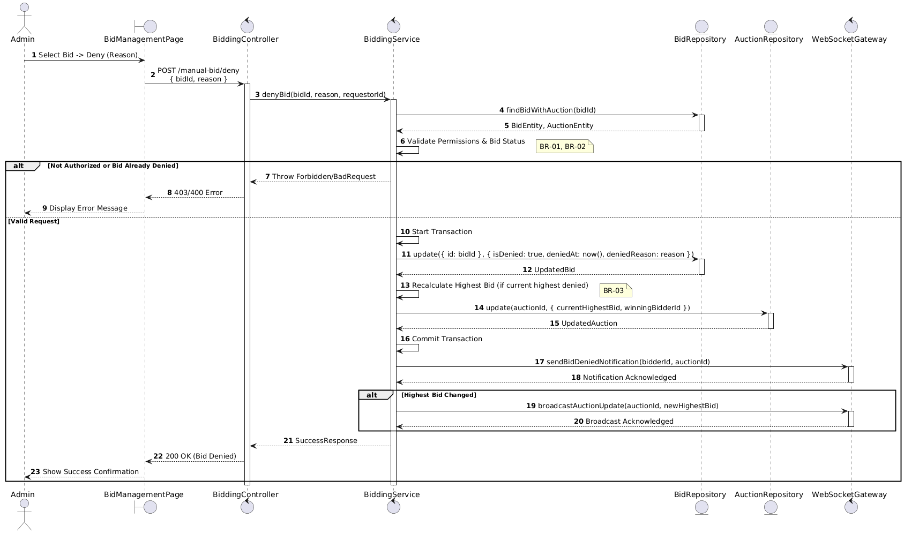

Activities Flow

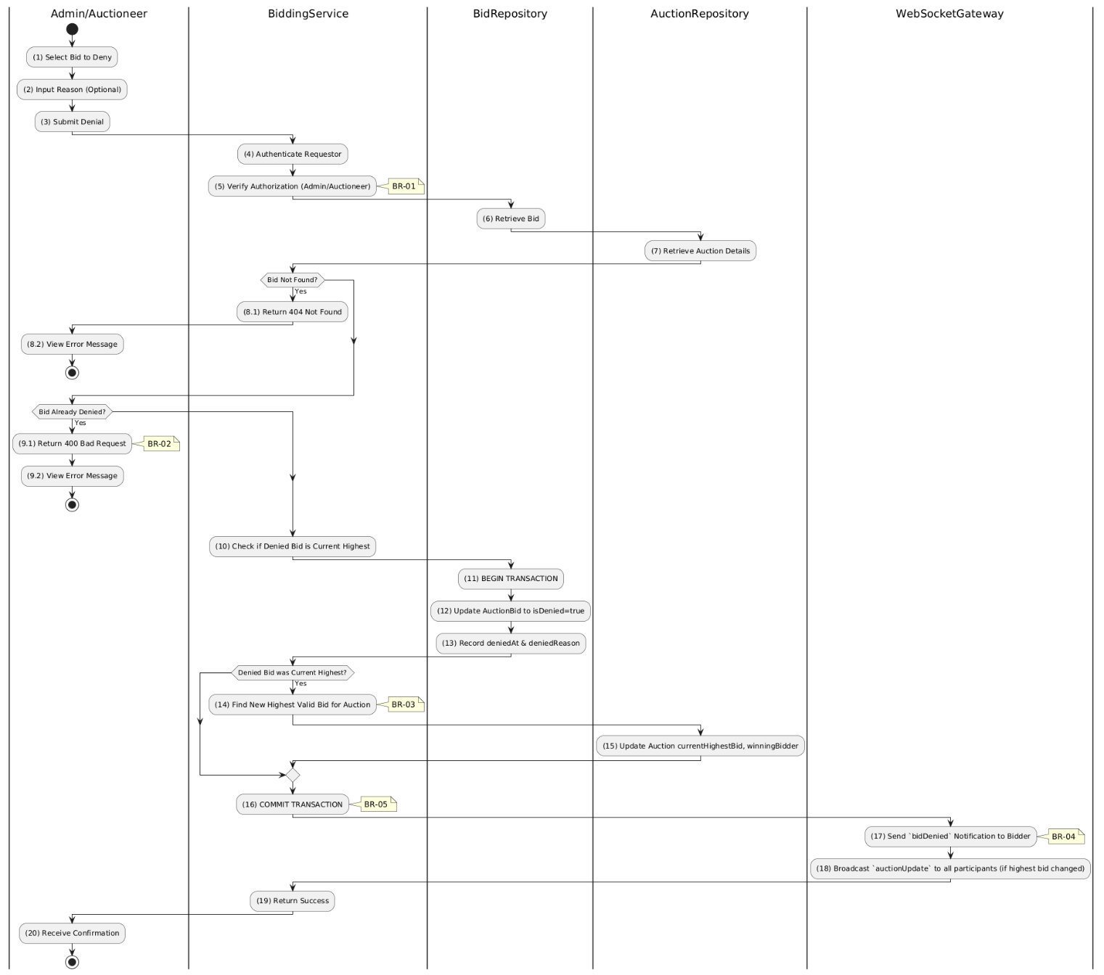

Business Rules
Activity | BR Code | Description
(1) | BR-01 | - Displaying Rule (Bid Management Page):  When Admin/Auctioneer reviews bids, system displays BidManagementPage.  System displays list of bids with bidder info, amount, timestamp.  System displays "Deny" button and optional reason input for each bid.
(2)-(3) | BR-02 | - Validation Rule (Input - Front-end):  When Admin enters denial reason, system uses Text_change() method.  On clicking "Deny", system displays MSG 11 ("Are you sure you want to deny this bid?").  System waits for confirmation before proceeding.
(4)-(5) | BR-03 | - Validation Rule (Authorization - Back-end):  System checks if requestor role is admin, super_admin, or auction owner in USERS table.  If unauthorized:  $→$ System displays MSG 5 ("Forbidden") on the View.
(6)-(8.1) | BR-04 | - Validation Rule (Bid Existence - Back-end):  System retrieves data from the 'AUCTION_BID' table in the database (Refer to 'AUCTION_BID' table in 'DB Sheet' file) based on the bid ID.  If bid not found:  $→$ System displays MSG 20 ("Bid not found") on the View.
(9.1) | BR-05 | - Validation Rule (Already Denied - Back-end):  System checks if isDenied flag is already true.  If already denied:  $→$ System displays MSG 16 ("Bid already denied") on the View.
(12)-(13) | BR-06 | - Storing Rule:  System saves to AUCTION_BID table:  - isDenied = true  - deniedAt = now()  - deniedReason = [input reason]
(14)-(15) | BR-07 | - Processing Rule (Recalculate Highest Bid):  If denied bid was current highest, system retrieves data from the 'AUCTION_BID' table in the database (Refer to 'AUCTION_BID' table in 'DB Sheet' file) to find the next valid highest bid.  The Auction information will be updated in table 'AUCTION' in the database with the new highest bid and winning bidder.
(17)-(18) | BR-08 | - Processing Rule (WebSocket Notifications):  System sends bidDenied notification to the bidder whose bid was denied.  If highest bid changed, system broadcasts auctionUpdate to all room participants.
(20) | BR-09 | - Displaying Rule (Success Confirmation):  System displays MSG 7 ("Bid denied successfully") on the View.  System refreshes bid list showing denied status.

Manage Auction Finalization Use Case

Manage Auction Finalization Use Case

Use Case Description
Name | Manage Auction Finalization
Description | This use case allows the Admin to choose one of the corresponding functions of CRUD to adjust Auction Finalization information in the system.
Actor | Admin, Auctioneer, Bidder (Winner), System
Trigger | - When the Admin clicks on the "Auction Finalization" button on the navigation sidebar.
Pre-condition | - 1. Admin's device must be connected to the internet.  2. Admin is signed in with their account.
Post-condition | - The Auction Finalization information is updated to the corresponding function that the Admin executes.

Sequence Flow

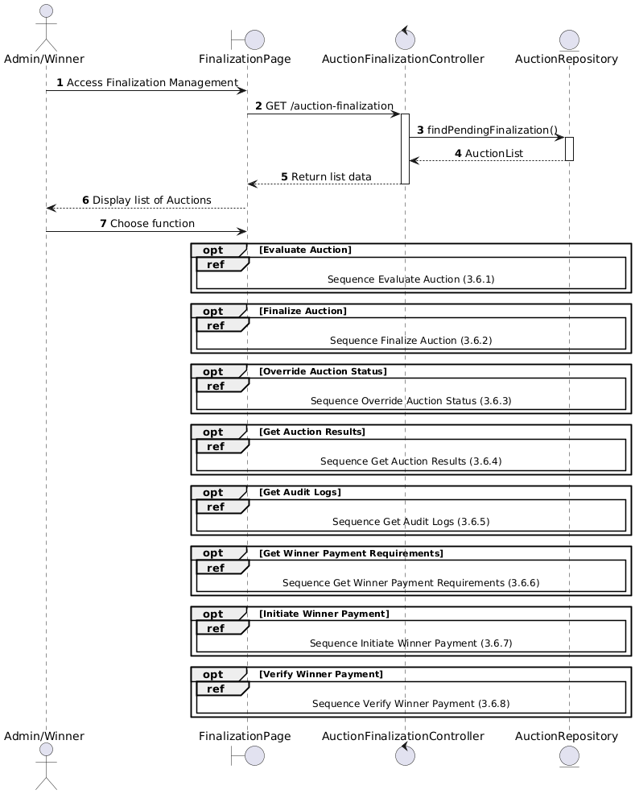

Activities Flow

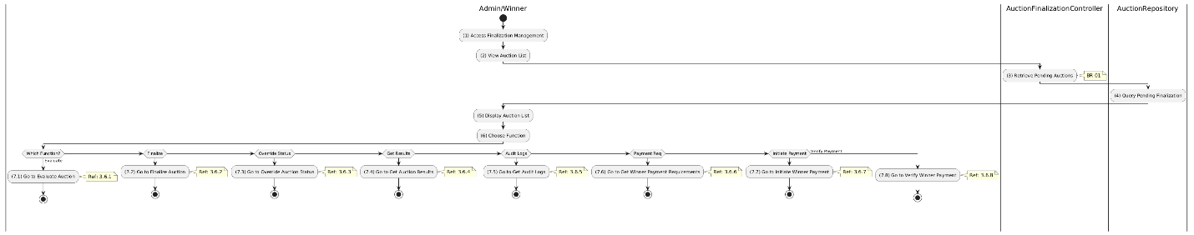

Business Rules
Activity | BR Code | Description
(5) | BR-01 | - Displaying Rule:  The system displays an "Auction Finalization Management" screen. (Refer to "Auction Finalization Management" view in "View Description" file).
(6) | BR-02 | - Choosing Rule:  Admin can only choose one feature at a time to use.

Auction Evaluation Use Case

Use Case Description
Name | Evaluate Auction
Description | This use case allows the Admin to search Auction Evaluation information in the system based on input keywords.
Actor | Admin
Trigger | - When Admin clicks on the 'Evaluate' button on the AuctionEvaluationPage screen.
Pre-condition | - • Admin's device must be connected to the internet.  • Admin is signed in with their account.
Post-condition | - The Auction Evaluation information will be displayed on the AuctionEvaluationPage screen.

Sequence Flow

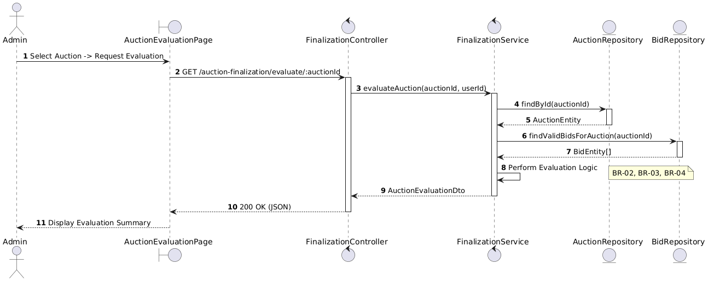

Activities Flow

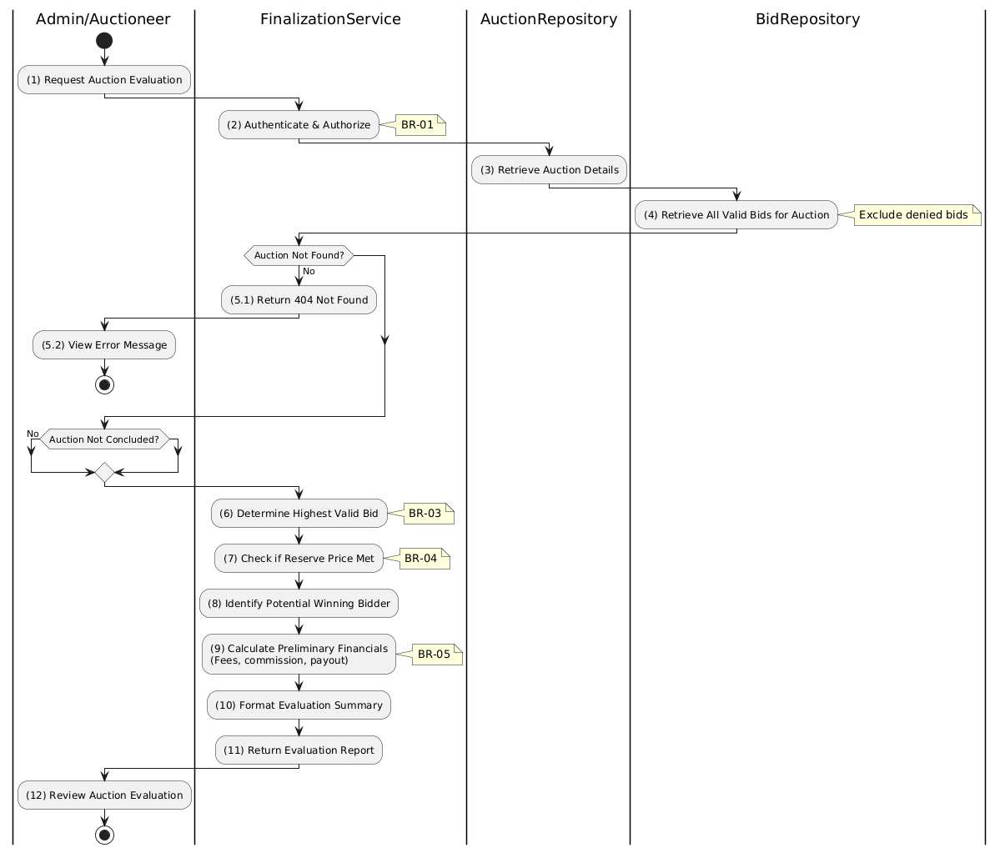

Business Rules
Activity | BR Code | Description
(1) | BR-01 | - Displaying Rule (Auction Evaluation Page):  When Admin selects an auction for evaluation, system displays AuctionEvaluationPage.  System displays auction details, bid summary, and "Get Evaluation" button.
(2) | BR-02 | - Validation Rule (Authorization - Back-end):  System checks if requestor role is admin or auctioneer in USERS table.  If unauthorized:  $→$ System displays MSG 5 ("Forbidden") on the View.
(3) | BR-03 | - Querying Rule (Auction Data):  System retrieves data from the 'AUCTION' table in the database (Refer to 'AUCTION' table in 'DB Sheet' file) based on the auction ID.  If auction not found:  $→$ System displays MSG 20 ("Auction not found") on the View.  System verifies auction has concluded or is near conclusion.
(4) | BR-04 | - Querying Rule (Valid Bids):  System retrieves data from the 'AUCTION_BID' table in the database (Refer to 'AUCTION_BID' table in 'DB Sheet' file) based on the auction ID where bids are not denied.  Excludes bids from ineligible participants.
(6)-(9) | BR-05 | - Processing Rule (Evaluation Calculation):  System determines highest valid bid from query results.  System checks if highest bid meets or exceeds reservePrice.  System calculates: platform commission, estimated payout, associated fees.
(12) | BR-06 | - Displaying Rule (Evaluation Summary):  System displays evaluation report showing:  - Highest valid bid amount  - Potential winner (masked identifier)  - Reserve price status (Met/Not Met)  - Financial summary (commission, fees, payout).

Auction Finalization Use Case

Use Case Description
Name | Finalize Auction
Description | This use case allows the Admin to update existing Auction information in the system.
Actor | Admin
Trigger | - When the Admin clicks on the 'Finalize Auction' button on the FinalizationPage.
Pre-condition | - • Admin's device must be connected to the internet.  • Admin is signed in with their account.
Post-condition | - The Auction information will be updated in the system and display finalized status on FinalizationPage datagrid.

Sequence Flow

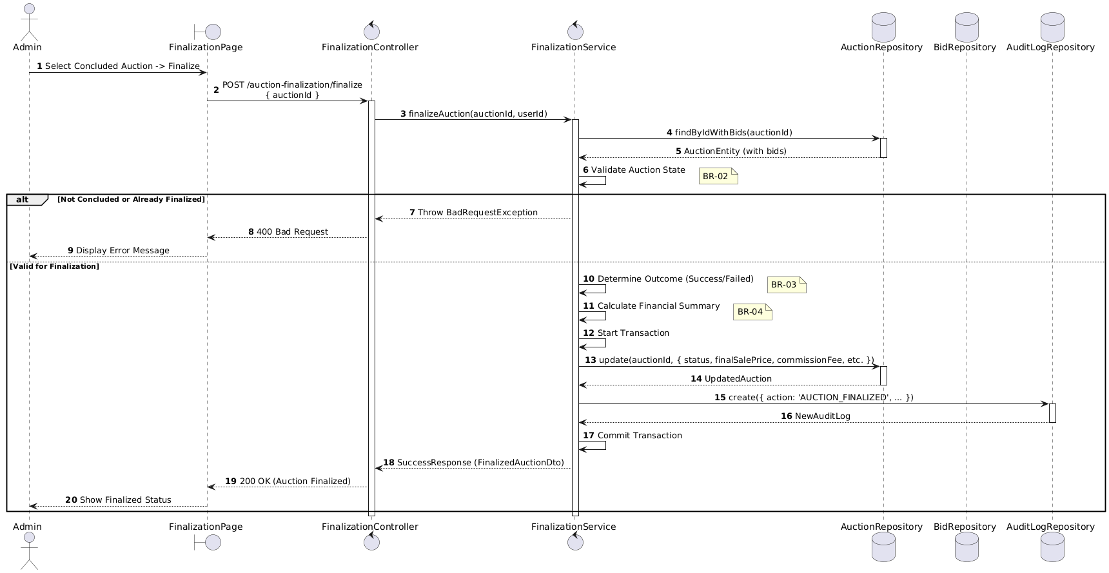

Activities Flow

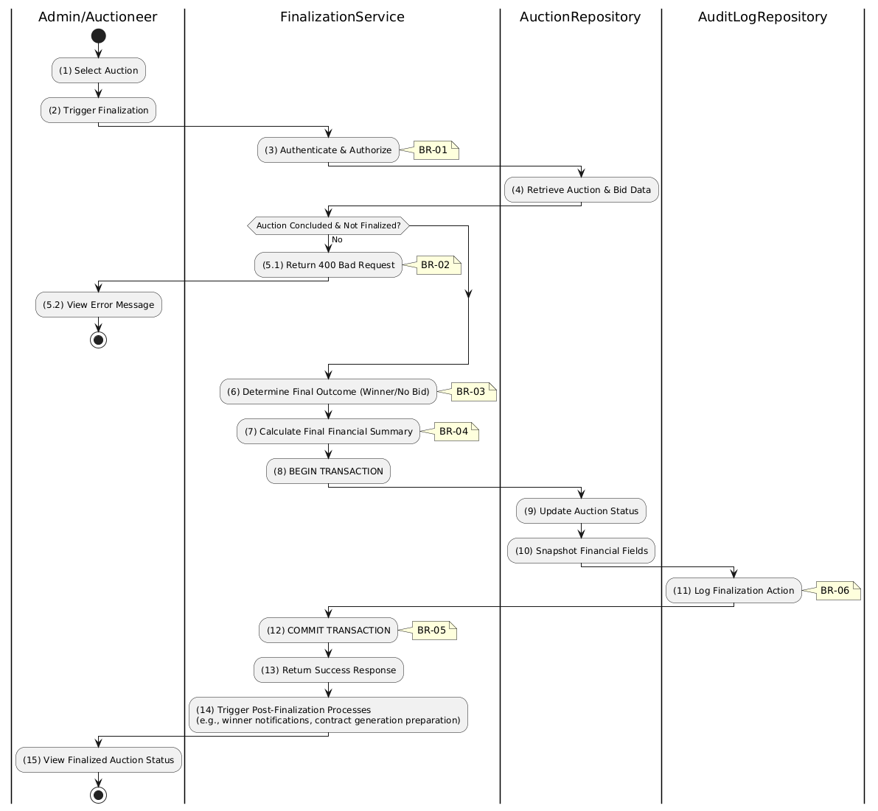

Business Rules
Activity | BR Code | Description
(1)-(2) | BR-01 | - Displaying Rule (Finalization Page):  When Admin selects a concluded auction, system displays FinalizationPage.  System displays evaluation summary and "Finalize Auction" button.  System shows current status and end time.
(2) | BR-02 | - Validation Rule (Confirmation - Front-end):  When Admin clicks "Finalize Auction", system displays MSG 11 ("Confirm auction finalization? This action is irreversible.").  System waits for confirmation before proceeding.
(3) | BR-03 | - Validation Rule (Authorization - Back-end):  System checks if requestor role is admin or auctioneer in USERS table.  If unauthorized:  $→$ System displays MSG 5 ("Forbidden") on the View.
(5.1) | BR-04 | - Validation Rule (Auction State - Back-end):  System checks if auctionEndAt has passed AND status is NOT already success or failed.  If invalid state:  $→$ System displays MSG 25 ("Cannot finalize - invalid auction state") on the View.
(6) | BR-05 | - Processing Rule (Outcome Determination):  System determines final status based on highest valid bid vs reservePrice:  - If bid >= reservePrice: status = success  - Otherwise: status = failed.
(9)-(10) | BR-06 | - Storing Rule:  System saves to AUCTION table:  - status = [success/failed]  - finalSalePrice = [highest bid amount]  - commissionFee = [calculated fee]  - finalizedAt = now()
(11) | BR-07 | - Storing Rule (Audit Log):  System creates record in AUCTION_AUDIT_LOG table:  - action = 'AUCTION_FINALIZED'  - adminId = [current user]  - createdAt = now()
(15) | BR-08 | - Displaying Rule (Success Confirmation):  System displays MSG 7 ("Auction finalized successfully") on the View.  System updates status display to final outcome.

Auction Status Override Use Case

Use Case Description
Name | Override Auction Status
Description | This use case allows the Admin to override an Auction's status in the system. This is a "break-glass" feature for correcting errors (e.g., accidentally setting an auction live too early, or reverting a cancellation).
Actor | Admin, Super Admin
Trigger | - When the Admin selects "Override Status" in the management dashboard, selects a new status, and submits POST /auction-finalization/override.
Pre-condition | - • Admin's device must be connected to the internet.  • Admin is signed in with their account and has admin or super_admin role.
Post-condition | - The Auction's status is updated to the manually specified value and an STATUS_OVERRIDE audit log entry is created in the system.

Sequence Flow

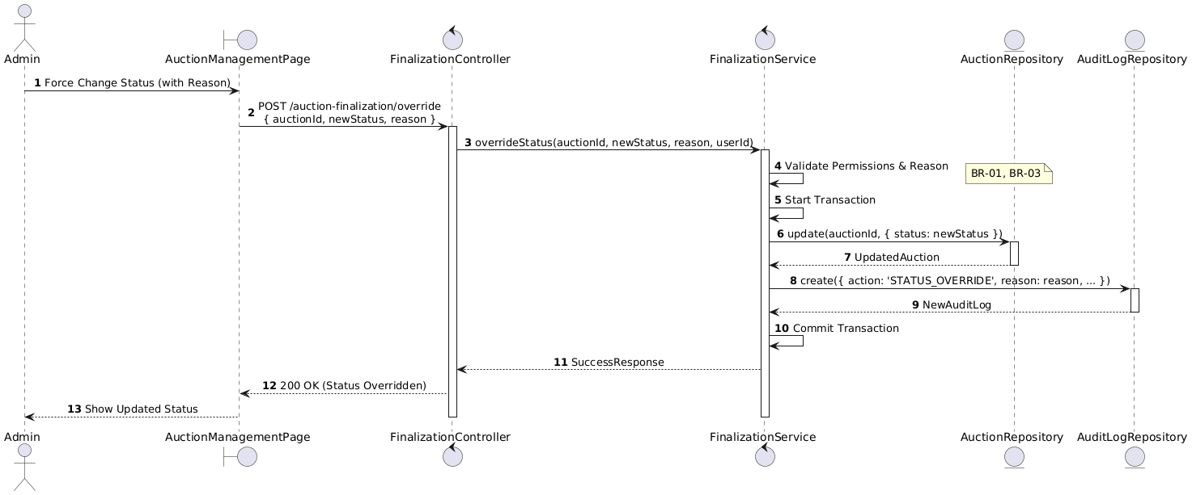

Activities Flow

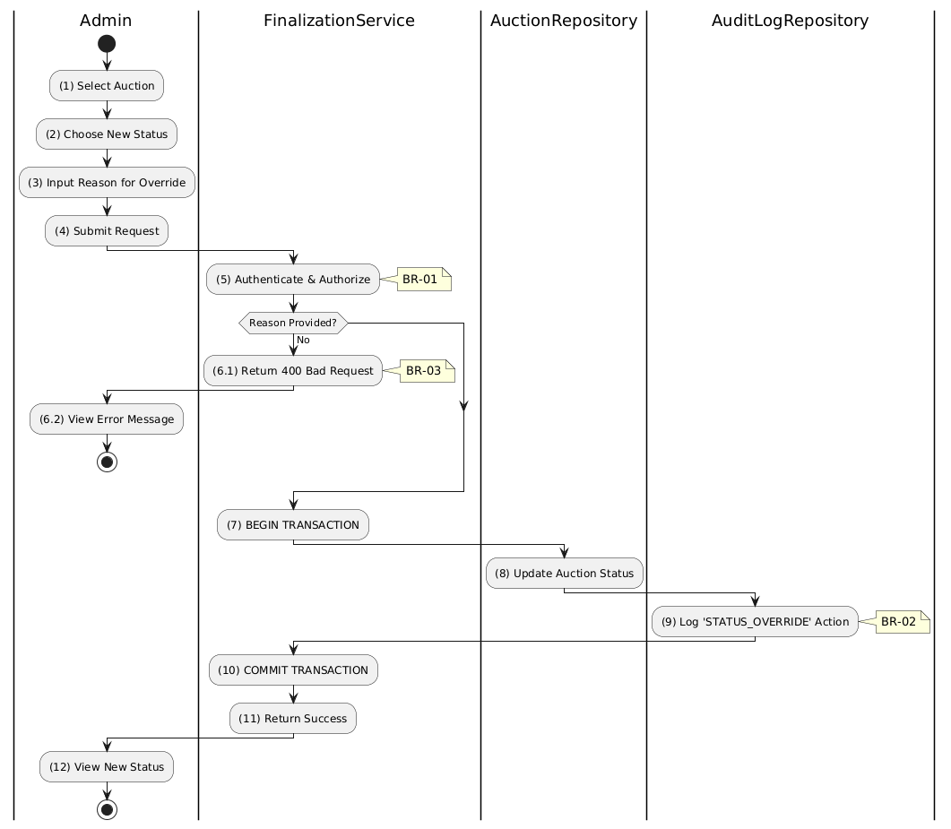

Business Rules
Activity | BR Code | Description
(1)-(2) | BR-01 | - Displaying Rule (Auction Management Page):  When Admin selects "Override Status", system displays status override modal/form.  System displays dropdown with available status options.  System displays mandatory reason text input field.
(3) | BR-02 | - Validation Rule (Input - Front-end):  When Admin selects new status, system uses Selection_change() method.  When Admin enters override reason, system uses Text_change() method.  If isEmpty(reason):  $→$ System displays MSG 1 ("Reason is mandatory").
(4) | BR-03 | - Validation Rule (Confirmation - Front-end):  On submit, system displays MSG 11 ("Are you sure you want to override status? This is an administrative action.").  System waits for confirmation.
(5) | BR-04 | - Validation Rule (Authorization - Back-end):  System checks if requestor role is admin or super_admin in USERS table.  Only privileged users can execute this "break-glass" function.  If unauthorized:  $→$ System displays MSG 5 ("Forbidden") on the View.
(8) | BR-05 | - Storing Rule:  System saves to AUCTION table:  - status = [selected new status]
(9) | BR-06 | - Storing Rule (Audit Log - Mandatory):  System creates record in AUCTION_AUDIT_LOG table:  - action = 'STATUS_OVERRIDE'  - reason = [input reason]  - adminId = [current user]  - previousStatus = [old status]  - newStatus = [new status]
(12) | BR-07 | - Displaying Rule (Success Confirmation):  System displays MSG 7 ("Status override applied successfully") on the View.  System refreshes auction status display.

Get Auction Audit Logs Use Case

Use Case Description
Name | Get Audit Logs
Description | This use case allows the Admin to search for Audit Logs in the system. This includes status overrides, bid denials, registration approvals/rejections, and finalization events, ensuring accountability and traceability.
Actor | Admin, Auctioneer
Trigger | - When the Admin navigates to the "Audit Log" tab of an auction
Pre-condition | - • Admin's device must be connected to the internet.  • Admin is signed in with their account and has admin or auctioneer role.
Post-condition | - The Audit Logs information will be retrieved and displayed to the Admin in the system, sorted by timestamp (newest first).

Sequence Flow

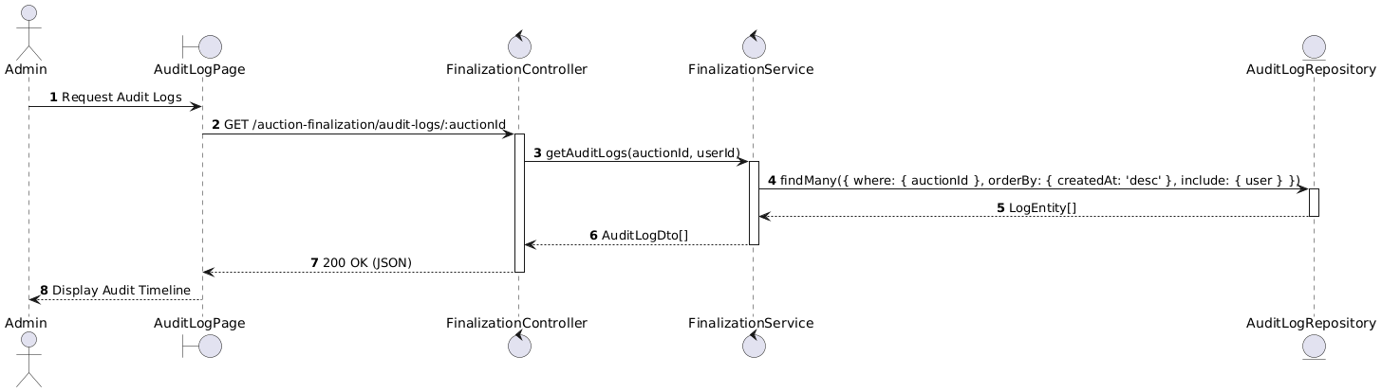

Activities Flow

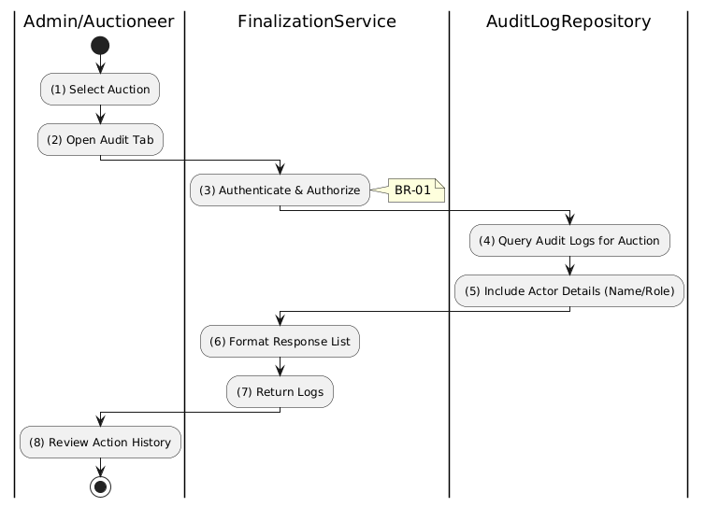

Business Rules
Activity | BR Code | Description
(1)-(2) | BR-01 | - Displaying Rule (Audit Log Page):  When Admin opens Audit tab for an auction, system displays AuditLogPage.  System shows loading indicator while fetching logs.
(3) | BR-02 | - Validation Rule (Authorization - Back-end):  System checks if requestor role is admin or auctioneer in USERS table.  If unauthorized:  $→$ System displays MSG 5 ("Forbidden") on the View.
(4)-(5) | BR-03 | - Querying Rule:  System retrieves data from the 'AUCTION_AUDIT_LOG' table in the database (Refer to 'AUCTION_AUDIT_LOG' table in 'DB Sheet' file) based on the auction ID.  System orders results by creation date (newest first).  System retrieves related User information to display admin names.
(4) | BR-04 | - Processing Rule (Immutability):  Audit logs are read-only records.  No API endpoints exist to modify or delete log entries.  Preserves data integrity for accountability.
(8) | BR-05 | - Displaying Rule (Audit Timeline):  System displays chronological list of audit entries showing:  - Action type (STATUS_OVERRIDE, AUCTION_FINALIZED, etc.)  - Actor name and role  - Timestamp  - Reason (if applicable).

Get Auction Results Use Case

Use Case Description
Name | Get Auction Results
Description | This use case allows the User to search for Auction Results in the system. This includes the final sale price, the winning bidder (anonymized), and the total number of bids.
Actor | All Authenticated Users (Participants, Guests)
Trigger | - When the User navigates to a "Results" page
Pre-condition | - • User's device must be connected to the internet.  • User is signed in with their account.
Post-condition | - The Auction Results information will be retrieved and displayed to the User in the system.

Sequence Flow

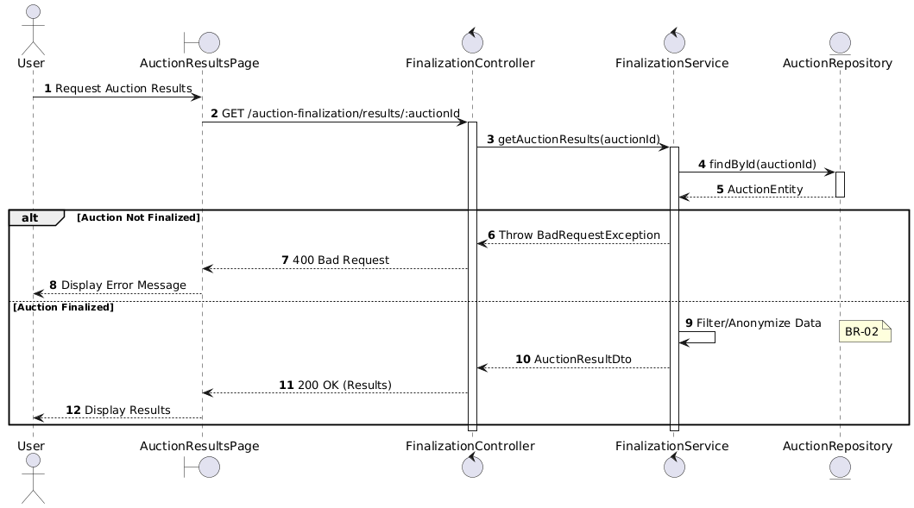

Activities Flow

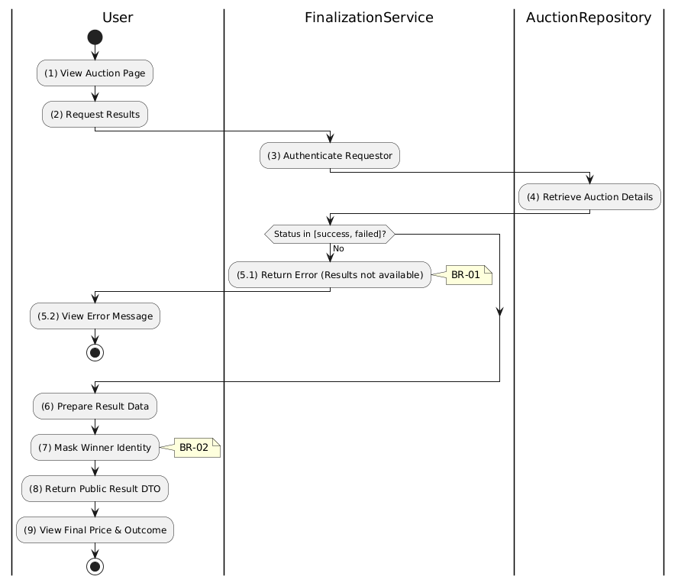

Business Rules
Activity | BR Code | Description
(1)-(2) | BR-01 | - Displaying Rule (Auction Results Page):  When user navigates to auction results, system displays AuctionResultsPage.  System shows loading state while fetching results.
(3) | BR-02 | - Validation Rule (Authentication - Back-end):  System verifies user is authenticated.  Results page accessible to all authenticated users.
(4) | BR-03 | - Querying Rule:  System retrieves data from the 'AUCTION' table in the database (Refer to 'AUCTION' table in 'DB Sheet' file) based on the auction ID to get auction details.  If auction not found:  $→$ System displays MSG 20 ("Auction not found") on the View.
(5.1) | BR-04 | - Validation Rule (Status Check - Back-end):  System checks if status is in terminal states: success or failed.  If not finalized:  $→$ System displays MSG 26 ("Results not yet available") on the View.
(7) | BR-05 | - Processing Rule (Privacy - Anonymization):  System masks winning bidder identity in public results.  Display format: "Bidder ***123" instead of full name/email.  Protects participant privacy.
(9) | BR-06 | - Displaying Rule (Results Display):  System displays auction results showing:  - Final sale price (or "No winning bid" if failed)  - Outcome status badge (Success/Failed)  - Winner identifier (masked)  - Total number of bids placed.

Get Winner Payment Requirements Use Case

Use Case Description
Name | Get Winner Payment Requirements
Description | This use case allows the Winner to search for Payment Requirements in the system. This includes the final amount due, payment methods, and deadlines.
Actor | Winner (Bidder)
Trigger | - When the Winner navigates to the details page of an auction they won, triggering GET /auction-finalization/winner-payment-requirements/:auctionId.
Pre-condition | - • Winner's device must be connected to the internet.  • Winner is signed in with their account and is the confirmed winning bidder for the auction.
Post-condition | - The Payment Requirements information (payment amount, available payment methods, and payment instructions/deadlines) will be retrieved and displayed to the Winner in the system.

Sequence Flow

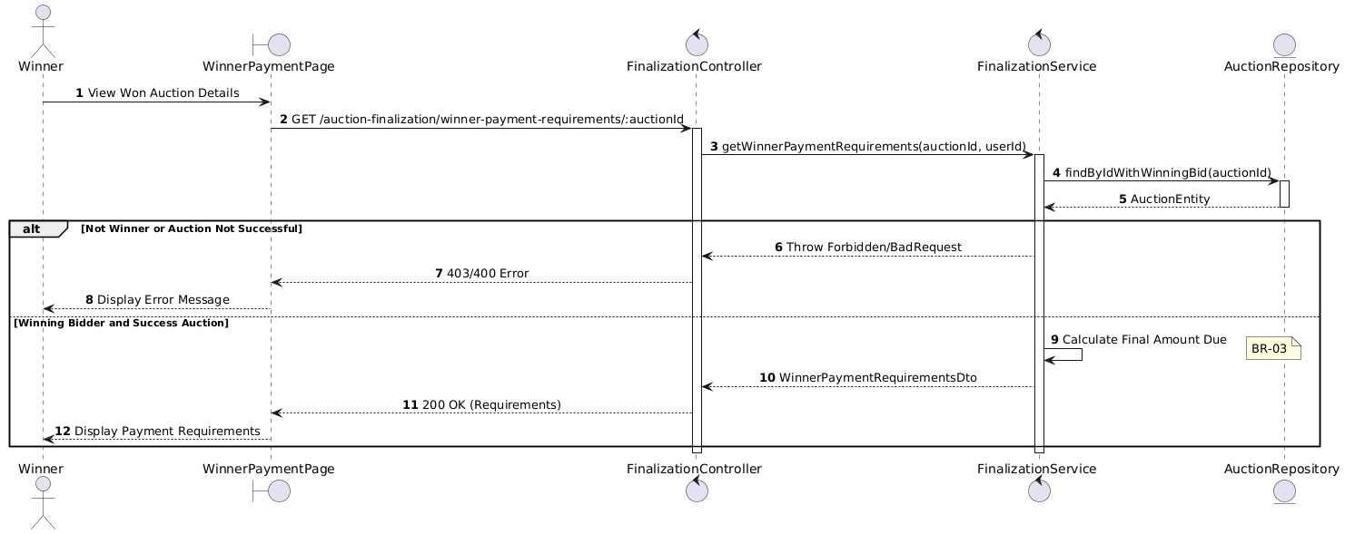

Activities Flow

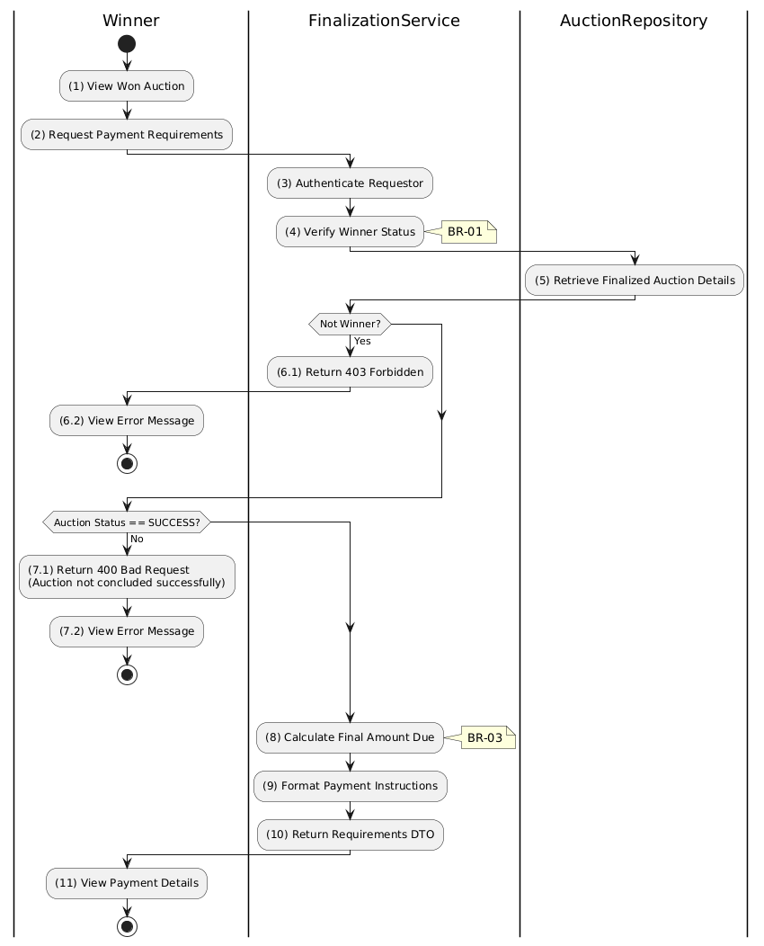

Business Rules
Activity | BR Code | Description
(1)-(2) | BR-01 | - Displaying Rule (Winner Payment Page):  When Winner views their won auction, system displays WinnerPaymentPage.  System shows loading state while fetching payment requirements.
(3)-(4) | BR-02 | - Validation Rule (Winner-Only Access - Back-end):  System verifies authenticated user is the winningBidderId in AUCTION table.  If not the winner:  $→$ System displays MSG 5 ("Forbidden - Not the winning bidder") on the View.
(7.1) | BR-03 | - Validation Rule (Auction Status - Back-end):  System checks if auction status = 'success'.  If not successful auction:  $→$ System displays MSG 26 ("Payment requirements not available") on the View.
(8) | BR-04 | Processing Rule (Balance Calculation):  System calculates final amount due:  $finalAmountDue=finalSalePrice+applicableFees-depositAmountSnapshot$  - Ensures accurate billing excluding already-paid deposit.
(9) | BR-05 | - Processing Rule (Payment Deadline):  System calculates payment deadline based on configuration.  Default: 7 days from finalizedAt timestamp.
(11) | BR-06 | - Displaying Rule (Payment Requirements Display):  System displays payment details showing:  - Final amount due  - Breakdown (sale price, fees, deposit credit)  - Payment deadline  - Available payment methods (Stripe).

Initiate Winner Payment Use Case

Use Case Description
Name | Initiate Winner Payment
Description | This use case allows the Winner to create a Payment Session in the system. This generates a payment session (via Stripe) for the calculated balance.
Actor | Winner (Bidder)
Trigger | - When the Winner clicks "Pay Final Amount" on the auction result page
Pre-condition | - • Winner's device must be connected to the internet.  • Winner is signed in with their account and is the confirmed winning bidder for the auction.
Post-condition | - A Payment record of type winning_payment is created with status pending, a Stripe Checkout Session is created, and the Winner receives the checkout URL in the system.

Sequence Flow

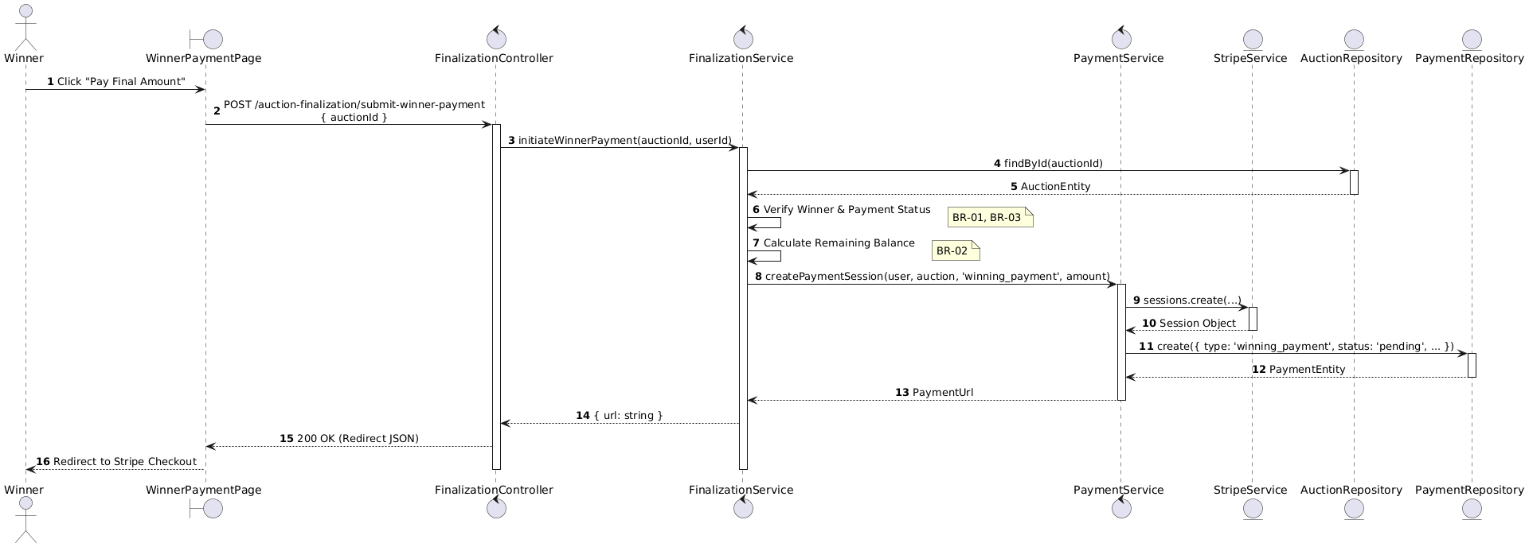

Activities Flow

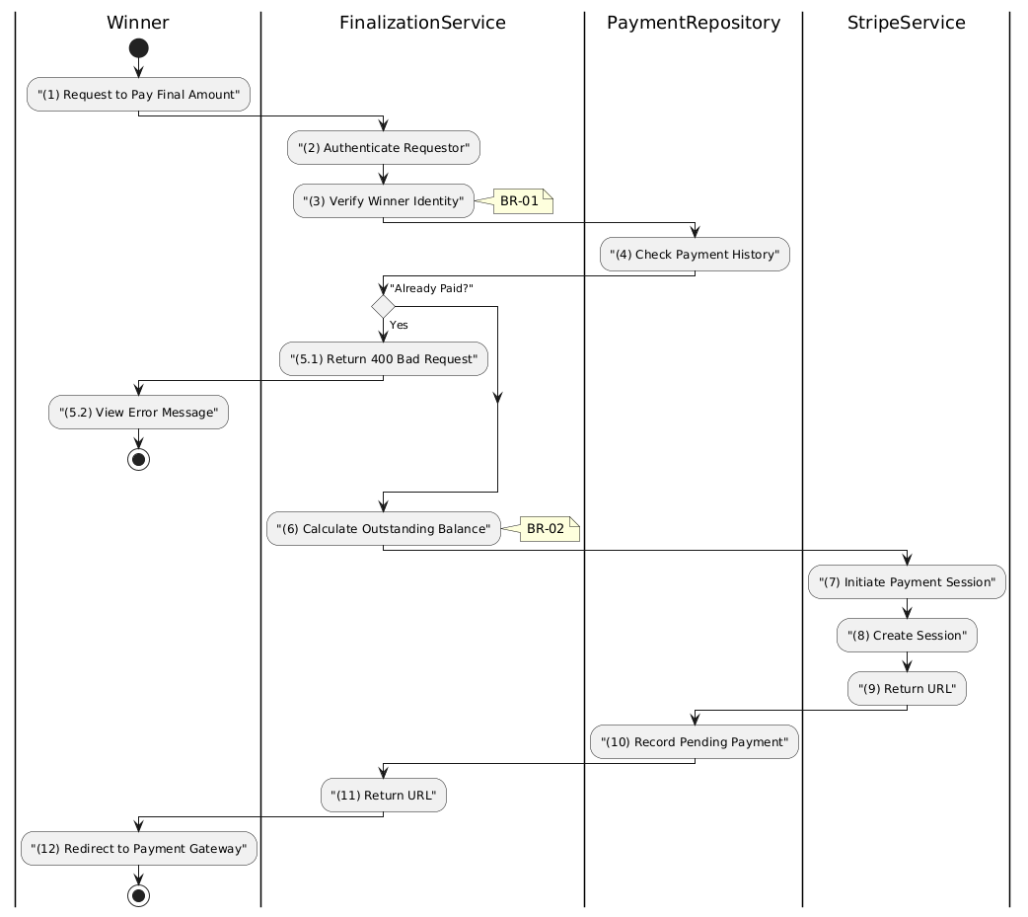

Business Rules
Activity | BR Code | Description
(1) | BR-01 | - Displaying Rule (Winner Payment Page):  When Winner views payment requirements, system displays "Pay Final Amount" button.  Button is enabled only if payment not yet completed.
(1) | BR-02 | - Validation Rule (Confirmation - Front-end):  When Winner clicks "Pay Final Amount", system displays MSG 11 ("Proceed to payment for [amount]?").  System waits for confirmation before redirecting.
(2)-(3) | BR-03 | - Validation Rule (Winner-Only Access - Back-end):  System verifies authenticated user is the winningBidderId in AUCTION table.  If not the winner:  $→$ System displays MSG 5 ("Forbidden") on the View.
(4)-(5.1) | BR-04 | - Validation Rule (Duplicate Prevention - Back-end):  System retrieves data from the 'PAYMENT' table in the database (Refer to 'PAYMENT' table in 'DB Sheet' file) to check for existing completed winning payment.  If already paid:  $→$ System displays MSG 16 ("Payment already completed") on the View.
(6) | BR-05 | Processing Rule (Balance Calculation):  System calculates outstanding balance:  $balance=finalSalePrice+fees-depositAmountSnapshot$  - This is the amount to charge via Stripe.
(7)-(9) | BR-06 | - Processing Rule (Stripe Session):  System creates Stripe Checkout Session with calculated amount.  System includes success/cancel redirect URLs.
(10) | BR-07 | - Storing Rule:  System creates record in PAYMENT table:  - type = 'winning_payment'  - status = 'pending'  - sessionId = [Stripe session ID]  - amount = [calculated balance]
(12) | BR-08 | - Displaying Rule (Redirect):  System redirects Winner to Stripe Checkout URL.  Winner completes payment on Stripe's hosted page.

Verify Winner Payment Use Case

Use Case Description
Name | Verify Winner Payment
Description | This use case allows the System to update Payment status in the system. This involves checking the status with the payment gateway (Stripe) and, upon successful verification, updates the relevant payment records and marks the auction as fully paid.
Actor | Winner, Admin
Trigger | - When the Winner is redirected back from Stripe to the application (triggering a client-side call to POST /auction-finalization/verify-winner-payment) or a Stripe webhook notifies the backend.
Pre-condition | - • Winner's device must be connected to the internet.  • A winning_payment session was successfully initiated and Payment has been completed on Stripe.
Post-condition | - The Payment record's status is updated to completed and the Winner is granted access to the asset transfer process in the system.

Sequence Flow

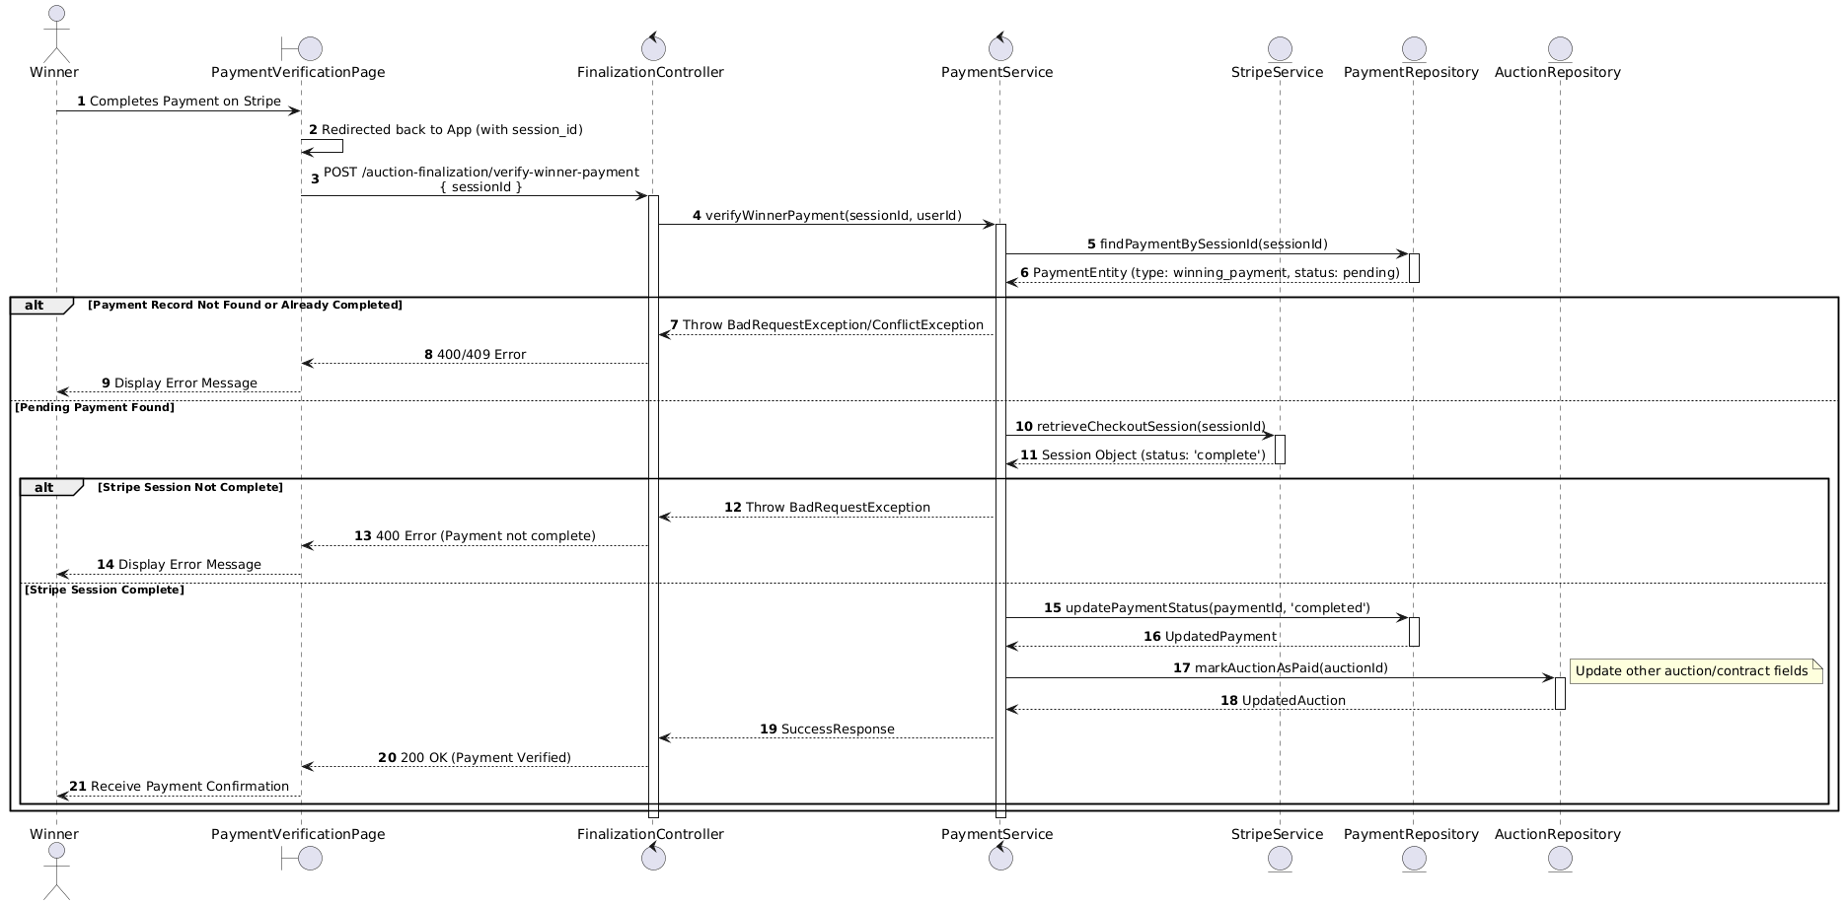

Activities Flow

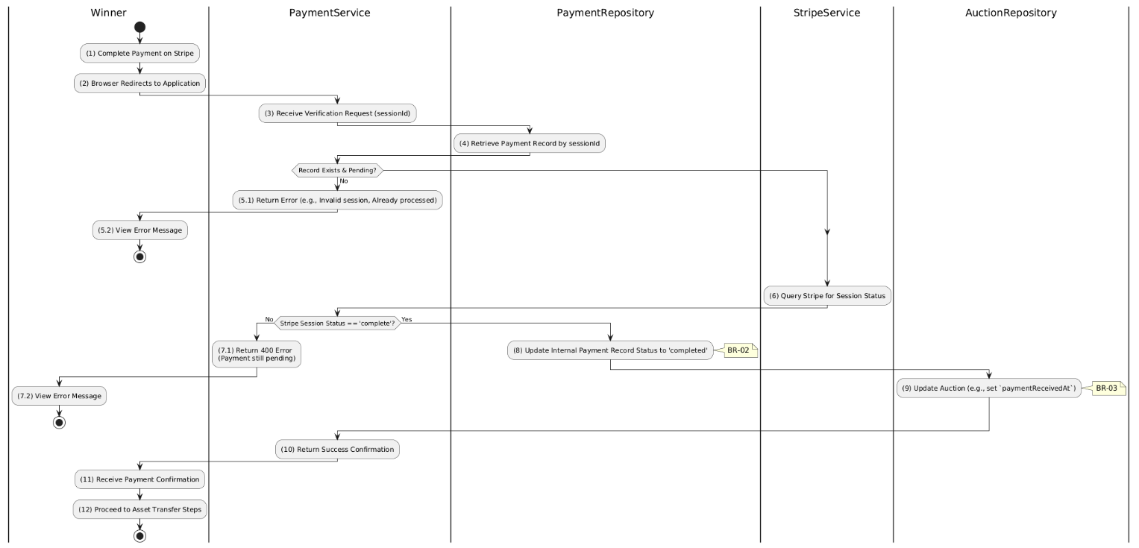

Business Rules
Activity | BR Code | Description
(1)-(2) | BR-01 | - Displaying Rule (Payment Verification Page):  When Winner is redirected back from Stripe, system displays PaymentVerificationPage.  System shows loading indicator while verifying payment.
(4)-(5.1) | BR-02 | - Validation Rule (Record Lookup - Back-end):  System retrieves data from the 'PAYMENT' table in the database (Refer to 'PAYMENT' table in 'DB Sheet' file) based on the session ID to find payment record.  If record not found or already completed:  $→$ System displays MSG 9 ("Payment verification failed") or returns success (idempotent).
(6) | BR-03 | - Validation Rule (Stripe Confirmation - Back-end):  System queries Stripe API to confirm session status is complete.  If Stripe session not complete:  $→$ System displays MSG 9 ("Payment not yet confirmed by gateway") on the View.
(6) | BR-04 | - Validation Rule (Amount Matching - Back-end):  System verifies amount_total from Stripe matches expected final payment amount.  If mismatch:  $→$ System flags for manual intervention and logs discrepancy.
(8) | BR-05 | - Storing Rule (Payment Status):  System updates PAYMENT table:  - status = 'completed'  - completedAt = now()
(9) | BR-06 | - Storing Rule (Auction Update):  System updates AUCTION table:  - paymentReceivedAt = now()  Winner now eligible for asset transfer process.
(11)-(12) | BR-07 | - Displaying Rule (Success Confirmation):  System displays MSG 7 ("Payment verified successfully") on the View.  System displays next steps for asset transfer/collection.  System shows payment receipt summary.

Manage Auction Costs Use Case

Manage Auction Cost Use Case

Use Case Description
Name | Manage Auction Cost
Description | This use case allows the Admin to choose one of the corresponding functions of CRUD to adjust Auction Cost information in the system.
Actor | Admin, Auctioneer
Trigger | - When the Admin clicks on the "Auction Cost" button on the navigation sidebar.
Pre-condition | - 1. Admin's device must be connected to the internet.  2. Admin is signed in with their account.
Post-condition | - The Auction Cost information is updated to the corresponding function that the Admin executes.

Sequence Flow

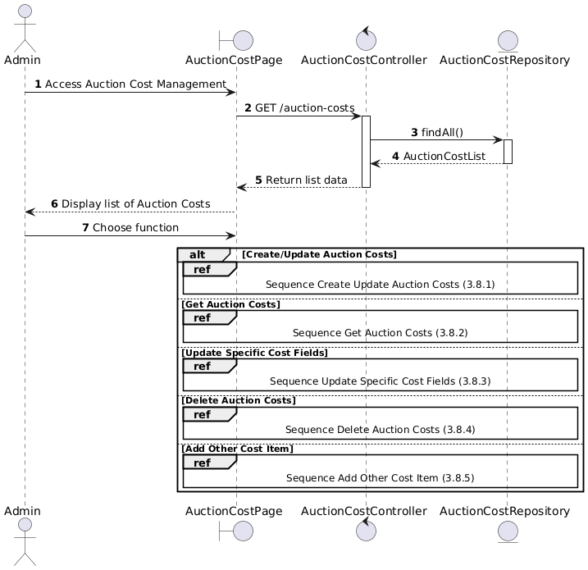

Activities Flow

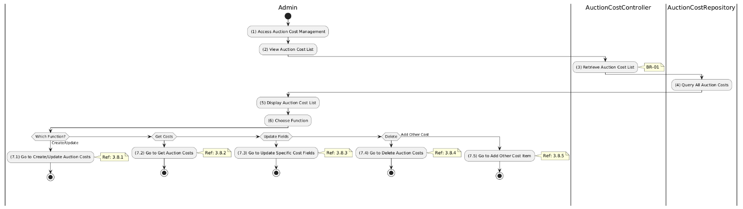

Business Rules
Activity | BR Code | Description
(5) | BR-01 | - Displaying Rule:  The system displays an "Auction Cost Management" screen. (Refer to "Auction Cost Management" view in "View Description" file).
(6) | BR-02 | - Choosing Rule:  Admin can only choose one feature at a time to use.

Create/Update Auction Cost Use Case

Use Case Description
Name | Create/Update Auction Costs
Description | This use case allows the Admin to create a new or update existing Auction Costs information in the system.
Actor | Admin
Trigger | - When the Admin clicks on the 'Save Costs' button on the AuctionCostPage.
Pre-condition | - • Admin's device must be connected to the internet.  • Admin is signed in with their account.
Post-condition | - The Auction Costs information will be stored into the system and display updated record on AuctionCostPage datagrid.

Sequence Flow

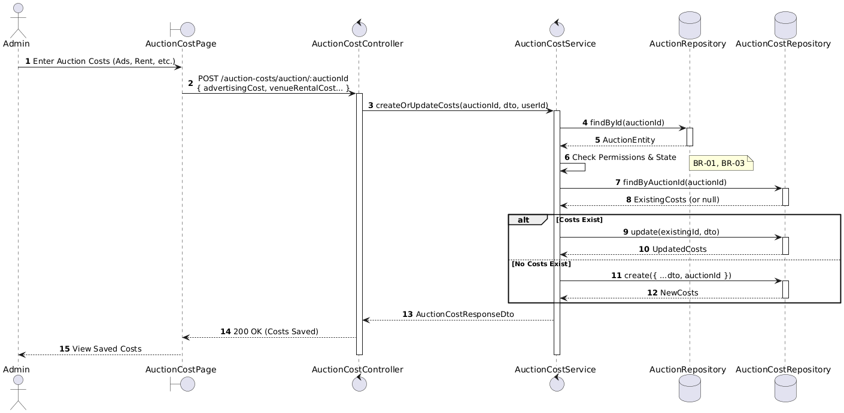

Activities Flow

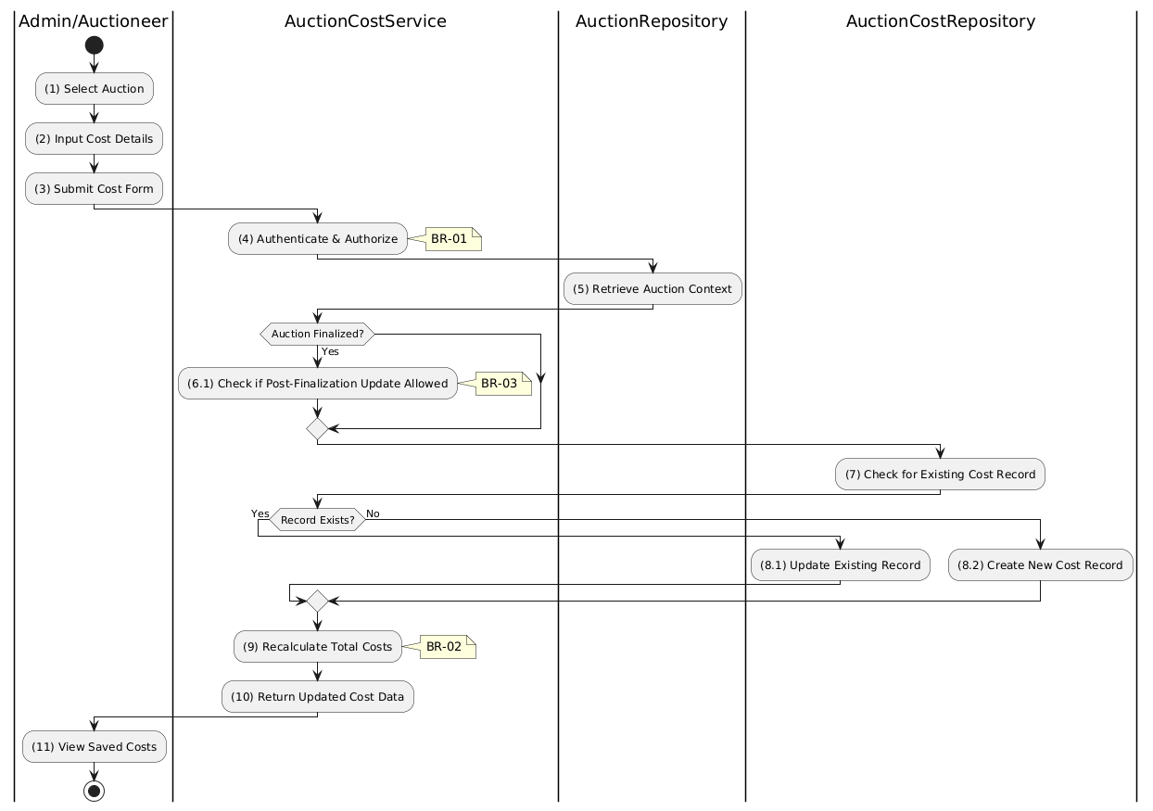

Business Rules
Activity | BR Code | Description
(1) | BR-01 | - Displaying Rule (Auction Cost Page):  When Admin/Auctioneer selects an auction for cost management, system displays AuctionCostPage.  If costs exist, fields are pre-populated with existing values.
(2) | BR-02 | - Validation Rule (Input Fields - Front-end):  When Admin inputs cost values, system triggers Text_change() validation.  All cost fields must be non-negative numbers.  If invalid:  $→$ System displays MSG 4 ("Invalid cost value") adjacent to field.
(4) | BR-03 | - Validation Rule (Authorization - Back-end):  System checks if requestor role is admin or auctioneer in USERS table.  If unauthorized:  $→$ System displays MSG 5 ("Forbidden") on the View.
(6.1) | BR-04 | - Validation Rule (Auction Status - Back-end):  System checks if auction is finalized.  Updates generally allowed only for non-finalized auctions.  Policy may permit post-finalization corrections.
(7)-(8.2) | BR-05 | - Querying/Storing Rule (Upsert Logic):  System retrieves data from the 'AUCTION_COST' table in the database (Refer to 'AUCTION_COST' table in 'DB Sheet' file) based on the auction ID to check for existing record.  If exists: The cost data will be updated in the existing record.  If not exists: The cost data will be stored as a new record.
(9) | BR-06 | Processing Rule (Total Calculation):  System automatically calculates totalCosts field:  $totalCosts=advertisingCost+venueRentalCost+appraisalCost+...$
(11) | BR-07 | - Displaying Rule (Confirmation):  System displays MSG 7 ("Auction costs saved successfully") on the View.  System displays updated cost breakdown with calculated total.

Get Auction Cost Use Case

Use Case Description
Name | Get Auction Costs
Description | This use case allows the User to search Auction Costs information in the system based on input keywords.
Actor | User
Trigger | - When User clicks on the 'View Costs' button on the AuctionDetailPage screen.
Pre-condition | - • User's device must be connected to the internet.  • User is signed in with their account.
Post-condition | - The Auction Costs details will be displayed on the AuctionCostSummaryPage screen.

Sequence Flow

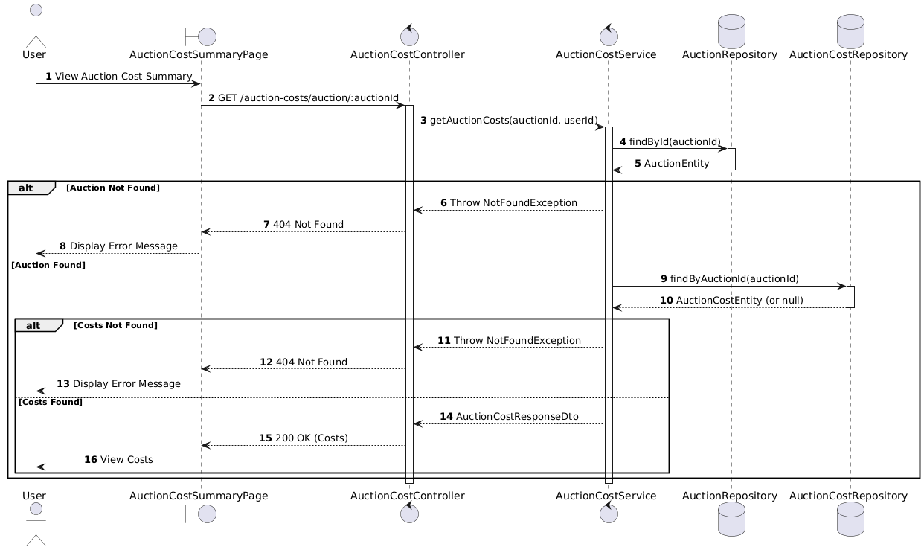

Activities Flow

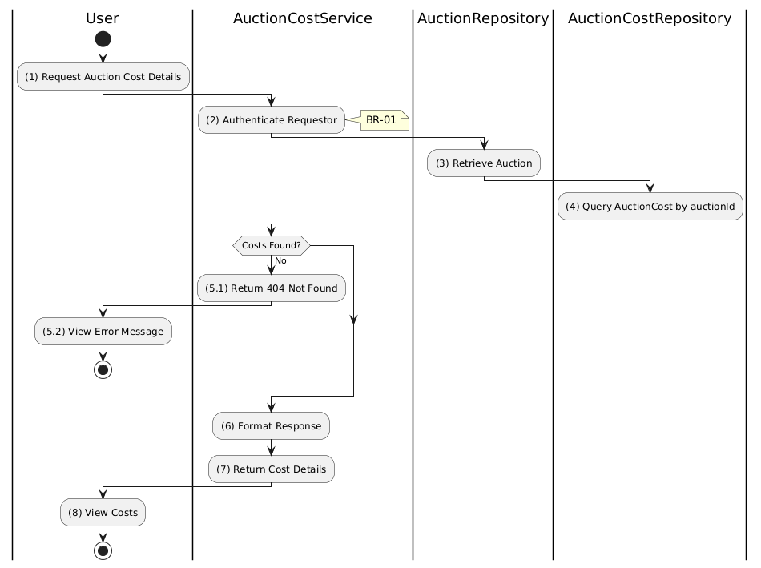

Business Rules
Activity | BR Code | Description
(1) | BR-01 | - Displaying Rule (Auction Cost Summary Page):  When User navigates to auction cost summary, system displays AuctionCostSummaryPage.  System shows loading indicator while fetching cost data.
(2) | BR-02 | - Validation Rule (Authentication - Back-end):  System verifies requestor is authenticated.  If not authenticated:  $→$ System displays MSG 5 ("Authentication required") on the View.
(3) | BR-03 | - Validation Rule (Auction Existence - Back-end):  System retrieves data from the 'AUCTION' table in the database (Refer to 'AUCTION' table in 'DB Sheet' file) based on the auction ID to verify it exists.  If not found:  $→$ System displays MSG 20 ("Auction not found") on the View.
(4)-(5.1) | BR-04 | - Querying Rule:  System retrieves data from the 'AUCTION_COST' table in the database (Refer to 'AUCTION_COST' table in 'DB Sheet' file) based on the auction ID.  If no cost record found:  $→$ System displays MSG 20 ("Costs not recorded for this auction") on the View.
(8) | BR-05 | - Displaying Rule (Cost Breakdown):  System displays cost details showing:  - Individual cost categories (advertising, venue, appraisal, etc.)  - Other costs list (description and amount for each)  - Calculated total costs.

Update Specific Auction Cost Use Case

Use Case Description
Name | Update Specific Cost Fields
Description | This use case allows the Admin to update existing Auction Costs information in the system.
Actor | Admin
Trigger | - When the Admin clicks on the [Icon Edit] button on the right of each item on the EditAuctionCostPage datagrid.
Pre-condition | - • Admin's device must be connected to the internet.  • Admin is signed in with their account.
Post-condition | - The Auction Costs information will be updated in the system and display new record on AuctionCostPage datagrid.

Sequence Flow

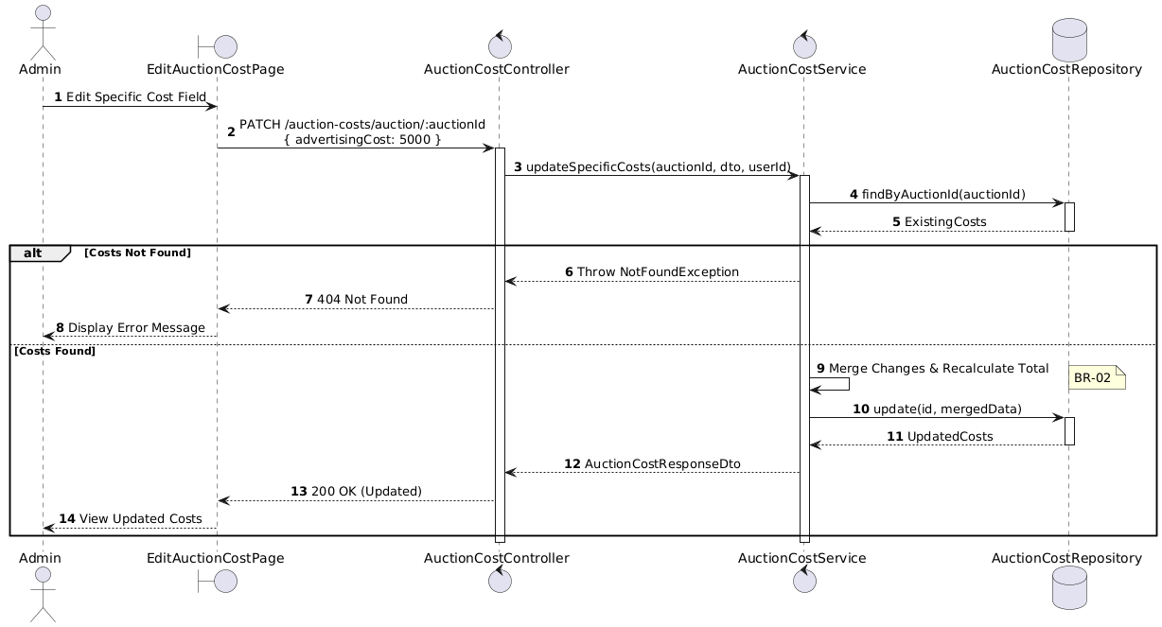

Activities Flow

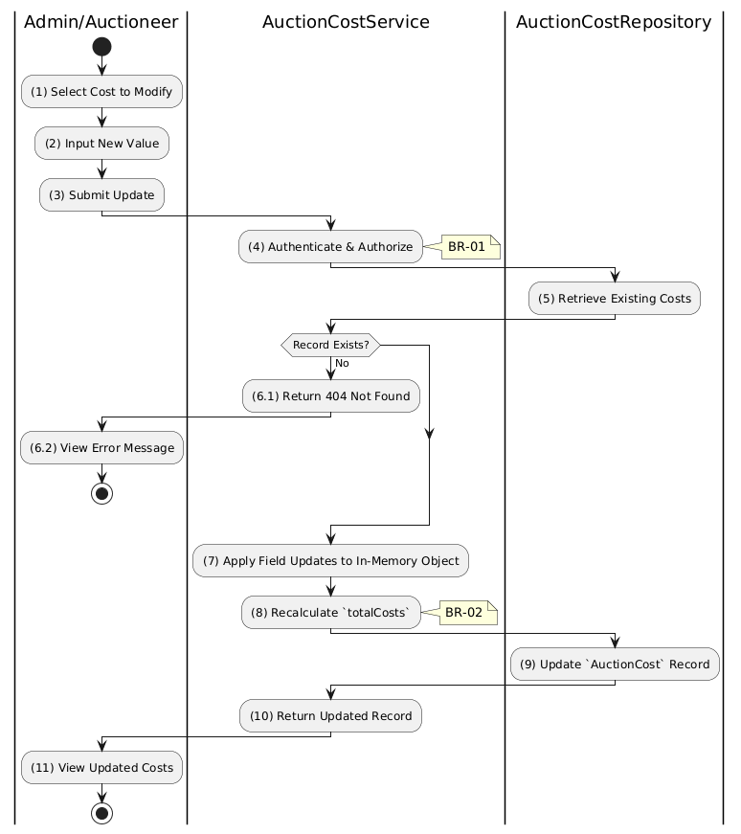

Business Rules
Activity | BR Code | Description
(1) | BR-01 | - Displaying Rule (Edit Auction Cost Page):  When Admin/Auctioneer selects a cost field to modify, system displays EditAuctionCostPage.  System pre-populates current value in the editable field.
(2) | BR-02 | - Validation Rule (Input Field - Front-end):  When Admin inputs new cost value, system triggers Text_change() validation.  Value must be a non-negative number.  If negative:  $→$ System displays MSG 4 ("Cost value cannot be negative") adjacent to field.
(4) | BR-03 | - Validation Rule (Authorization - Back-end):  System checks if requestor role is admin or auctioneer in USERS table.  If unauthorized:  $→$ System displays MSG 5 ("Forbidden") on the View.
(5)-(6.1) | BR-04 | - Querying Rule (Existing Record):  System retrieves data from the 'AUCTION_COST' table in the database (Refer to 'AUCTION_COST' table in 'DB Sheet' file) based on the auction ID.  If no record found:  $→$ System displays MSG 20 ("No cost record exists for this auction") on the View.
(7)-(8) | BR-05 | - Processing Rule (Merge & Recalculate):  System merges partial update into existing cost object.  System recalculates totalCosts field dynamically.
(9) | BR-06 | - Storing Rule:  System updates AUCTION_COST record with merged values and new totalCosts.
(11) | BR-07 | - Displaying Rule (Confirmation):  System displays MSG 7 ("Cost updated successfully") on the View.  System displays refreshed cost breakdown with recalculated total.

Delete Auction Cost Use Case

Use Case Description
Name | Delete Auction Costs
Description | This use case allows the Admin to delete a Auction Costs information in the system.
Actor | Admin
Trigger | - When the Admin clicks on the [Icon Delete] button on the right of each item on the AuctionCostPage datagrid.
Pre-condition | - • Admin's device must be connected to the internet.  • Admin is signed in with their account.
Post-condition | - The Auction Costs information will be removed from the system and display data change on AuctionCostPage datagrid.

Sequence Flow

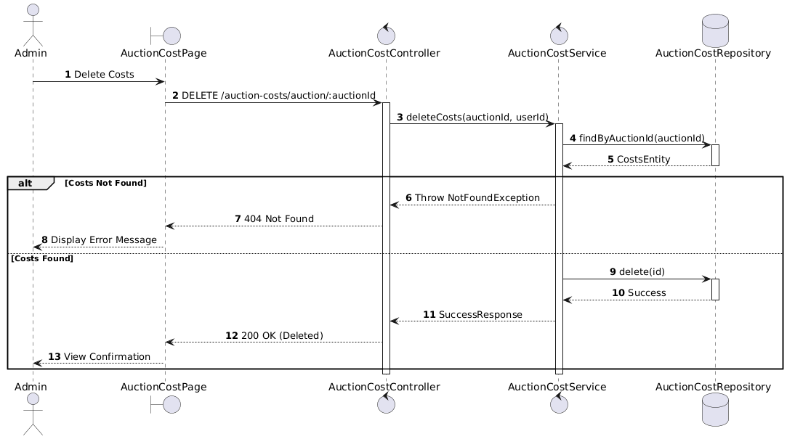

Activities Flow

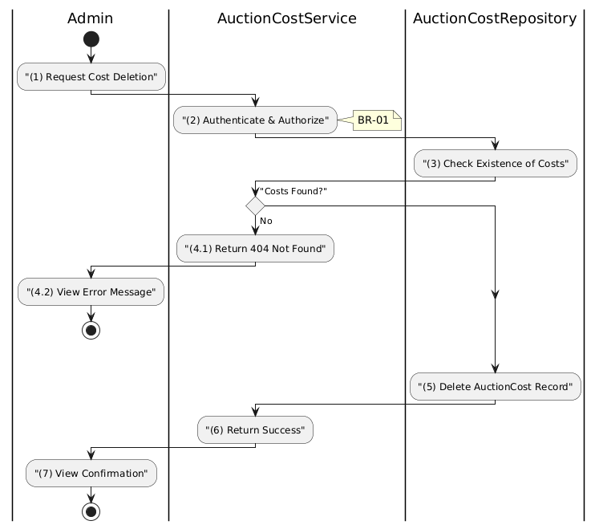

Business Rules
Activity | BR Code | Description
(1) | BR-01 | - Displaying Rule:  The system displays a 'Confirmation message box' screen. (Refer to View Description) with MSG 11 (Are you sure you want to delete all auction costs?).  Shows auction name and cost summary before deletion.
(1) | BR-02 | - Selecting Rule:  User selects button. If 'Cancel', use Close() to end.  If 'Confirm Delete', call method deleteCosts(auctionId).
(5) | BR-03 | - Validation Rule (Back-end/Save):  Check selection against table AUCTION_COST for constraints.  If auction is 'finalized' or 'completed' → display MSG 9 (Cannot delete historical records).  If costs not found → display MSG 11 (Not Found), return 404.  Else, delete data in table AUCTION_COST, display MSG 7 (Success), use Close(), update datagrid.

Add Other Cost in Auction Cost Use Case

Use Case Description
Name | Add Other Cost Item
Description | This use case allows the Admin to create a new Other Cost Item information in the system.
Actor | Admin
Trigger | - When the Admin clicks on the 'Add Other Cost' button on the AuctionCostPage.
Pre-condition | - • Admin's device must be connected to the internet.  • Admin is signed in with their account.
Post-condition | - The Other Cost Item information will be stored into the system and display new record on AuctionCostPage datagrid.

Sequence Flow

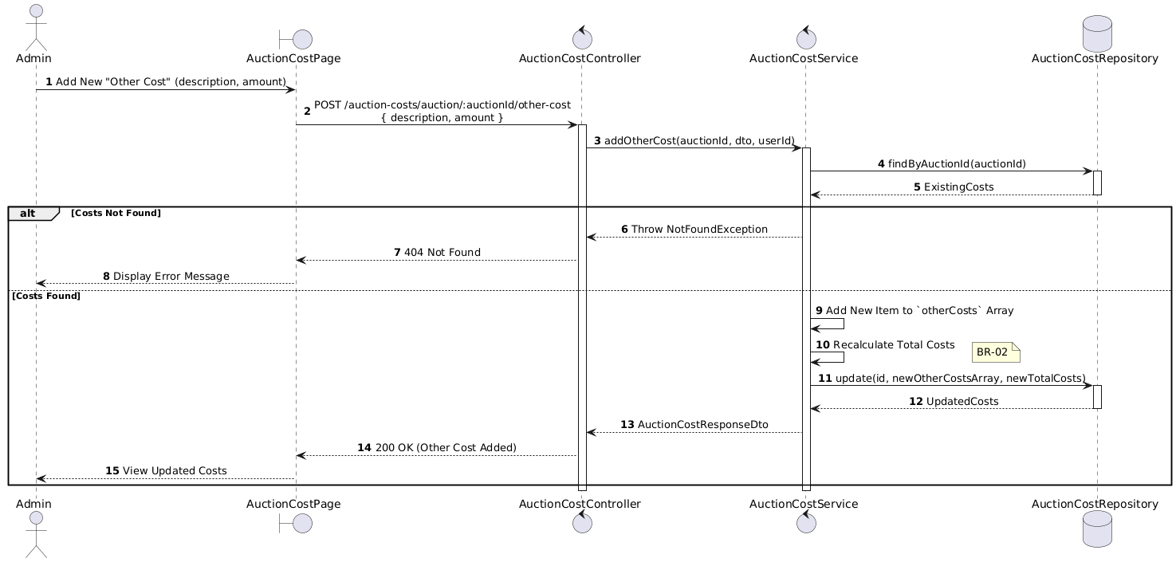

Activities Flow

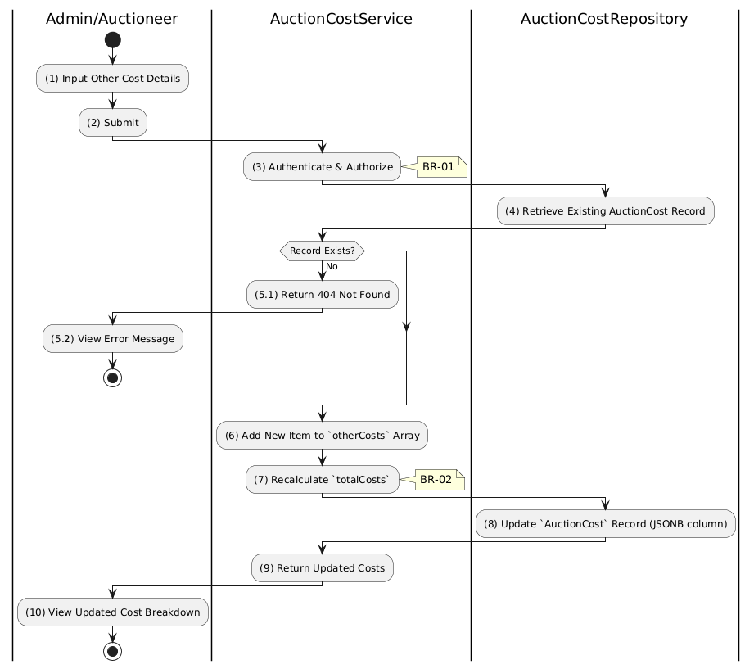

Business Rules
Activity | BR Code | Description
(1) | BR-01 | - Displaying Rule (Add Other Cost Form):  When Admin/Auctioneer clicks "Add Other Cost", system displays input form.  Form includes Description (text) and Amount (number) fields.
(1) | BR-02 | - Validation Rule (Required Fields - Front-end):  When Admin submits form, system triggers validation.  If description is isEmpty() or amount is empty/invalid:  $→$ System displays MSG 1 ("Description and Amount are required") adjacent to fields.
(1) | BR-03 | - Validation Rule (Amount - Front-end):  When Admin inputs amount, system triggers Text_change() validation.  Amount must be a positive number.  If invalid:  $→$ System displays MSG 4 ("Invalid amount") adjacent to field.
(3) | BR-04 | - Validation Rule (Authorization - Back-end):  System checks if requestor role is admin or auctioneer in USERS table.  If unauthorized:  $→$ System displays MSG 5 ("Forbidden") on the View.
(4)-(5.1) | BR-05 | - Querying Rule (Existing Record):  System retrieves data from the 'AUCTION_COST' table in the database (Refer to 'AUCTION_COST' table in 'DB Sheet' file) based on the auction ID.  If no cost record found:  $→$ System displays MSG 20 ("Please create base cost record first") on the View.
(6)-(7) | BR-06 | - Processing Rule (Array Append & Recalculate):  System appends new item to otherCosts JSON array.  System recalculates totalCosts including new other cost amount.
(8) | BR-07 | - Storing Rule:  System updates AUCTION_COST record:  - Updates otherCosts JSONB column with appended array  - Updates totalCosts with recalculated value
(10) | BR-08 | - Displaying Rule (Confirmation):  System displays MSG 7 ("Other cost added successfully") on the View.  System displays updated cost breakdown including new other cost item.

Manage Article Use Case

Manage Article Use Case

Use Case Description
Name | Manage Article
Description | This use case allows the Admin to choose one of the corresponding functions of CRUD to adjust Article information in the system.
Actor | Admin, All (Public for viewing)
Trigger | - When the Admin clicks on the "Article" button on the navigation sidebar.
Pre-condition | - 1. Admin's device must be connected to the internet.  2. Admin is signed in with their account.
Post-condition | - The Article information is updated to the corresponding function that the Admin executes.

Sequence Flow

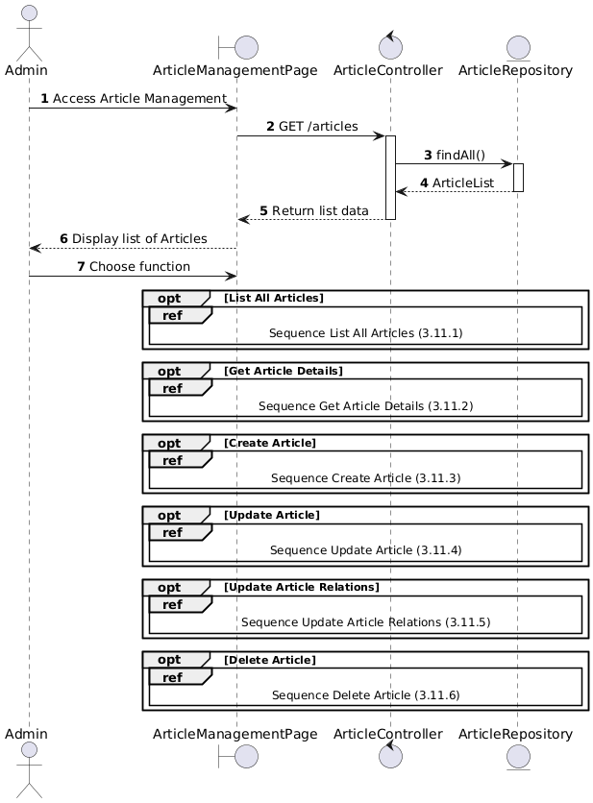

Activities Flow

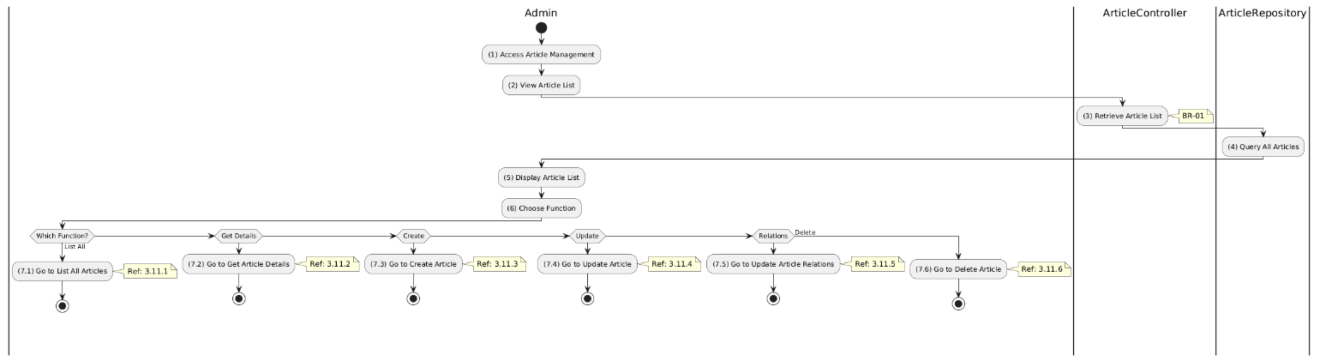

Business Rules
Activity | BR Code | Description
(5) | BR-01 | - Displaying Rule:  The system displays an "Article Management" screen. (Refer to "Article Management" view in "View Description" file).
(6) | BR-02 | - Choosing Rule:  Admin can only choose one feature at a time to use.

Get All Article Use Case

Use Case Description
Name | List All Articles
Description | This use case allows any user to view a list of articles including news, auction notices, and reports.
Actor | All (Public - Guest, Bidder, Auctioneer, Admin)
Trigger | - When the user navigates to the articles/news page
Pre-condition | - • User's device must be connected to the internet.
Post-condition | - The Article information is updated to the corresponding function that the Admin executes.

Sequence Flow

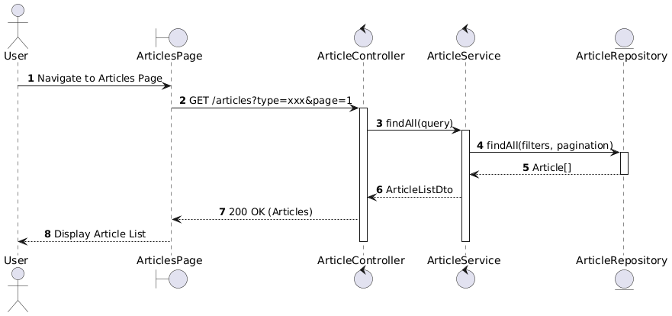

Activities Flow

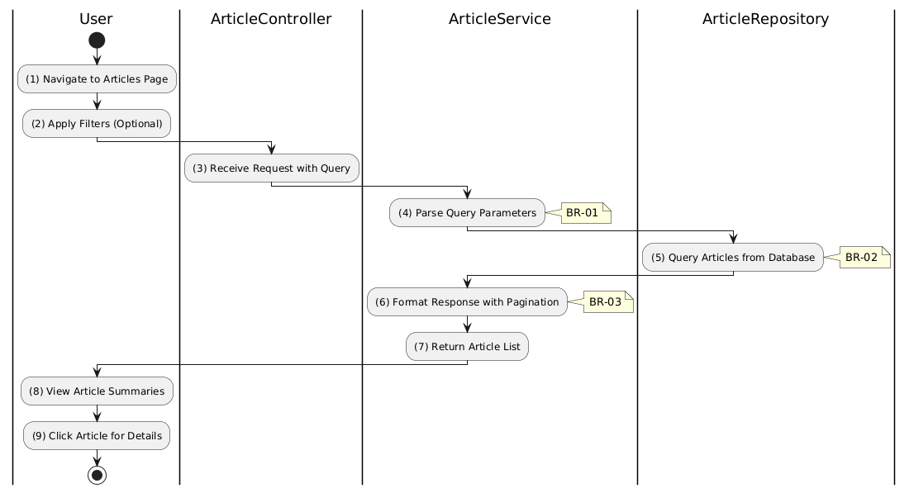

Business Rules
Activity | BR Code | Description
(1) | BR-01 | - Displaying Rule (Articles Page):  System displays ArticlesPage with article cards.  Each card shows: title, description excerpt, author, date, type badge.  System shows loading state while fetching.
(2) | BR-02 | - Processing Rule (Filtering):  System supports filtering by type:  - news: General news  - auction_notice: Auction announcements  - auction_report: Result reports  - legal_document: Legal docs.
(5) | BR-03 | - Querying Rule:  System retrieves data from the 'ARTICLE' table in the database.  Includes: id, type, title, description, image, author, createdAt.  Orders by createdAt DESC (newest first).
(6) | BR-04 | - Processing Rule (Pagination):  System returns paginated results.  Default page size: 10 articles.  Includes: items, total count, page number, total pages.
(8) | BR-05 | - Displaying Rule (Article Cards):  System displays article summaries with:  - Thumbnail image  - Title (clickable)  - Description excerpt (max 200 chars)  - Author name and date.

Create Article Use Case

Use Case Description
Name | Create Article
Description | This use case allows the Admin to create a new article (news, auction notice, report, or legal document).
Actor | Admin, Super Admin
Trigger | - When the Admin clicks "Create Article" and submits POST /articles.
Pre-condition | - • Admin's device must be connected to the internet.  • Admin is signed in with admin privileges.
Post-condition | - The new article is created and stored in the database.

Sequence Flow

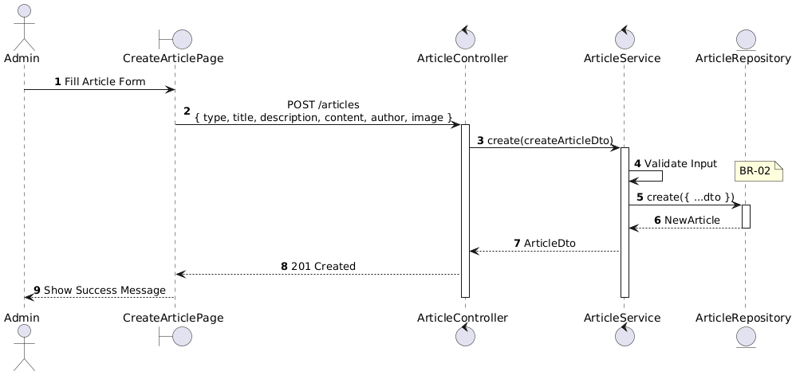

Activities Flow

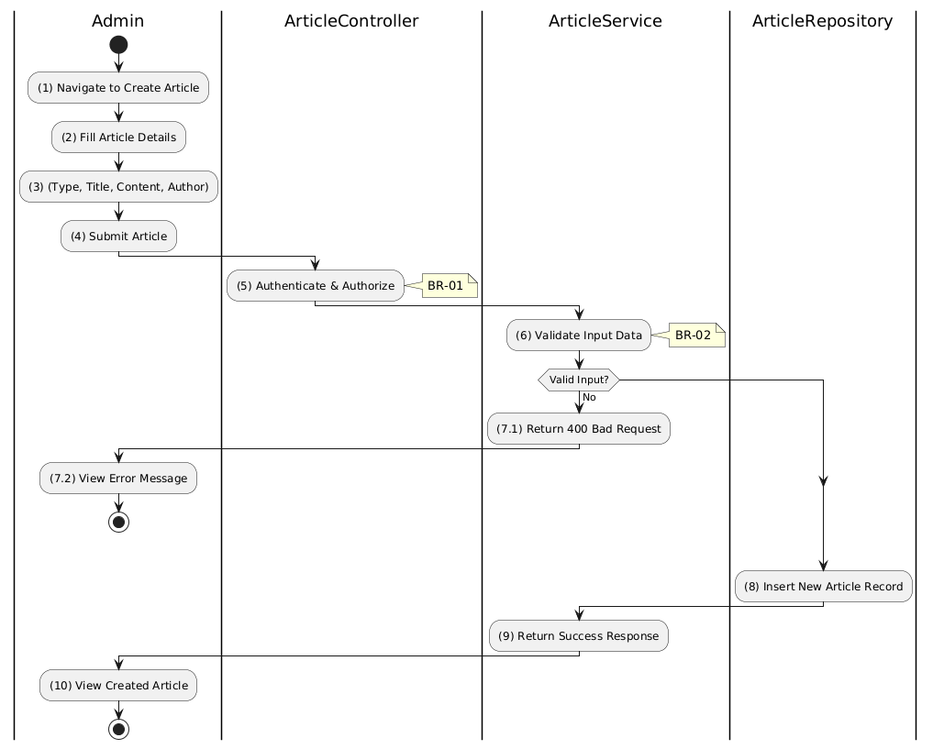

Business Rules
Activity | BR Code | Description
(1) | BR-01 | - Displaying Rule (Create Article Form):  System displays form with: type dropdown, title, description, content (rich editor), author, image upload.  All fields except image are mandatory.
(2) | BR-02 | - Validation Rule (Input - Front-end):  Type must be: news, auction_notice, auction_report, or legal_document.  Title: max 255 chars.  If isEmpty():  $→$ Display MSG 1 (Mandatory).
(5) | BR-03 | - Validation Rule (Authorization - Back-end):  System checks if requestor role is admin or super_admin.  If unauthorized:  $→$ System displays MSG 5 ("Forbidden") on the View.
(8) | BR-04 | - Storing Rule:  System saves to ARTICLE table:  - type, title, description, content, author  - image (JSON with url, publicId if uploaded)  - createdAt = now()
(10) | BR-05 | - Displaying Rule (Success Confirmation):  System displays MSG 7 ("Article created successfully") on the View.  System redirects to article detail page or list.

Get Article Detail Use Case

Use Case Description
Name | Get Article Details
Description | This use case allows any user to view the full details of a specific article.
Actor | All (Public - Guest, Bidder, Auctioneer, Admin)
Trigger | - When the user clicks on an article
Pre-condition | - • User's device must be connected to the internet.
Post-condition | - The article details are retrieved and displayed to the user.

Sequence Flow

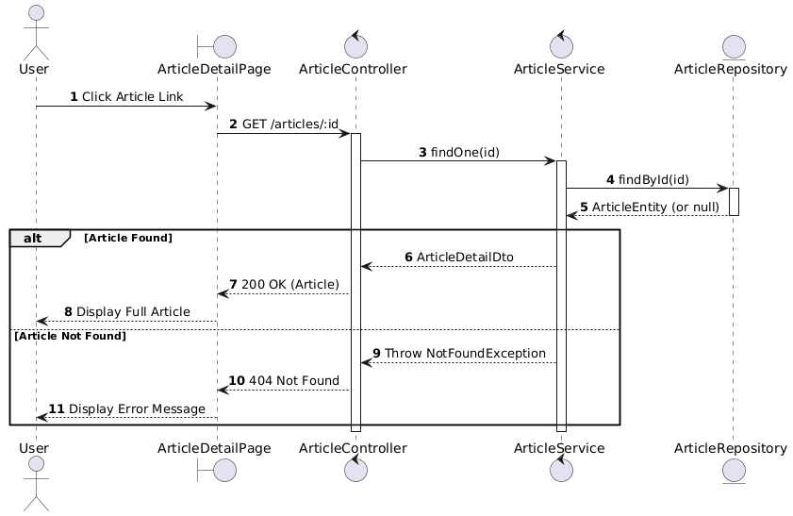

Activities Flow

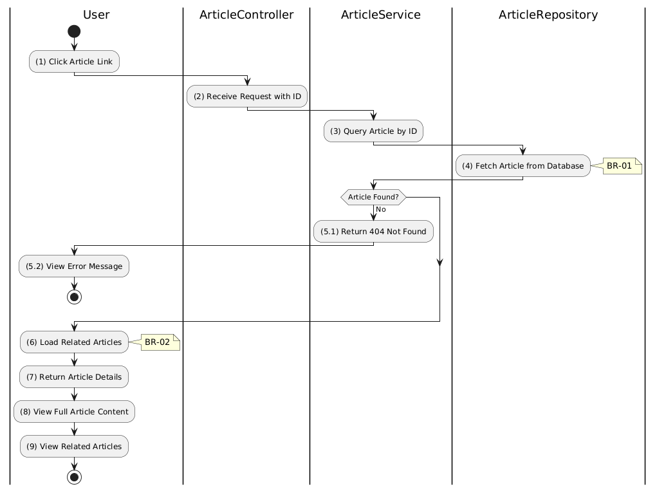

Business Rules
Activity | BR Code | Description
(1) | BR-01 | - Displaying Rule (Article Detail Page):  System displays ArticleDetailPage with full content.  Shows: title, full content, author, date, type, image.  Shows loading state while fetching.
(4) | BR-02 | - Querying Rule:  System retrieves data from the 'ARTICLE' table by ID.  Includes: all fields including full content.  If not found:  $→$ System displays MSG 20 ("Article not found").
(6) | BR-03 | - Processing Rule (Related Articles):  System loads related articles via ARTICLE_RELATION table.  Returns up to 5 related articles.  Allows user navigation to related content.
(8) | BR-04 | - Displaying Rule (Content Display):  System renders full article content.  Supports rich text/HTML content.  Displays header image if available.
(9) | BR-05 | - Displaying Rule (Related Articles):  System displays related articles sidebar/section.  Shows thumbnail, title, date for each related article.  Clickable links to navigate.

Update Article Use Case

Use Case Description
Name | Update Article
Description | This use case allows the Admin to update an existing article's content and metadata.
Actor | Admin, Super Admin
Trigger | - When the Admin submits updates via “Confirm Changes” button
Pre-condition | - • Admin's device must be connected to the internet.  • Admin is signed in with admin privileges.  • Article exists.
Post-condition | - The article is updated in the database.

Sequence Flow

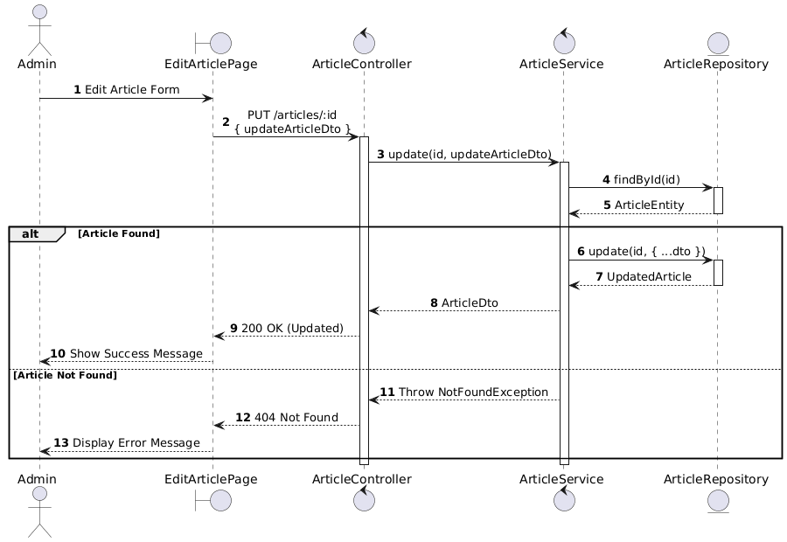

Activities Flow

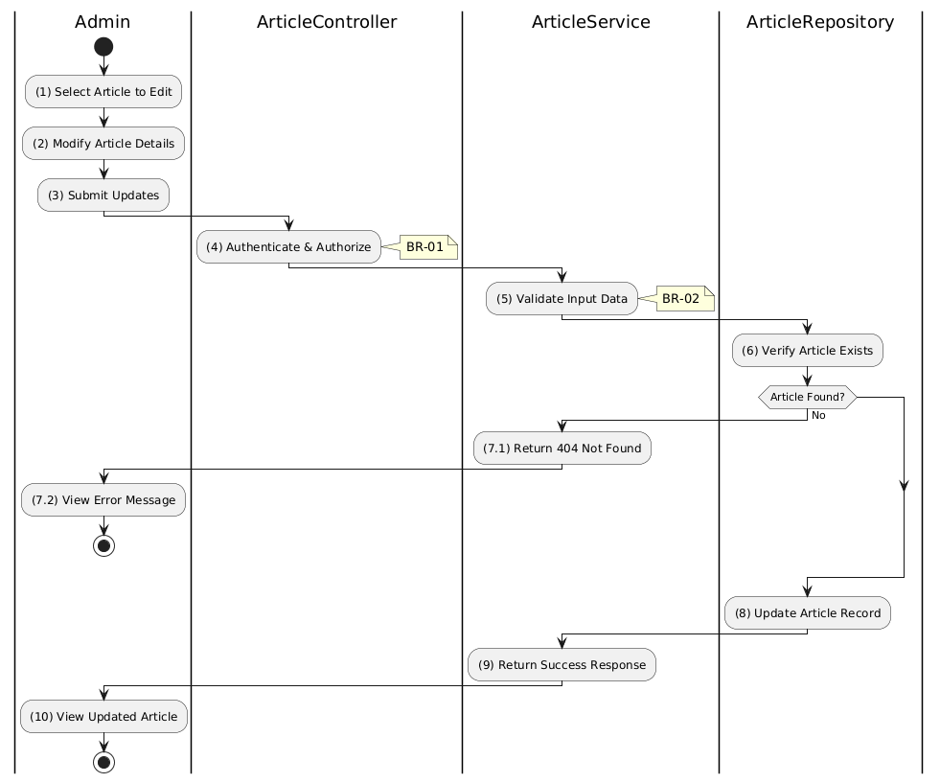

Business Rules
Activity | BR Code | Description
(1) | BR-01 | - Displaying Rule (Edit Article Page):  System pre-fills form with existing article data.  All fields are editable: type, title, description, content, author, image.
(4) | BR-02 | - Validation Rule (Authorization - Back-end):  System checks if requestor role is admin or super_admin.  If unauthorized:  $→$ System displays MSG 5 ("Forbidden") on the View.
(5) | BR-03 | - Validation Rule (Input):  Same validation rules as create apply.  Type must be valid enum value.  Title: max 255 chars.
(8) | BR-04 | - Storing Rule:  System updates ARTICLE table:  - All provided fields updated  - updatedAt = now()  - Unprovided fields remain unchanged.
(10) | BR-05 | - Displaying Rule (Success Confirmation):  System displays MSG 7 ("Article updated successfully") on the View.  System refreshes article display with new content.

Update Article Relations Use Case

Use Case Description
Name | Update Article Relations
Description | This use case allows the Admin to update the related articles for a specific article.
Actor | Admin, Super Admin
Trigger | - When the Admin submits related article updates
Pre-condition | - • Admin's device must be connected to the internet.  • Admin is signed in with admin privileges.  • Article exists.
Post-condition | - The article's relations are updated in the database.

Sequence Flow

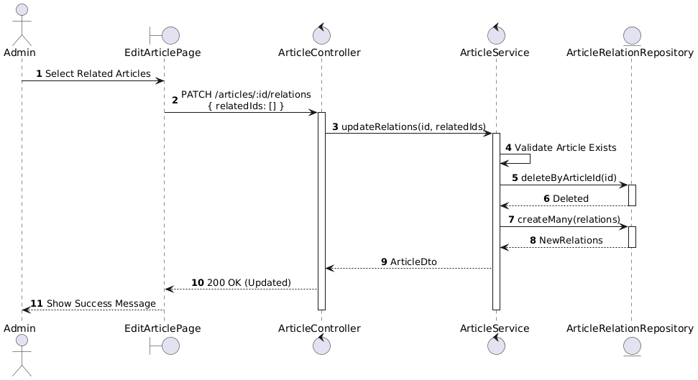

Activities Flow

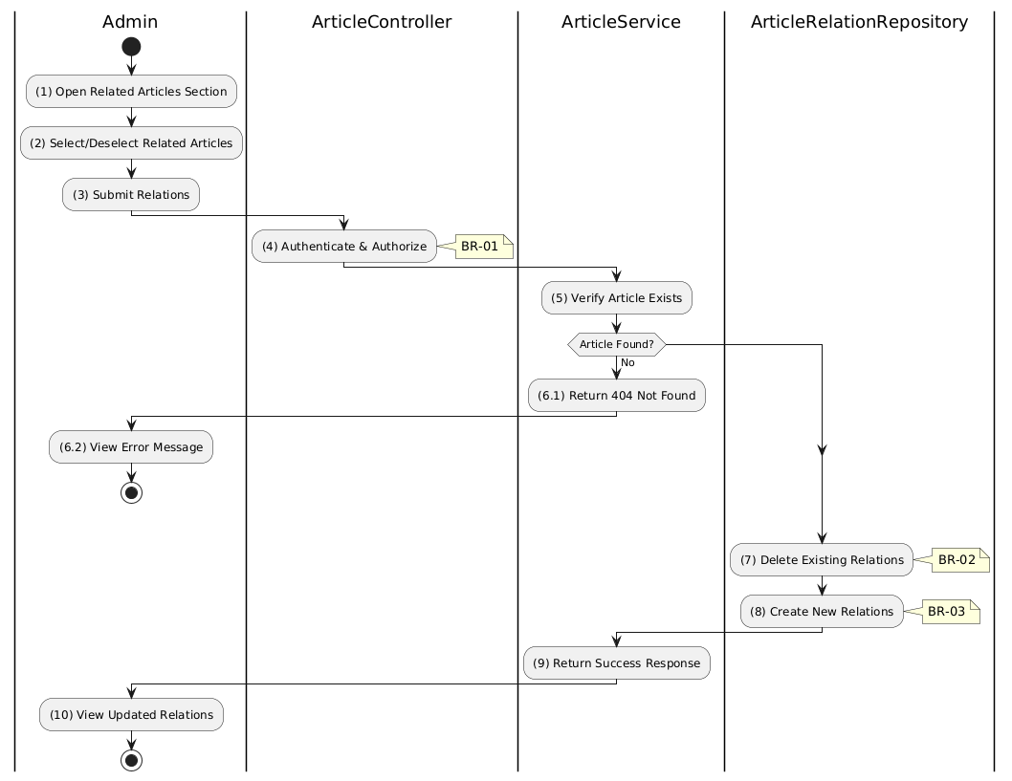

Business Rules
Activity | BR Code | Description
(1) | BR-01 | - Displaying Rule (Relations Section):  System displays searchable/selectable list of other articles.  Currently related articles are pre-selected.  Admin can select/deselect articles.
(4) | BR-02 | - Validation Rule (Authorization - Back-end):  System checks if requestor role is admin or super_admin.  If unauthorized:  $→$ System displays MSG 5 ("Forbidden") on the View.
(7) | BR-03 | - Processing Rule (Replace Strategy):  System uses replace strategy for relations.  Deletes all existing relations for the article.  Creates new relations from provided IDs.
(8) | BR-04 | - Storing Rule:  System saves to ARTICLE_RELATION table:  - articleId = [current article]  - relatedArticleId = [each selected article]  Creates bidirectional links if needed.
(10) | BR-05 | - Displaying Rule (Success Confirmation):  System displays MSG 7 ("Relations updated successfully") on the View.  System refreshes related articles section.

Delete Article Use Case

Use Case Description
Name | Delete Article
Description | This use case allows the Admin to delete an existing article from the system.
Actor | Admin, Super Admin
Trigger | - When the Admin confirms deletion
Pre-condition | - • Admin's device must be connected to the internet.  • Admin is signed in with admin privileges.  • Article exists.
Post-condition | - The article and its relations are removed from the database.

Sequence Flow

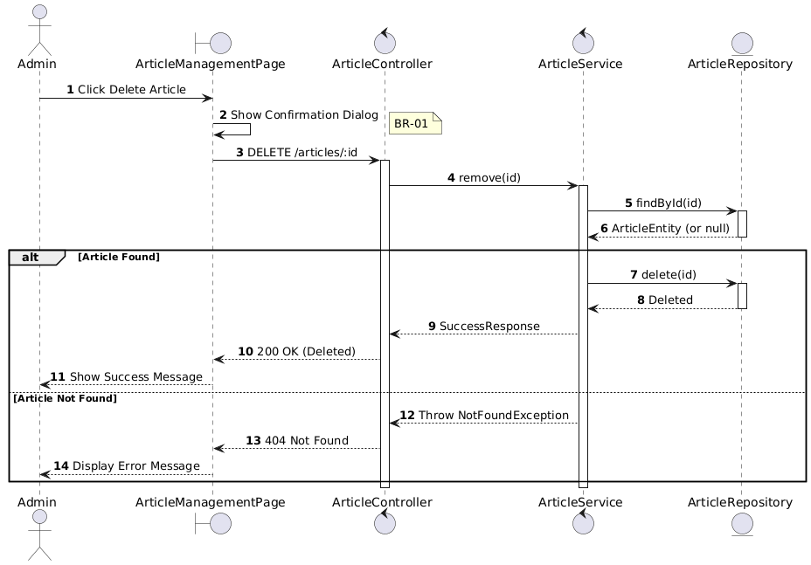

Activities Flow

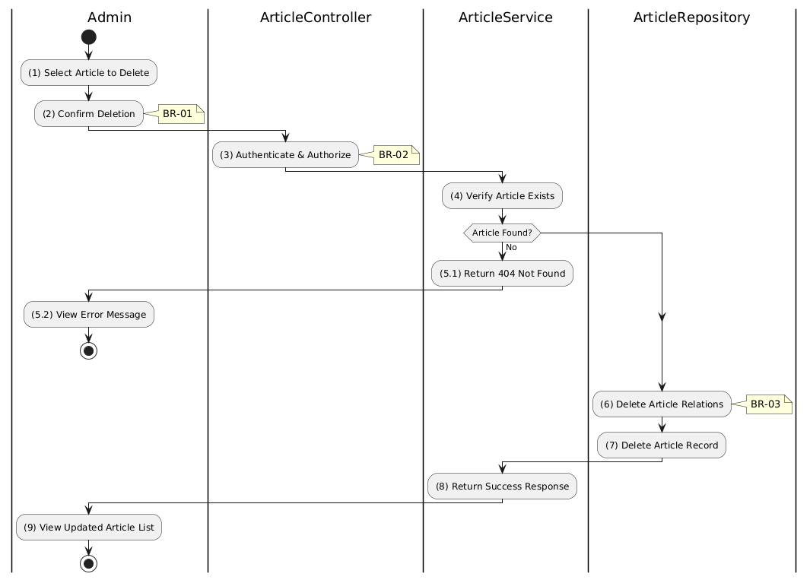

Business Rules
Activity | BR Code | Description
(1) | BR-01 | - Validation Rule (Confirmation - Front-end):  System displays MSG 11 ("Are you sure you want to delete this article? This action cannot be undone.").  System waits for confirmation before proceeding.
(3) | BR-02 | - Validation Rule (Authorization - Back-end):  System checks if requestor role is admin or super_admin.  If unauthorized:  $→$ System displays MSG 5 ("Forbidden") on the View.
(6) | BR-03 | - Processing Rule (Cascade Delete):  System deletes related entries in ARTICLE_RELATION table.  Uses ON DELETE CASCADE constraint.  Ensures referential integrity.
(7) | BR-04 | - Storing Rule:  System removes record from ARTICLE table.  Hard delete (permanent removal).  Article is no longer accessible.
(9) | BR-05 | - Displaying Rule (Success Confirmation):  System displays MSG 7 ("Article deleted successfully") on the View.  System refreshes article list to remove deleted entry.

List Description


View Description


Non-functional Requirements

User Access and Security
Actor  Function | Admin | Parent | Doctor
Adjust Doctor | X
Adjust Parent | X
Adjust Document | X
View User's Report | X
Supervise Prescription |  |  | X
Supervise Immunization Schedule |  |  | X
Supervise Child |  | X | X
Chat |  | X | X
Monitor Child Health Status |  | X | X
View Doctor Instruction |  | X
View Document |  | X
Track Child Events |  | X
Track Meal Times |  | X
Track Sleep Times |  | X
Sign Up for Parent |  | X
Sign In |  | X

X: User has full permission to do the action.
X(*): User has permission to do the action on his own items.
X(**): User has permission to do the action on items sent to him only.

Performance Requirements
Number of users
- Number of concurrent users: 500.
- Number of business users: 50.
Data volume
- Number of documents: 10,000.
- Data growth rate: 20% annually.
Level of availability
24/7 availability required for this application.
Usage frequency
Daily

Implementation Requirements
Location
The location where this website and mobile will be deployed: Ho Chi Minh City.
Read-only Duration
The duration this application can be set to read-only for a maximum duration of1 day.
Read-only Timeframe
The timeframe this application can be set to read-only: 2 AM - 4 AM EST.
Maintenance Window
The maintenance window for the application is scheduled on a quarterly basis, during the last weekend of each quarter.
Overall conversion timeline
Data conversion activities are planned on the 5th and 20th of every month are the major update dates.
Other plans and activities
[N/A]

Other Requirements

Archive Function
List | Actor | Condition
Parent information | Admin | The Admin is able to archive items in the "Parent Information" list by created date.
Doctor information | Admin | The Admin is able to archive items in the "Doctor Information" list by created date.
Document | Admin | The Admin is able to archive items in the "Document" list by created date.
Prescription | Doctor | The Doctor is able to archive items in the "Prescription" list by created date.
Immunization schedule | Doctor | The Doctor is able to archive items in the "Immunization schedule" list by created date.
Child information | Doctor / Parent | The Doctor/Parent is able to archive items in the "Child information" list by created date.
Child activity | Parent | The Parent is able to archive items in the "Child activity" list by created date.

Security Audit Function
Enable Security Audit Function for "Admin" to track any modifications on user’s permissions.

ChildHeathCare Sites
# | Site Name | Description
1 | Admin Site | - This is the control console for administrators. It provides functionalities to Create, Read, Update, and Delete (CRUD) information related to Doctors, Parents, and Documents.  - Additionally, it allows admins to view User's Reports, providing a comprehensive overview of the system's usage and user activities.
2 | Doctor site | - This site is designed for doctors. It enables them to create prescriptions and immunization schedules for parents.  - It also facilitates communication between doctors and parents through a chat feature, allowing for real-time consultation and advice.
3 | Parent site | - It allows parents to manage their children's health information and view documents provided by admins.  - Parents can also view prescriptions and schedules set by doctors.  - The chat feature enables parents to communicate directly with doctors for any health-related queries or concerns.

ChildHeathCare Lists
# | List Code | List Name | Description
1 | List01 | Parent information | - This list contains all the relevant information about the parents using the application.  - It includes details such as parent’s name, contact information, and their associated children in the system.
2 | List02 | Doctor information | - This list stores the details of the doctors available on the platform.  - Information includes the doctor’s name, specialization, and contact information.
3 | List03 | Document | - This list holds various documents provided by the admin or the doctors.  - These could be general health tips, prescriptions, immunization schedules, or any other relevant health documents.
4 | List04 | Prescription | - This list contains the prescriptions provided by the doctors for each child.  - Each prescription would include details like the medicine name, dosage, frequency, and duration.
5 | List05 | Immunization schedule | - This list holds the immunization schedules for each child.  - It includes details like the name of the vaccine, the date it was given, the date for the next dose, and any additional notes.
6 | List06 | Child information | - This list contains all the relevant information about the children.  - It may includes details such as the child’s name, date of birth, medical history, and associated parent information.
7 | List07 | Child activity | - This list tracks the various activities of each child.  - These activities could include feeding times, sleep patterns, and any other significant activities or milestones.

Custom Pages
* There is no custom page implemented in this application. *

Scheduled Agents
* There is no scheduled agent implemented in this application. *

Technical Concern
Low Growth Rate: If the growth rate of the application’s user base or data volume is low, there is less risk of performance issues. However, it’s important to plan for potential future growth to ensure the application can scale effectively.
Large Data Volume: A huge amount of data can lead to saving/loading issues. It can slow down database queries and increase the load time of pages. Efficient data management strategies and optimization of database queries can help mitigate these issues.
Excessive Content on a Single Page: Too much content on a single page can lead to longer load times and a less responsive user interface. Implementing pagination or infinite scrolling can help manage the amount of content displayed at once.
High Traffic: If the application experiences high levels of traffic, it could strain the server and lead to slower response times. Implementing load balancing and caching strategies can help manage high traffic.
Security Measures: While necessary, certain security measures can impact performance. For example, data encryption and decryption can be resource intensive. It’s important to implement security measures in a way that balances safety and performance.

Appendixes

Glossary
The list below contains all the necessary terms to interpret the document, including acronyms and abbreviations.
Term | Description
BR | Business Rule
CBR | Common Business Rule
DB | Notes Database
MSG | Message
UC | Use Case
N/A | Not Available or Not Applicable, used to indicate when information in a certain section could not be provided because it does not apply to this application.
UI | User Interface
SRS | Software Requirements Specification
TBD | To be determined or to be defined

Mapping to Notes Application
* There is no mapping between the migrated application and its source Notes application. *

Messages
This section describes the details of messages used in business rules e.g. error messages, confirmation messages, etc.
Message Code | Message Content | Button
MSG 1 | This field is mandatory. You must provide information in this field to proceed. | Ok
MSG 2 | Your username or password might be wrong. Please check and try again later. | Ok
MSG 3 | Sign in successful. | Ok
MSG 4 | Your information is not in the correct format. Please check again. | Ok
MSG 5 | Your entered email had been existed in the system. Please check again. | Ok
MSG 6 | Your entered phone number had been existed in the system. Please check again. | Ok
MSG 7 | Save data successful. | Ok
MSG 8 | The size of image is too large. You need to compress it to upload. | Ok
MSG 9 | Your action is failed due to constraints in the system. | Ok
MSG 10 | This username had been existed in the system. Please choose another username. | Ok
MSG 11 | Are you sure you want to delete this [item]? | Yes/No

Issues List
N/A

